**Azure_CosmosDb**

**Concepts of cosmosdb**

* Introduction
* Throughput and cost
* Horizantal Partitioning
* Global Distribution

**How-to**

* Data modeling and migration
* querying with SQL
* programming with .net SDK
* Building cosmosdb applications (serverside progeamming,batch & bulk operations , change feed)
* alternative way of modeling data in cosmosdb
* Table API > keyvalue store
* Gramlin API >graph db

**NoSQL ?**

* to solve problem of Big data. ie, 3 Vs
  + volume > db size Tb,Pb,..
  + velocity >Throughput , keep pace with requests that coming in fast (distributed workload across machines )
  + variety > this is about schema and problems that occur in relational DB regarding schema changes. as schemas evolve more, it is difficult to apply those schema changes to mission critical databases that require continuous uptime around clock.this is even more difficult for distributed DBs when those schema changes need to be deployed to multiple regions.
* Relation Dbs can't handle Big data
* in NoSql instead of one big machine (Tb,Pb size), scale-out to multiple machines in the face of volume , velocity and variety

**What is NoSql DB?**

* Distributed :: Replicas ensure high availability and resilience
  + NoSql db is ditributed from groundup.no extra effort needed.
  + multiple copies of data are distributed to separate replicas. more copies you have of same data , more available it is to more users. so, more resilient to failure if and when replica should go down.
* Scale-out :: Horizantal Partitoning for elastic storage and throughput.
  + horizontal partitioning, which balances the workload uniformly across a cluster of machines.these capabilities are built in.
* Schema-free :: no enforced schema
  + it doesn't mean there isn't any schema, but no enforced schema. So, every item in database have schema, which is its shape, but that shape can change without friction and downtime unlike relational databases and enforced schemas.

**Cosmos DB**

* Cosmos DB is massively scalable NoSQL database that's available to your application as a fully managed PaaS that runs on Azure.
* There are comprehensive service level agreements (SLAs) on **throughput, latency, consistency, and availability,** 
  + guaranteed no more than 52.56 minutes of downtime per year max with 99.99% availability
  + or no more than 5.26 minutes of downtime per year max with 99.999% availability
  + this you can get if you globally distribute your data.
* it delivers blazing fast reads and writes, typically within 10 ms or less, whether you've GB, TB or PB of data.
* Cosmos DB **automatically** manages the growth of your data by **horizontally partitioning** the workload behind the scenes.
* The process is transparent and provides elastic scale for virtually unlimited storage to handle volume, as well as throughput for velocity.
* Cosmos DB runs in Microsoft data centers throughout the world. Within any one data center, Cosmos DB **replicates your data automatically**, and that ensures high availability within that one region.
* you can also replicate your data across **multiple data centers** and distribute your data globally.
* Simply point and click on a map, and Cosmos DB does the rest
* You can also enable **multi‑master**, and that will ensure high performance writes, as well as reads in any region where your data is distributed.
* Cosmos DB has multiple APIs to support variety of schema‑free data models.
  + JSON documents using SQL API or the MongoDB API
  + Table data model> Table API
  + Graph data model > Gremlin API
  + columnar data model > Cassandra API

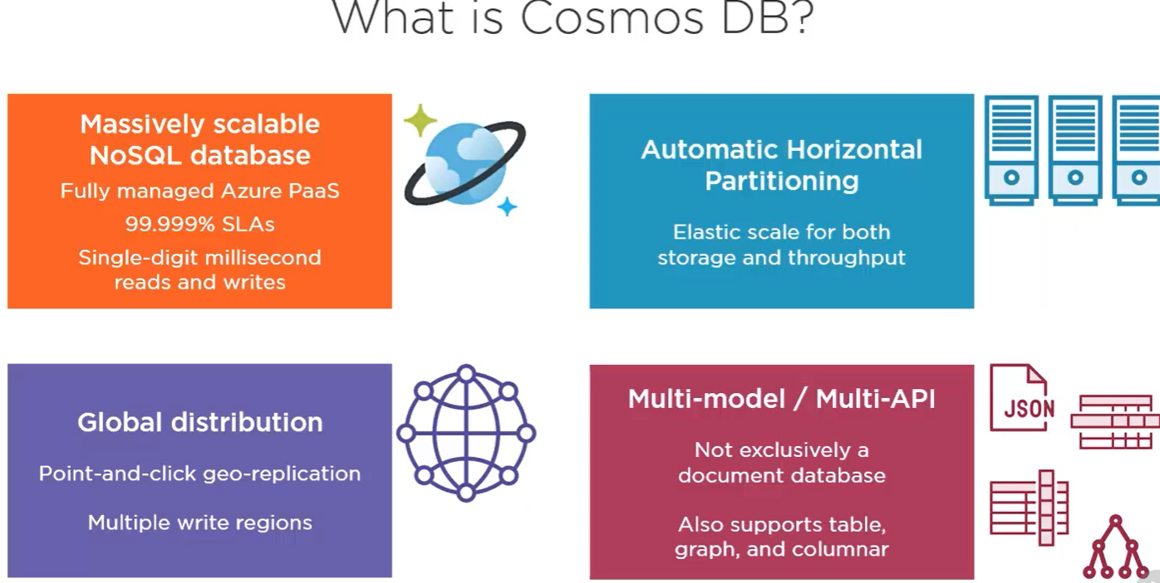

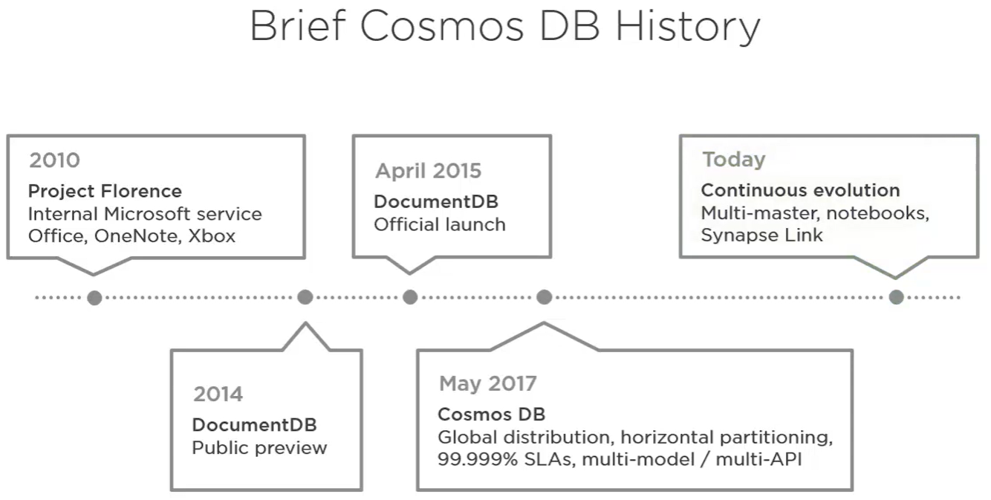

**Getting Started**

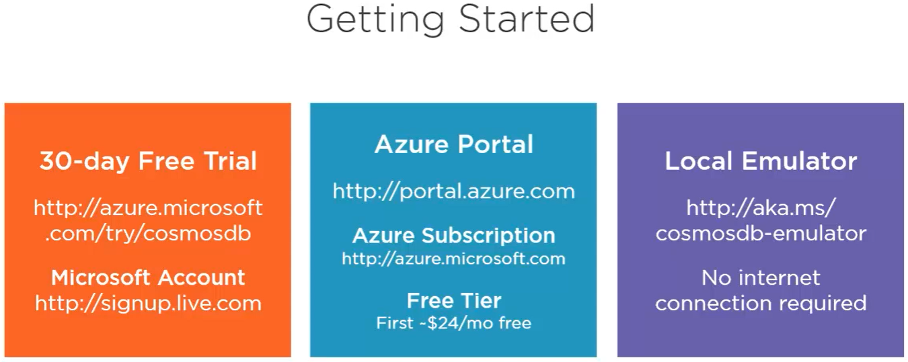

* above are 3 ways to use cosmosDb. Local emulator doesn’t support global distribution.

**Create CosmosDb:**

* portal.azure.com >create resource >search ‘azure cosmos db’ > Create ‘Core SQL API’
* **Core SQL** :: it gives json data model that can be queried using sql.it is special version of sql used to query json documents. This is most capable than others like mongo, table, Cassandra, gremlin APIs
* **Geo-redundancy** :: enables geo-replication between two regions
* **Mutli-region writes** :: enables both regions for writes and reads
* ‘Notebooks’ are not available for some regions. So some options might be disabled
* **Availablity zones** :: provides added redundancy for partial failures or outages within a single data center. This is useful for those data centres located in countries with data sovereignty and residency laws like Singapore, which does not permit geo-replication between southeast asia and hong kong. By using availability zones in south-east asia cosmosDb can offer redundancy in the event of major failure even within just that one region
* **Networking** ::
  + All networks :: our account is accessible over public internet
  + Public endpoint :: limited accessibility over selected networks
  + Private endpoint :: account can be accessible to only by clients within same virtual network or VNet on Azure
* **Encryption**: CosmosDB always encrypts data at rest using encryption keys (‘service-managed keys’) that it also creates and manages. If extra security needed, use your own personal ‘customer-managed encryption key’ which you’re storing in azure key vault.

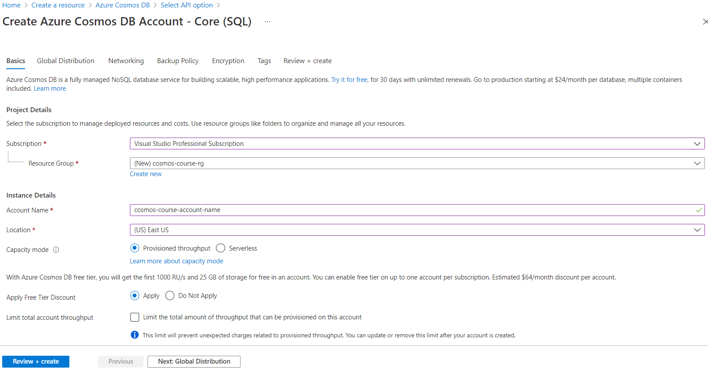 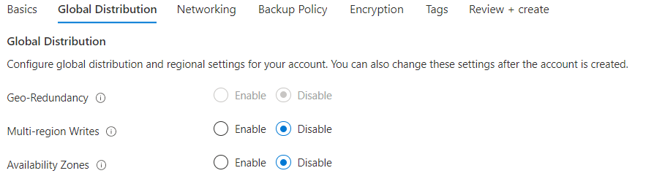 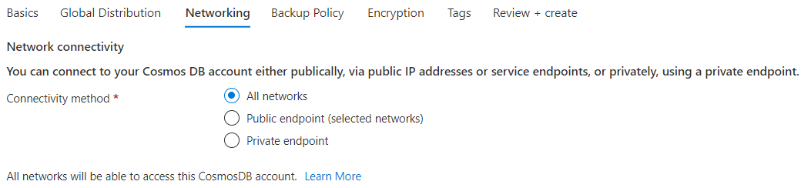 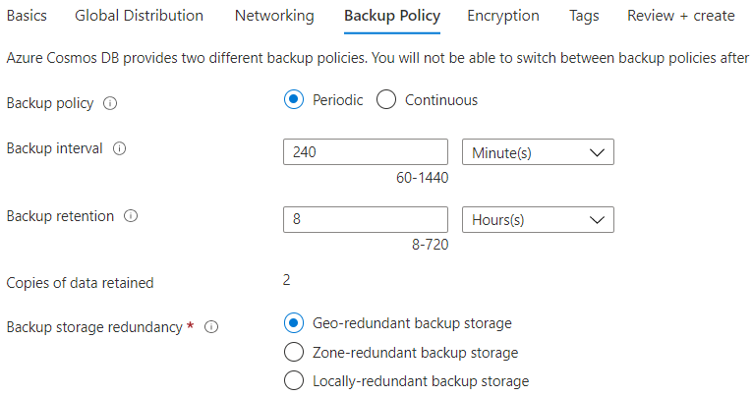 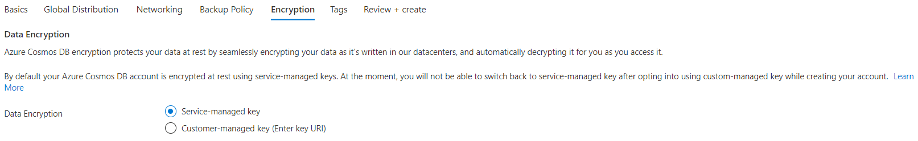

Now click > Review+Create

* Goto cosmosdb resource > overview

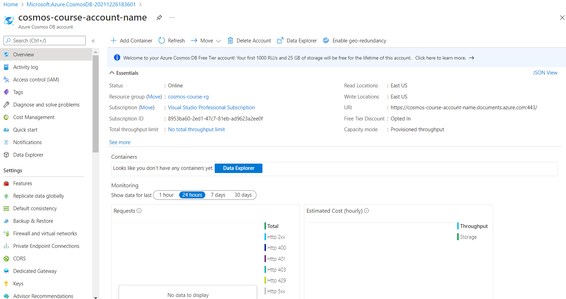

* ‘Keys’ tab have primary and secondary keys which gives unlimited access to account. So never share those. Generally your application only use ‘primary master key’. Use ‘secondary master key’ only when you want to change primary key (rotating keys). So, temporarily use ‘secondary key’ while you change primary key. This is to make uninterrupted running application.

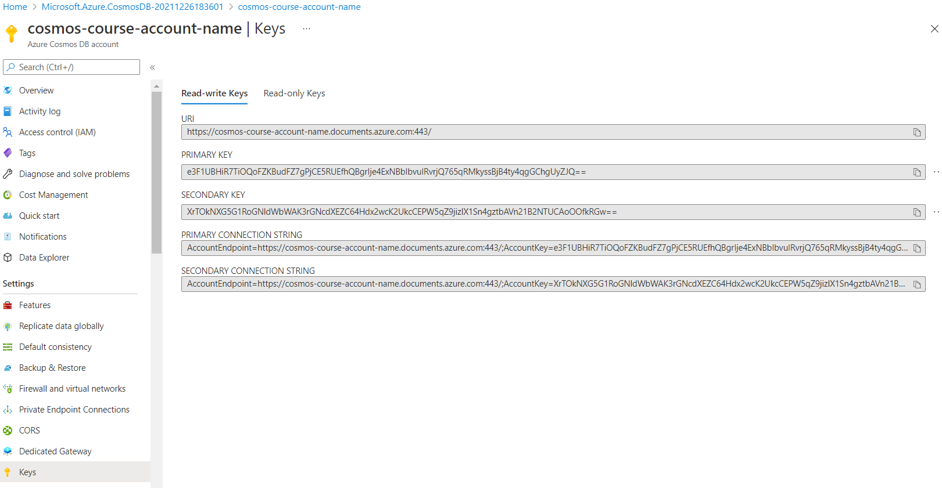

* URI end point+ Primary Key= Primary connection string
* URI endpoint+ secondary key=secondary connection string
* There are read-only version of these keys in ‘Read-only Keys’ tab for unlimited read access

**Creating a Container:**

* Go to ‘Data explorer’ tab
* Data explorer has full screen feature on top right corner

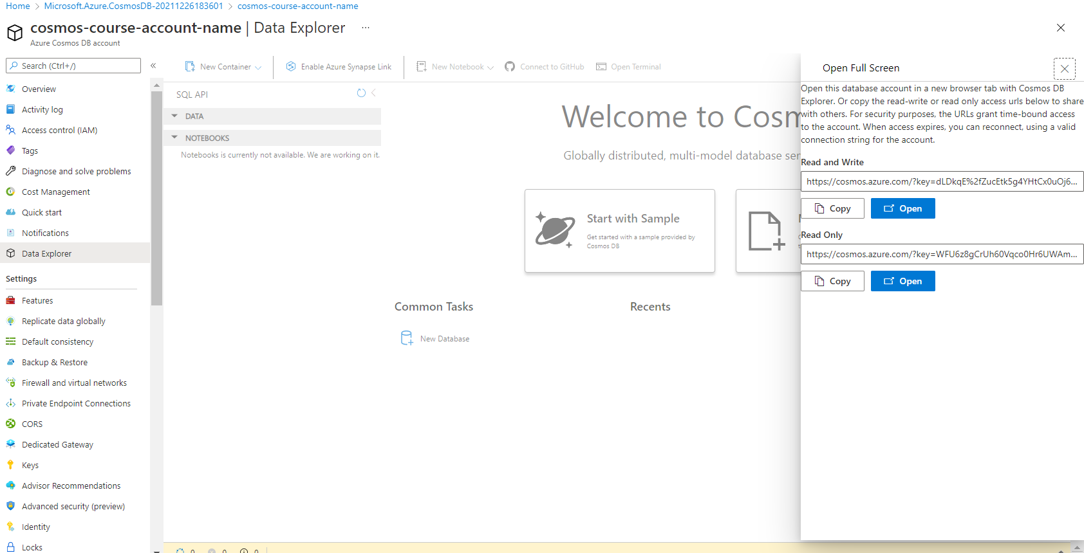

* The above keys are temporary for security reasons. they do expire.
* Open full screen in read and write mode to focus only on data explorer

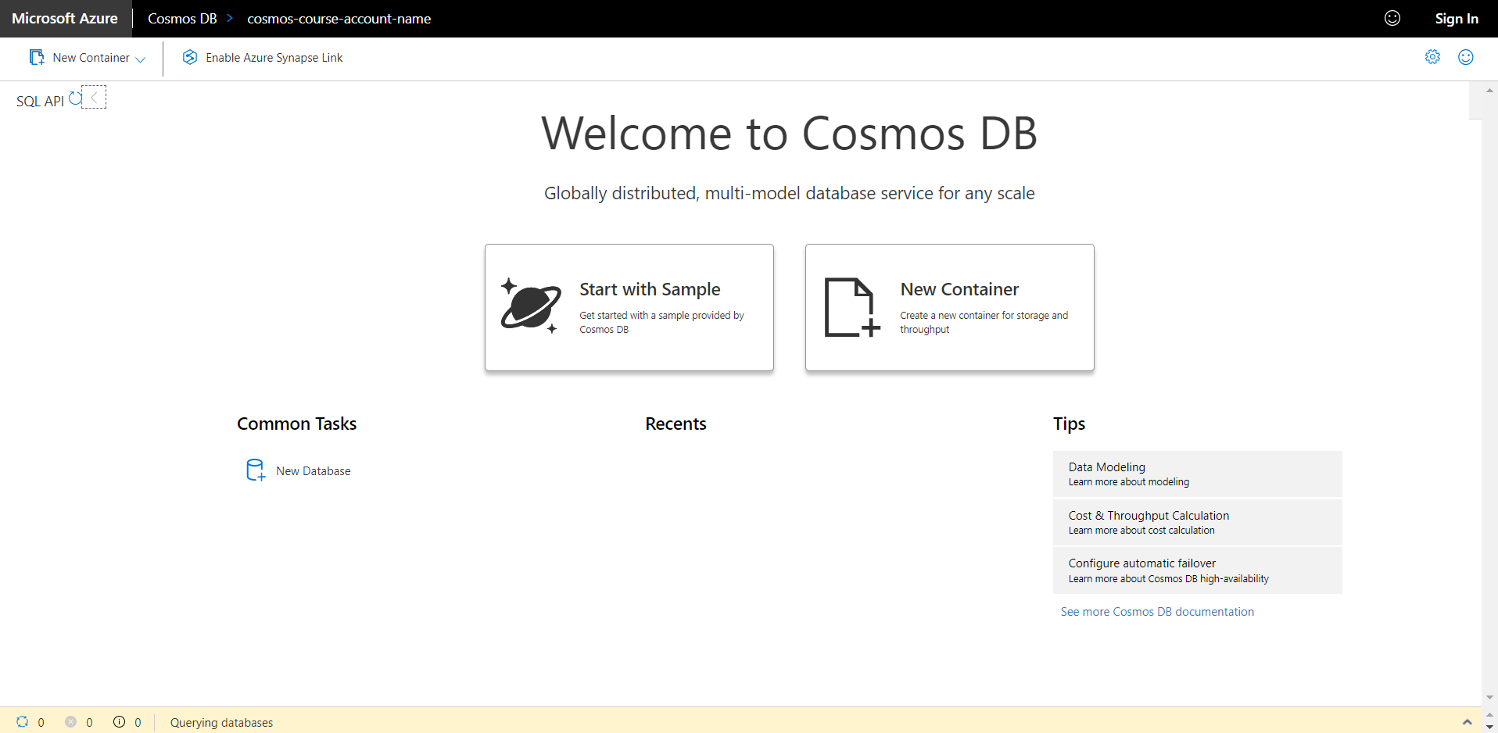

* Click ‘New Container’.
* First specify **new/existing database name** and specify **container name** to be created within that database
* In somecases you only have 1 container in DB. All the items in a container can be of different types and have different schemas, so you definitely not going to create 1 container for each type of entity in your data model.
* **Throughput**: performance level that you need the container to deliver.
  + higher number gives higher performance at higher cost
* **partitioning key** : partitioning has to do the way cosmosDB physically stores multiple documents together based on the partition key that you choose. Ie, common property in the data you writing to container .
* there are cases where you need multiple container in one DB, Because even though containers can provide unlimited storage, some data may require more or less throughput than others, and some data might have different partitioning needs than other data in order to deliver that unlimited storage.
* **Share throughput across containers** ::All containers in DB share throughput evenly. Uncheck this feature to control throughput at container level, since you’ll usually want to control throughput independently for each container in the database.
* Analytical store :: if on, Cosmos DB will automatically create a column store copy of your transactional data and keep it synchronized in near real time as you ingest data into your container. Then, using the Azure Synapse Link, you can use Azure Synapse Analytics for analytic workloads against the column store in the container with zero impact on the transactional workload.

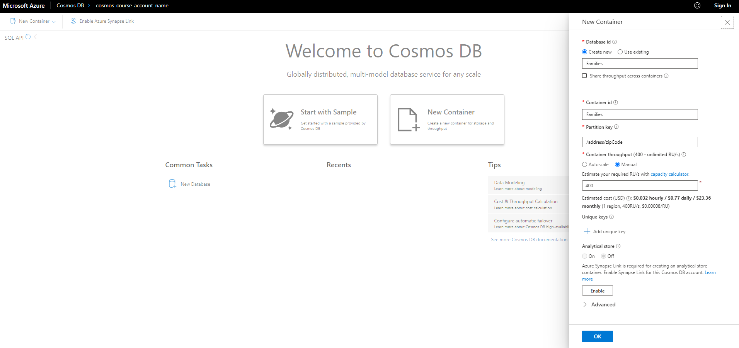

* Now Create Container

**Creating Documents:**

* ‘Families DB’ has ‘Families container’. Now create ‘documents/Items’ inside this container (click new item inside ‘items’ tab and type json)
* ‘zipcode’ property is needed since it is partition key and every document also needs ‘id’ own property which is unique among all documents within partition key.
* So,Each item is unique in container by ‘zip code’ and ‘id’. In many cases omit the id (remove it from json) when creating new document/item and global unique id (GUID) generates automatically

{

    "familyName":"Smith",

    "address":{

        "addressLine":"1234 Main street",

        "city":"Chicago",

        "state":"IL",

        "zipCode":"60601"

    },

    "parents":[

        "peter",

        "Alice"

    ],

    "kids":[

        "Adam",

        "Jacqueline",

        "Joshua"

   ]

}

Type and save. Id generates automatically

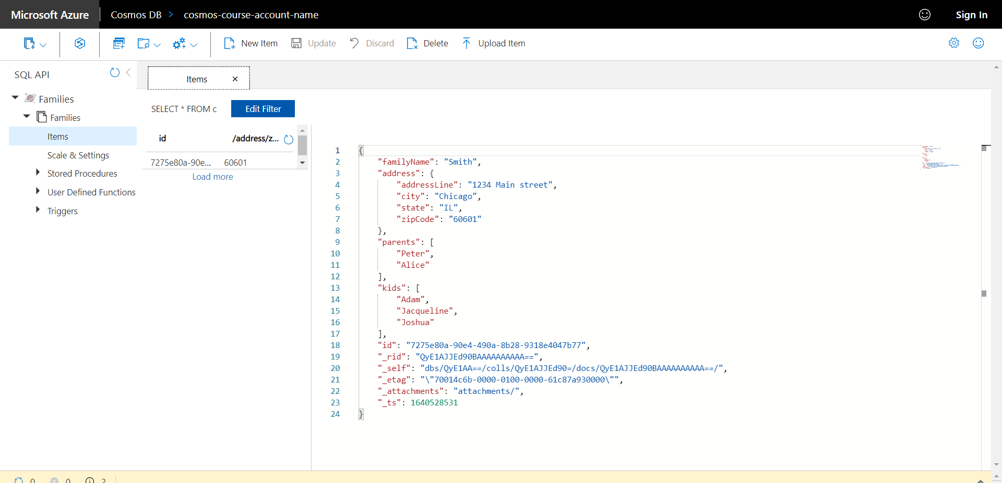

* Note! Unlike relational databases , here
  + 1. schema not defined for this database because we don’t have enforced schema.
  + 2. single document represents what would typically be stored as multiple rows in separate relational tables joined by related keys. Eg: address would be a separate row in the address table joined to the family in a 1-1 relationship & parents and kids would be stored as separate rows in other tables joined to the family in a 1‑to‑many relationship.
  + from a data modeling perspective, get used to the **denormalized nature** of JSON documents when transitioning from the highly normalized world of relational databases.
  + with no enforced schema, it's easy to accommodate new family properties as they come up in the future. Eg: pets
  + instead of manual creation, these documents are generally created using code, or by migrating from external data sources
  + existing documents can be updated using ‘update’ button
* click ‘new sql query button’ for querying documents using sql

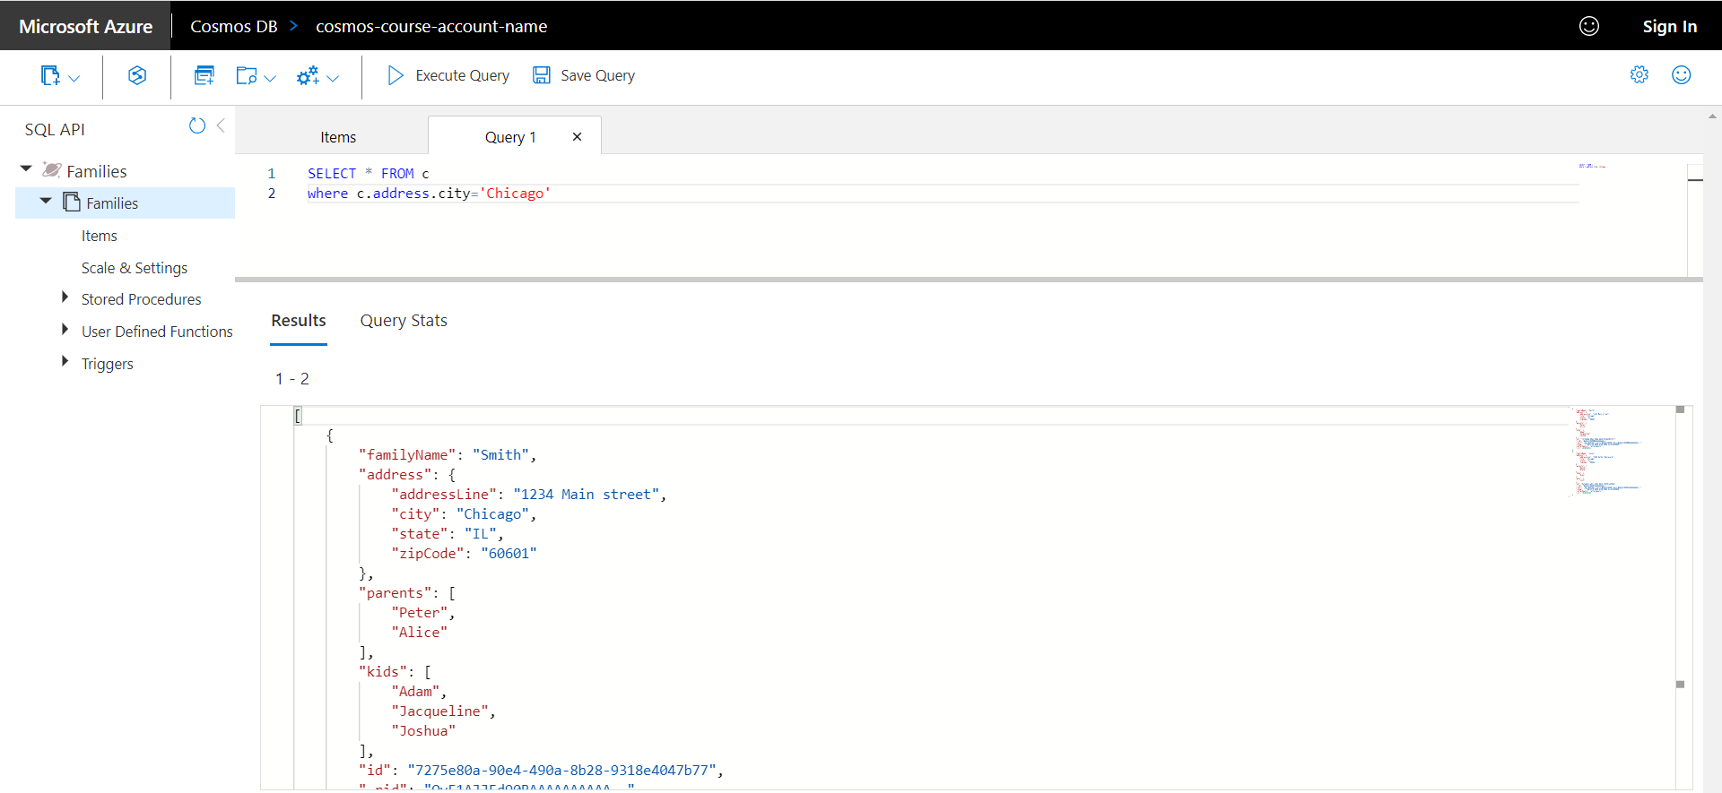

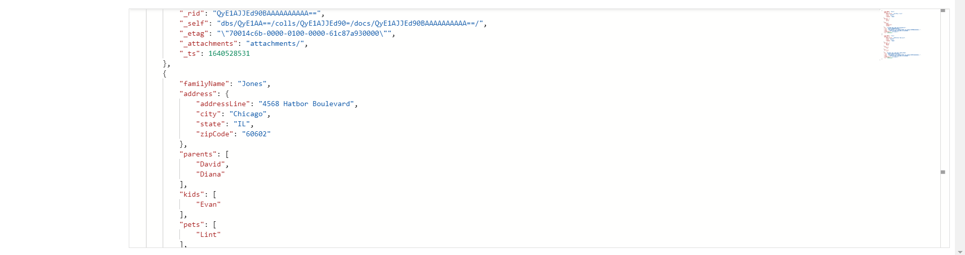

* the above query get 2 documents since both cities are ‘Chicago’ but both ‘zipcodes’ are different (ie, each document stored in different partition internally). So, this query is **‘Cross Partition Query’**
* SELECT * FROM c WHERE c.address.zipcode=’60601’return only 1 document , the only family in that zipcode. Since you filtering on partition key, this is called **‘single partition key’**
* SELECT * FROM c WHERE IS_DEFINED(c.pets) >returns only 1 family (jones family) since only this has pets property >it’s a **‘Cross Partition Query’** since it is checking all zipcodes
* SELECT * FROM c WHERE ARRAY_LENGTH(c.kids) > 2 >>returns only 1 family (smith family)

**Management Options:**

1. Azure Portal
2. Azure CLI

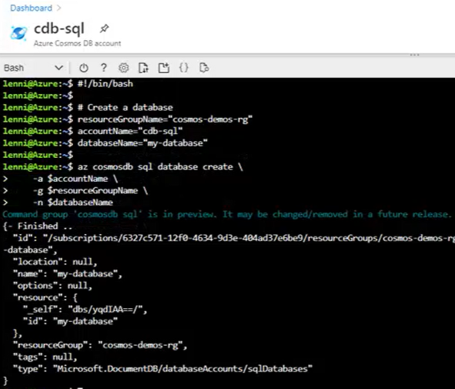

1. Powershell

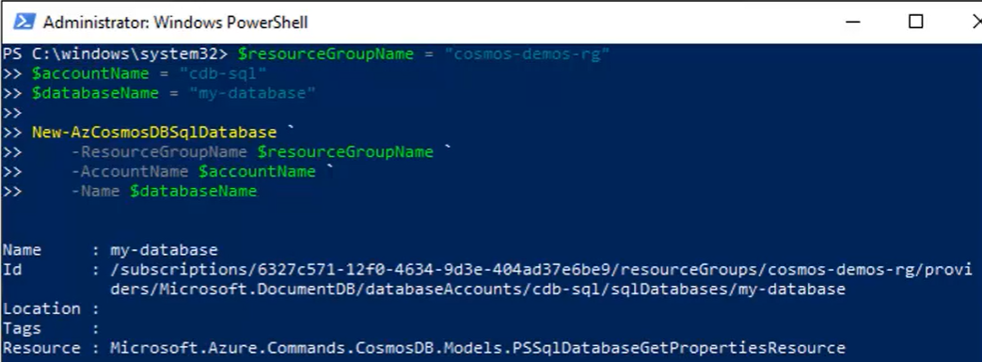

1. Notebooks

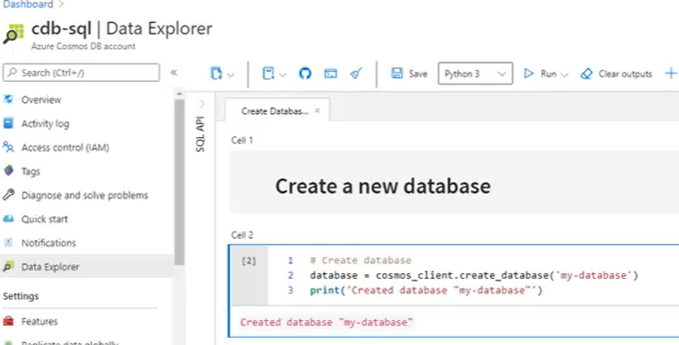

1. REST API (url or use .NET SDK wapper around REST API )

<https://docs.microsoft.com/en-us/rest/api/cosmos-db/create-a-database>

**Notebook:**

* Create DB, container

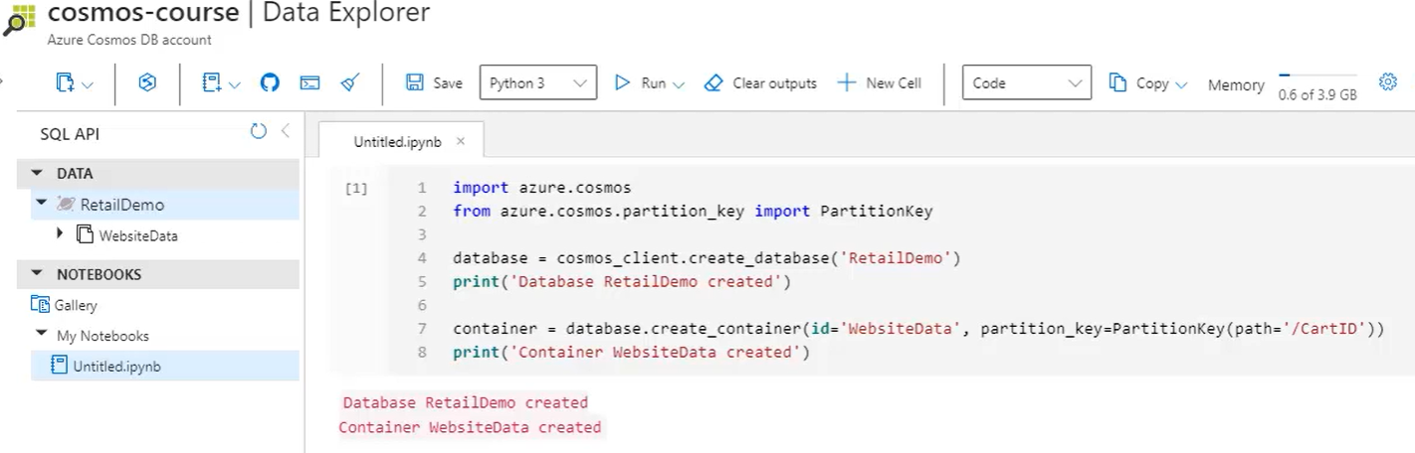

* %%upload magic :: Populate documents using json data from blob storage

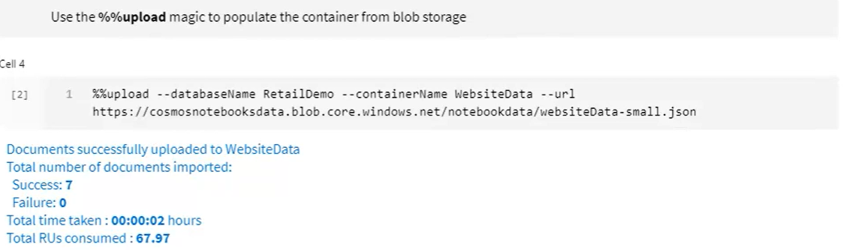

* %%sql magic: to use sql to query json documents and show then as table rows

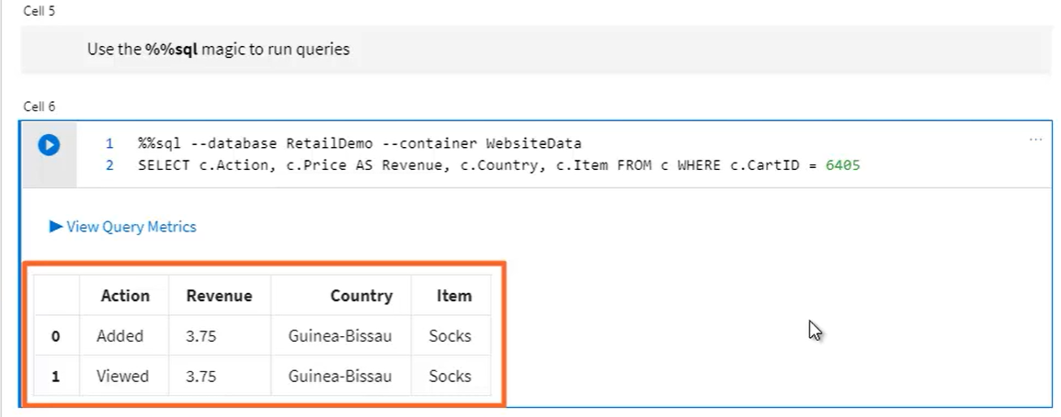

**Automatic Indexing:**

* CosmosDb automatically index every property in every item in a container
* JSON > Tree structure > flat list of keys & values where each key is expressed as property path to specific value. Then this list is indexed along with all other items in container.
* Result is you have container with no defined schema, yet its fully indexed. You can finetune this for better performance using custom indexing policy.
* This is for all APIs, not only for core SQL API

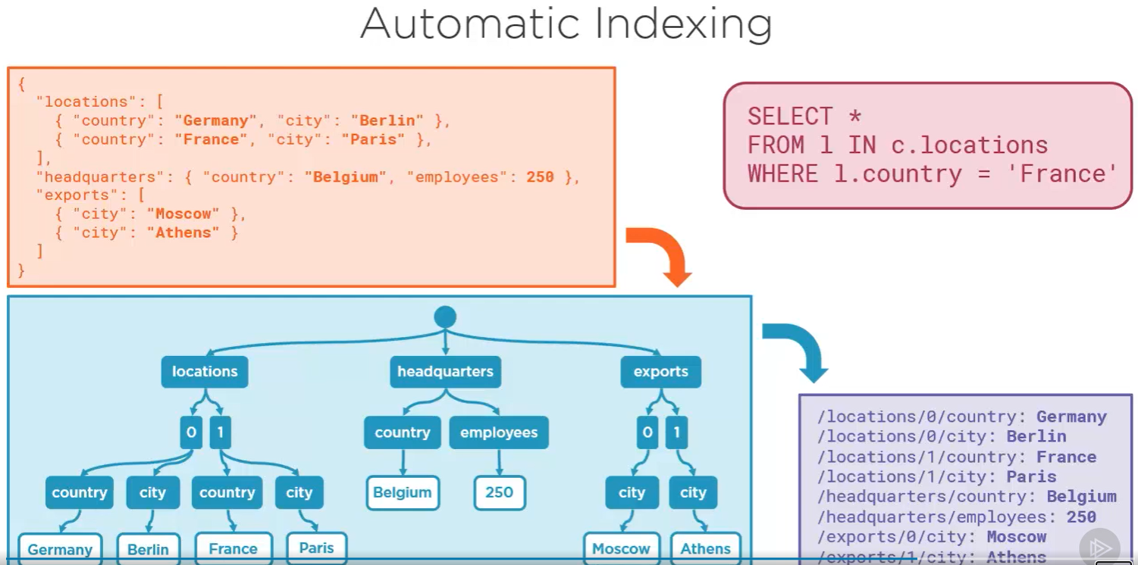

**Multiple APIs and Data Models :**

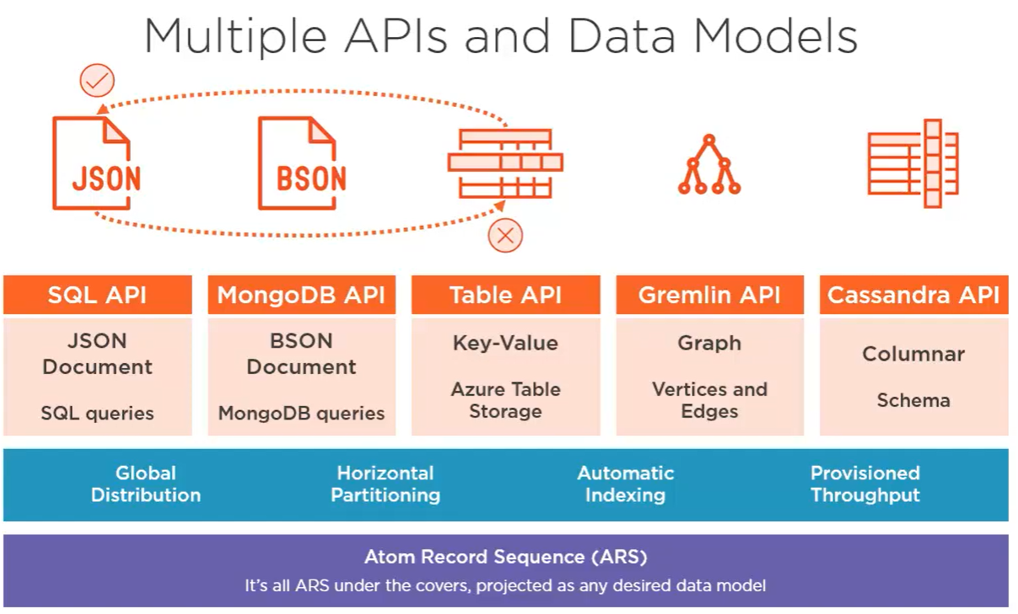

* **Core SQL API** works with **JSON Documents** Data Model. This is CORE SQL API which supports SQL for querying JSON. Only this API supports server side programming model for transactional stored procedure.
* **Mongo DB API** works with **BSON Document** Data Model (binary encoded version of json).this API provides wire-level support which gives compatibility with standard MongoDB driver for the protocol used to send packets over the network. So, without leaving mongoDB ecosystem we can use sacleout, throughput, and global distribution capabilities of cosmosDB
* **Table API** works with **Key Value store** data model. This API is evolution of Azure Table storage, one of the first NoSql DB available on Azure (way back called windows Azure). In this API, each item is called ROW. Like json document , each ROW consists of key-value pairs.but unlike json documents, it’s a simple item with scalar values only (numbers & strings, but no embedded objects or arrays). This is not like table in relational DB where each row has same columns. With Table API, you can have different set of key-value pairs from one row to the next inside same table. This is for Azure Table storage customers because it emulates Azure Table storage API. Existing Azure Table storage can be migrated to cosmosDb to take advantage of like global distribution, throuput, indexing on all properties.
* **Gemlin API** works with **Graph DB**. Graph DB stores vertices and edges which are flat entities and they are interconnected relationships, can easily query. Eg:in social networking application, you could easily find a user, then look for all of that user's posts where the location is New York, and of those, find all the relationships where some other user has commented on or liked those posts.
* **Cassandra API** works with **Columnar Data** model. Columnar is where in a departure from the typical way of dealing with schema‑free data in the NoSQL world, you actually do define the schema of your data up front. However, data is still stored physically in a schema‑free fashion, so it's still okay to have sparse columns. this API appeals to existing Cassandra developers who can use this API to treat Cosmos DB just like Cassandra from the client's side.
* The choice of which API to use is based entirely on how you'd like to treat your data, like a document, key value, graph, columnar, it actually makes no real difference to Cosmos DB which API you go with. The critical core concepts, global distribution, horizontal partitioning, automatic indexing, and provisioned throughput, well, these are all durable concepts that apply universally across all APIs and data models.
* all these APIs merely project your data as different data models, whereas internally your data is always stored as **ARS( atom‑record‑sequence)**, a Microsoft creation that defines the persistence layer for key value pairs.
* Since all data models are like key-value pairs, in theory, you ought to be able to switch between APIs within a single Cosmos DB account. In practice, you can't because there's a great deal of impedance mismatch between the different data models. Eg: a row created with the Table API could easily be transformed into a JSON document with scalar properties for the SQL API, but there's no direct way to do the reverse and project a complex JSON document created with a SQL API as a flat row for the Table API. Now, generally speaking, this won't pose a problem. You're going to pick the right API for your data model and then stick with it. You normally won't need or want to then switch to using a different API. But there is one very noteworthy exception to this where it's actually possible to switch between two different APIs over the same data. Specifically, you can use the **Gremlin API with the SQL API**, and that's because the entities and relationships in a graph are stored internally using a special JSON format known as GraphSON. you can use the Gremlin API to create and query a graph, and then you can use both the Gremlin API and the SQL API to manipulate the graph.

**THROUGHPUT AND COST**

**Measuring Performance:**

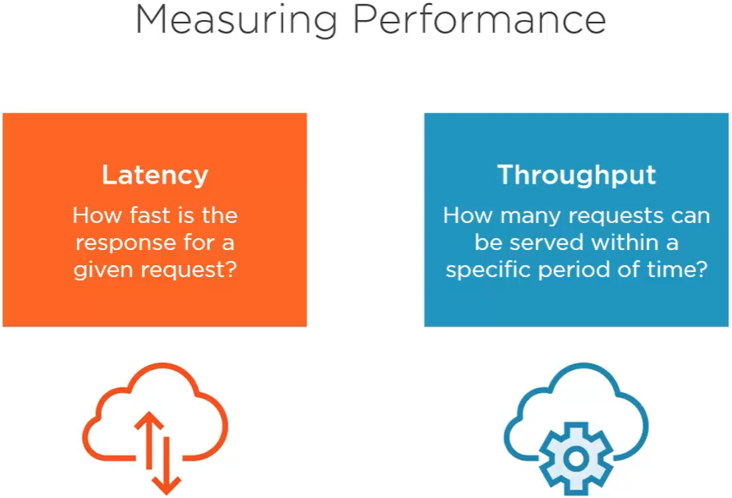

* **Latency:** means Overall wait time. How fast is the response for given request?
  + To reduce latency, bring data closer to consumers. Achieve this by global distribution
* **Throughput :** performance from the perspective of DB service itself. Ie: how many client requests on the container can be processed concurrently by CosmosDB?
  + To accomplish any size of work load, cosmosDB guarantees that it serves specific number of requests with in given period always. How may requests? Depends on no. of RU (request units) you ask for & pay for while creating container.

**Request Units:**

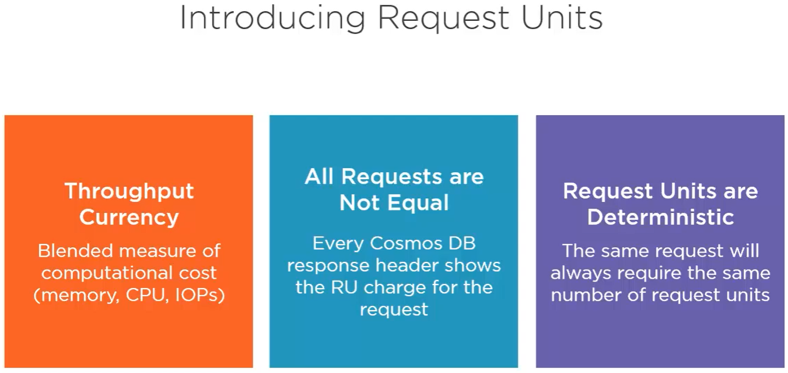

* Its a way of managing throughput to achieve the best performance.
* It is like throughput currency because they let you set the throughput levels that you need and that you essentially pay for in terms of your Azure bill. But you're not concerned with actual hardware.
* You don't worry about enough memory, CPU, IOPS, and so on because all those metrics get rolled up together in the form of a request unit, or RU.
* request units are not requests, but rather, all requests get charged in the form of request units.
* Because every request is different and is going to cost more less than other requests. Eg: writes will always cost more than reads because writing updates multiple replicas, while reading is achieved with one replica. And simpler queries will always cost less than more complex queries.
* So for every request, Cosmos DB tells you in the response exactly how many RUs that request consumed and was charged. The good news is that whatever the charge, request units are deterministic in Cosmos DB. Identical requests will repeatedly and consistently cost the same RUs.

This is true even when you run complex queries. Assuming no data changes in between each time you run the query, the RU charge will be the same each time. So ultimately, request units really are a very simple way to manage and ensure predictable throughput and cost for your application.

**Monitoring request units Consumption:**

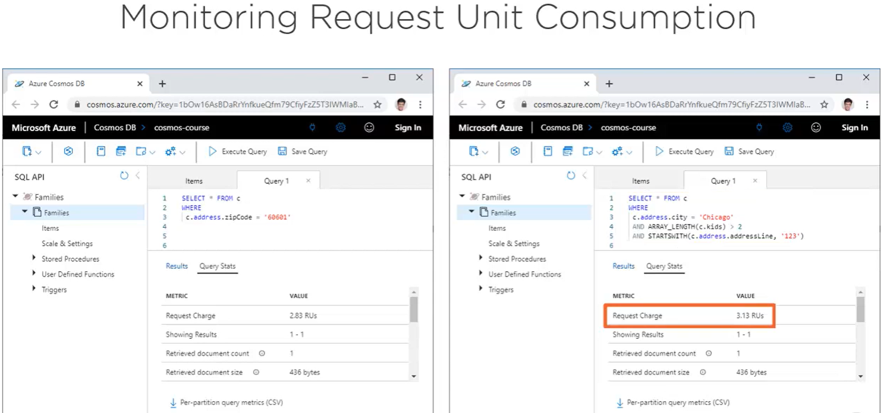 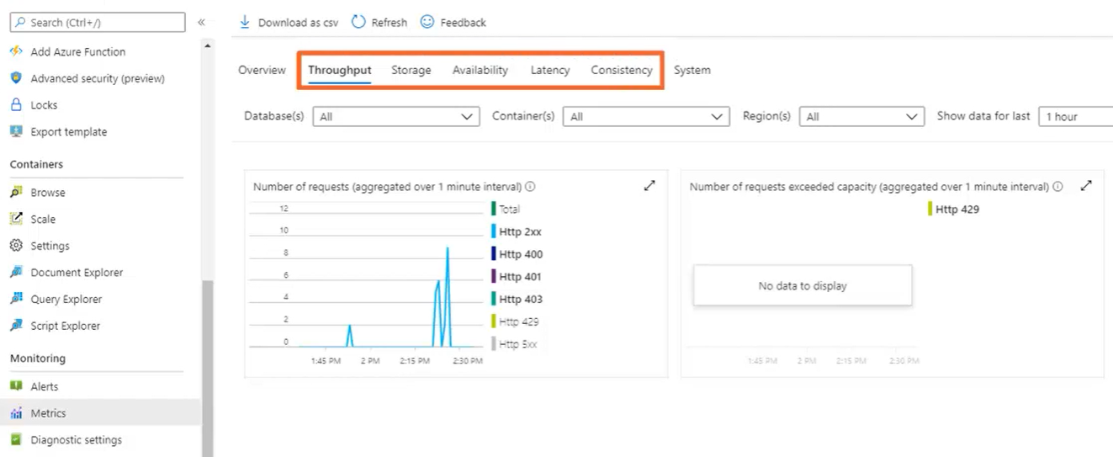

* Left chart > all http request
* Right chart > all throttle requests. Ie: requests that is failed because we exceeded the throuput that we provisioned for the container

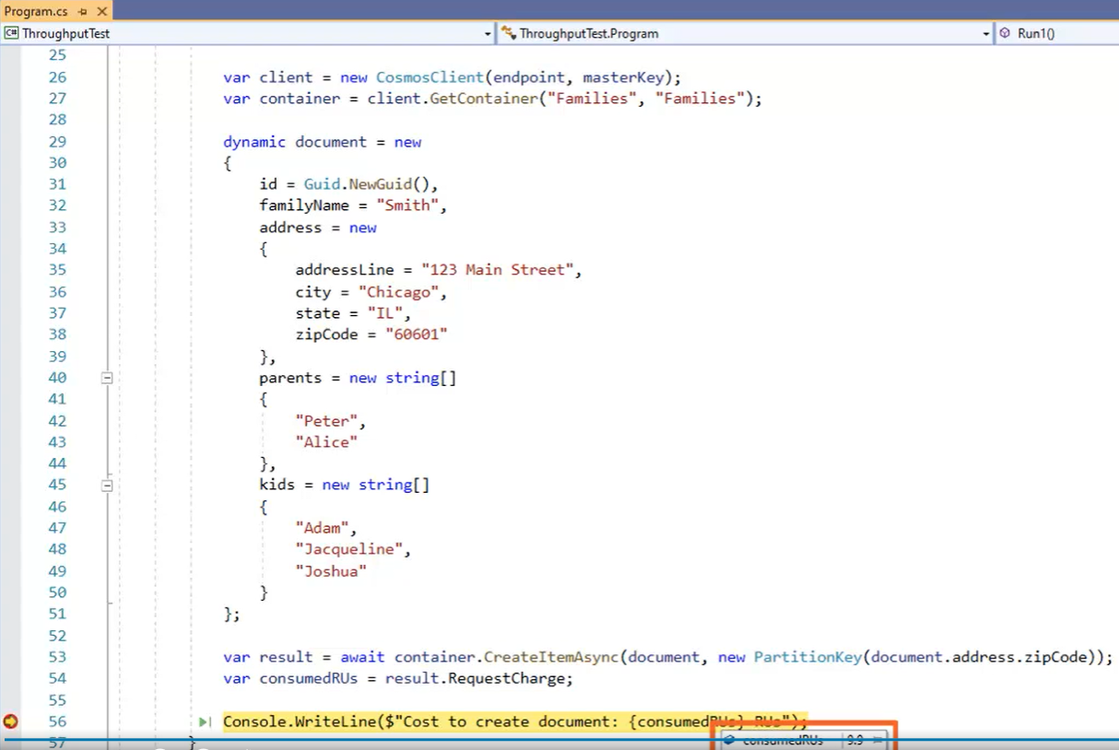

Above .net(comosDB SDK) code creates new document and gets RUs used for that creation

**ThroughPut Offers:** (for different type of workloads)

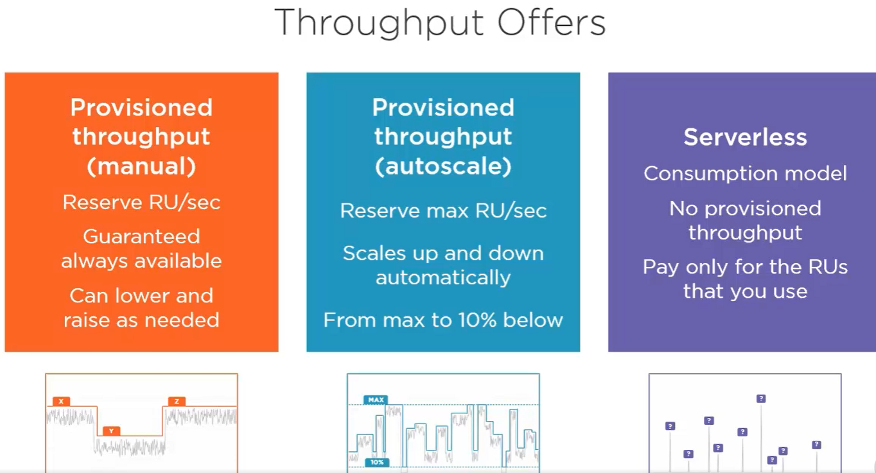

* **provision throughput** (manually) :: you explicitly reserve a fixed number of RUs per second that are guaranteed to be available all of the time.Eg: the Families container, here we're provisioning 400 request units per second. And any time you need to, you can raise and lower that number. Manually provisioned throughput is recommended for **predictable and stable workloads**. Eg: if you always hovering just under 5000 RUs a second, then that's what you’ll provision. Of course, you won't be needing 5000 RUs all the time. you may need less and you may need more. And when you're using less than what you've provisioned, that amounts to unused capacity and wasted dollars. So if you can predict your highs and lows, you can just turn the dial on throughput to meet those patterns. Simply drop to 2500 RUs a second when things are quieter and bring it back up to 5000 when it's time to.

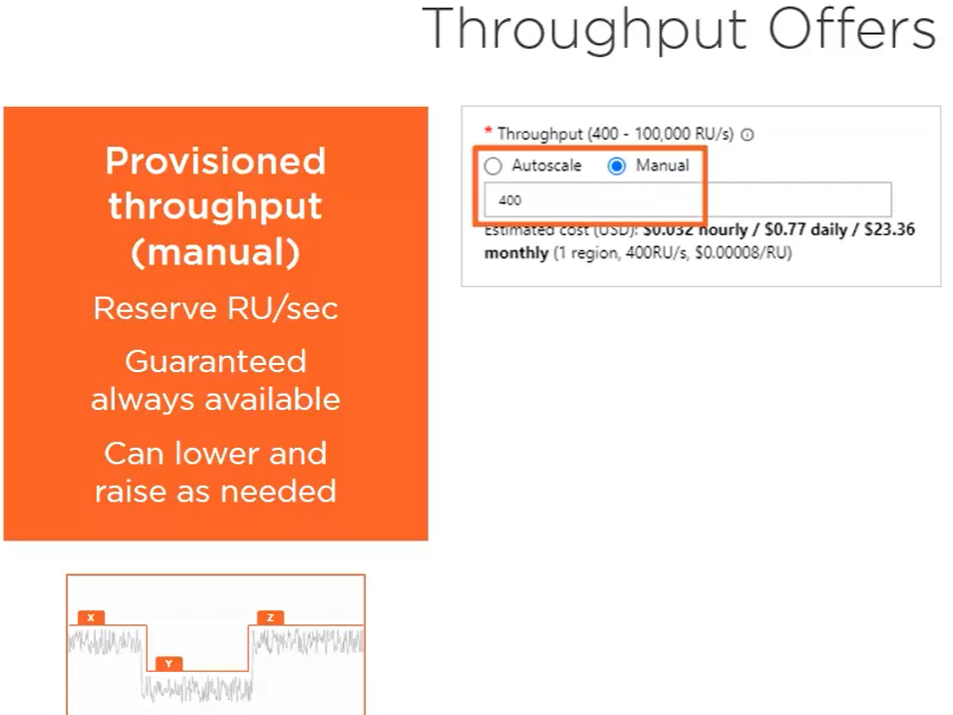

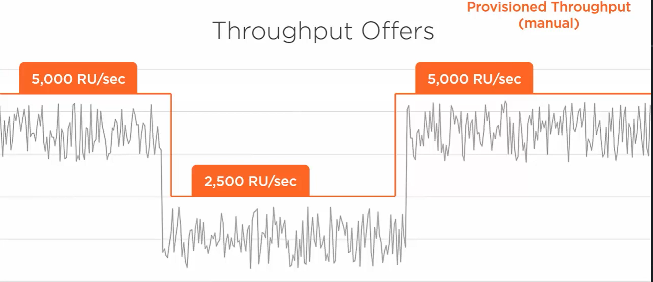

* **Autoscale‑provisioned throughput** :: Cosmos DB scales throughput up and down automatically, but it's still provisioned, meaning you're still reserving capacity that's guaranteed to be always available. And so long as you don't exceed the maximum throughput that you provision, the system will always be able to manage capacity for you. This works by automatically scaling from the maximum down to as low as 10% of that amount. Autoscale‑provisioned throughput is best for **unpredictable and variable workloads**. Eg: you set that at 5000 RUs a second. Cosmos DB then automatically watches the request level and raises or lowers the provisioned throughput accordingly, never provisioning less than 10% of the maximum, which is 500 RUs a second in this case. autoscale does cost more than manual scale, so the variance in unpredictability does need to be great enough to make it a more cost‑effective choice than manual‑provisioned throughput.

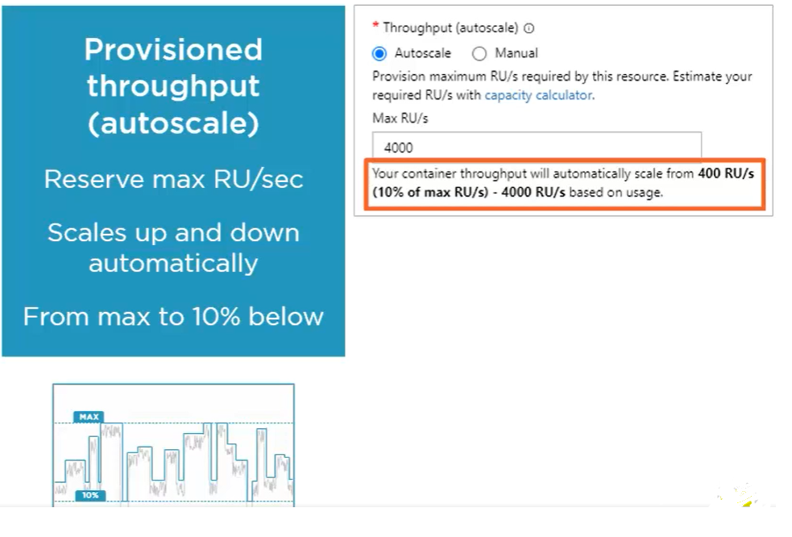

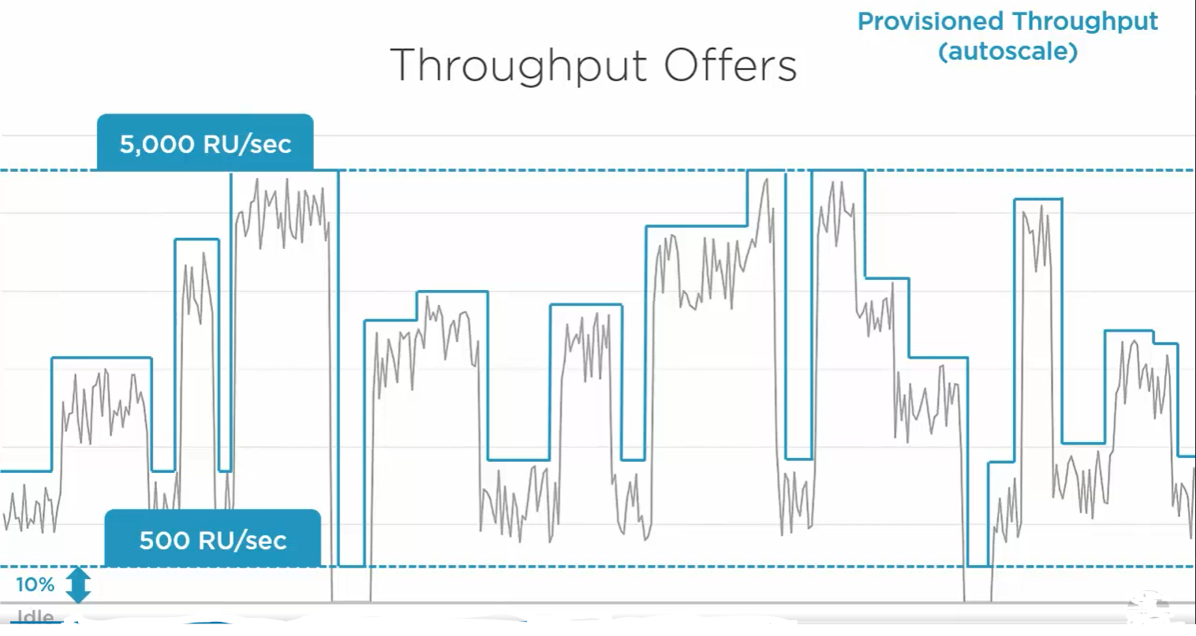

* **Serverless**:: you don't provision throughput at all. Instead, it's consumption based, so you only pay for the RUs that you use when you use them, and otherwise there's no cost to running the container. This is perfect for those **spiky workloads** where your container is mostly idle, like a tiny app you're sharing with some family and friends, or some demo that you give from time to time.

you could use **autoscale to handle this, but that would not be very cost effective** in these situations. Because while autoscale will provision more and less throughput as needed, you'll still be paying 10% of the maximum when you're idle, which is most of the time. Also autoscale works on hourly intervals before adjusting the provisioned throughput. So if your spikes are just like a few seconds here or a minute there, then that also amounts to unused capacity that you're paying for but not using. And so with serverless, you pay nothing during all the time that you're idle, and then, depending on each request, you'll pay more or less for the RUs consumed.

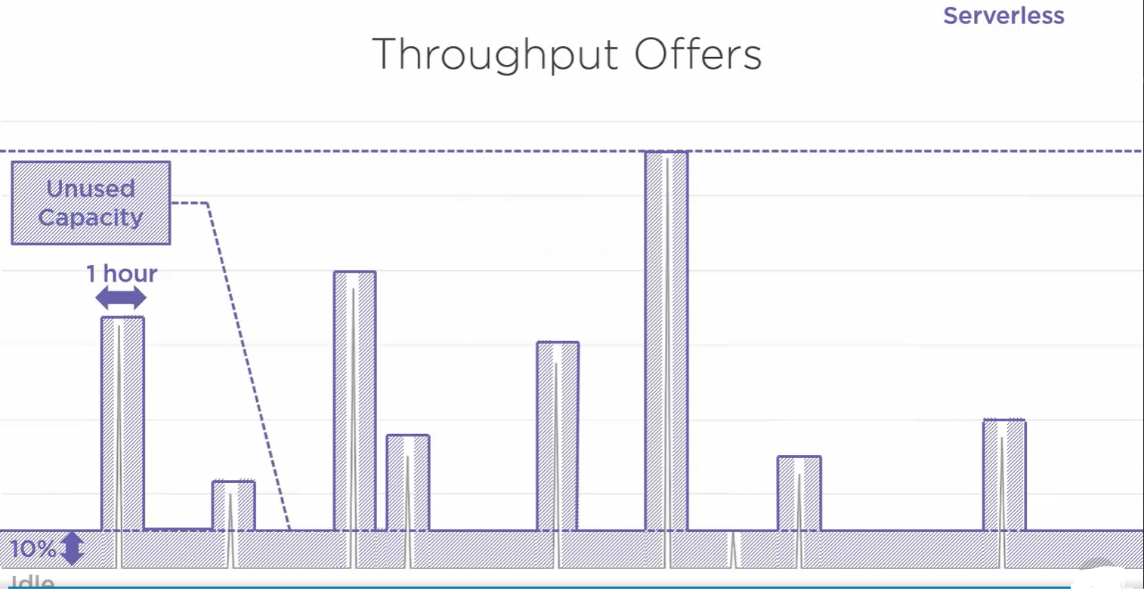

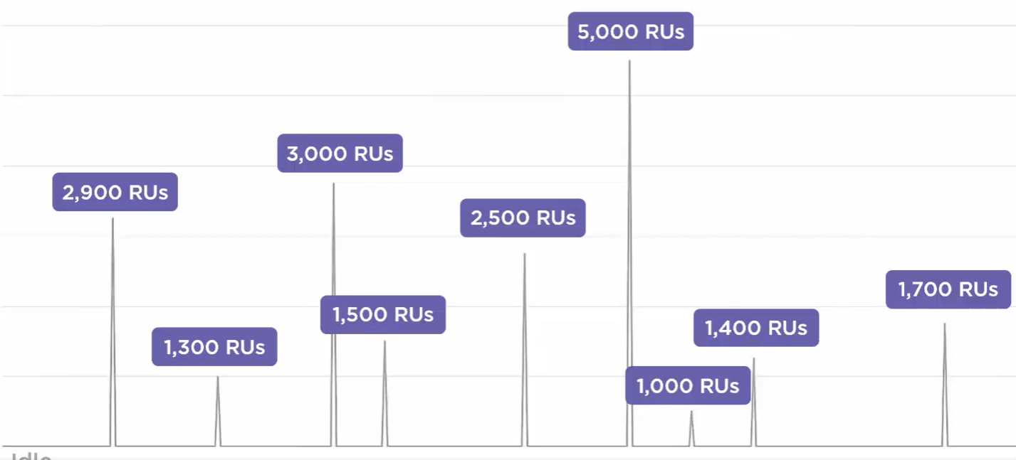

**Provisioning Container Throughput:**

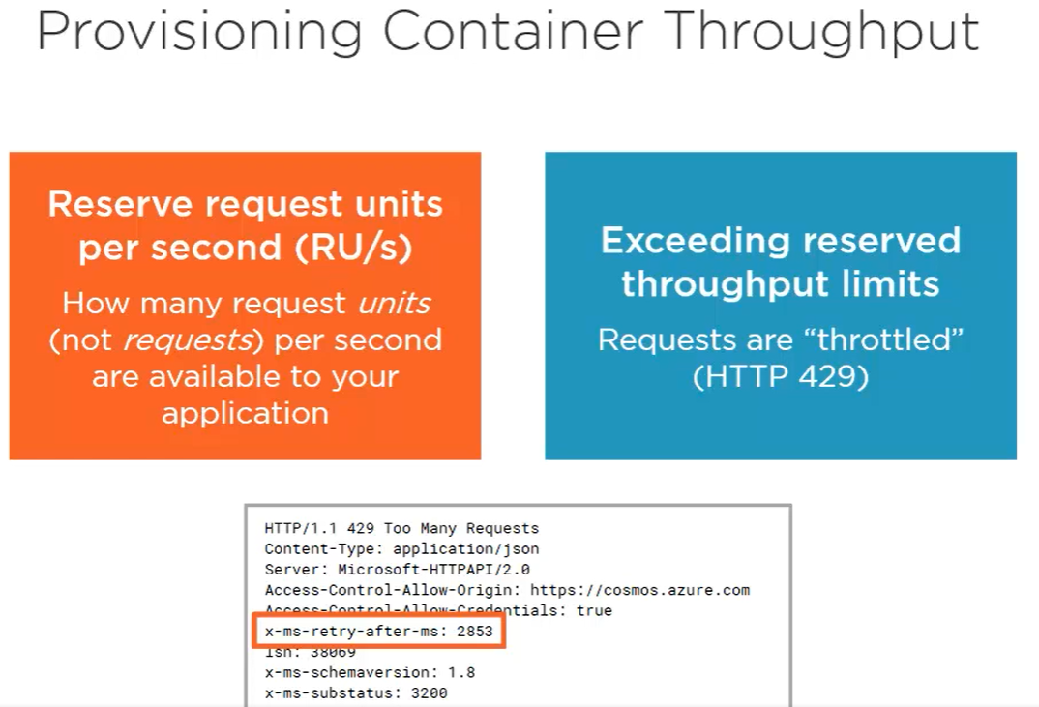

* You reserve certain Rus/sec to container. If it exceeds that request fails (trottles) with 429 error.
* Insider error response header “x-ms-retry-after-ms:2854” tells you how long to wait to give next request
* Too much throttling means you need to provision more throughput on the container
* Excessive throttling also results in inefficiencies in how you modelling, partitioning your data.
* Efficient data model can greatly reduce RUs consumed by application

**Exceeding Provisioned Throughput:**

* If you execeed throughput that is manually provisioned or you exceed maximum throughput that provisioned using autoscale, the your request gets throttled. Serverless don’t have throttle problem.

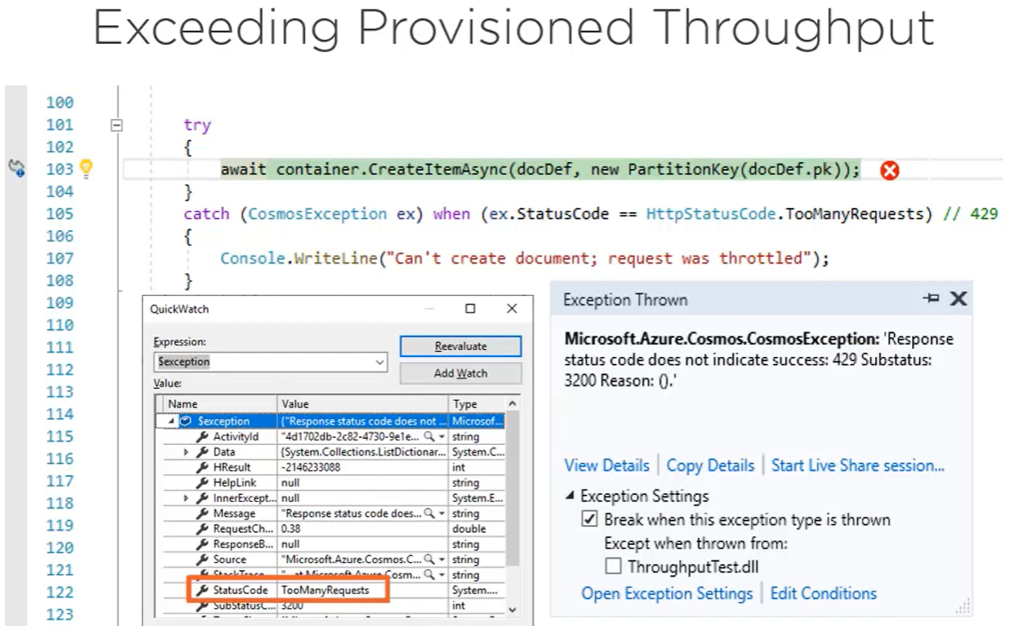

* The above error thrown after .net Cosmos SDK retried many times. So no need of retry logic here.

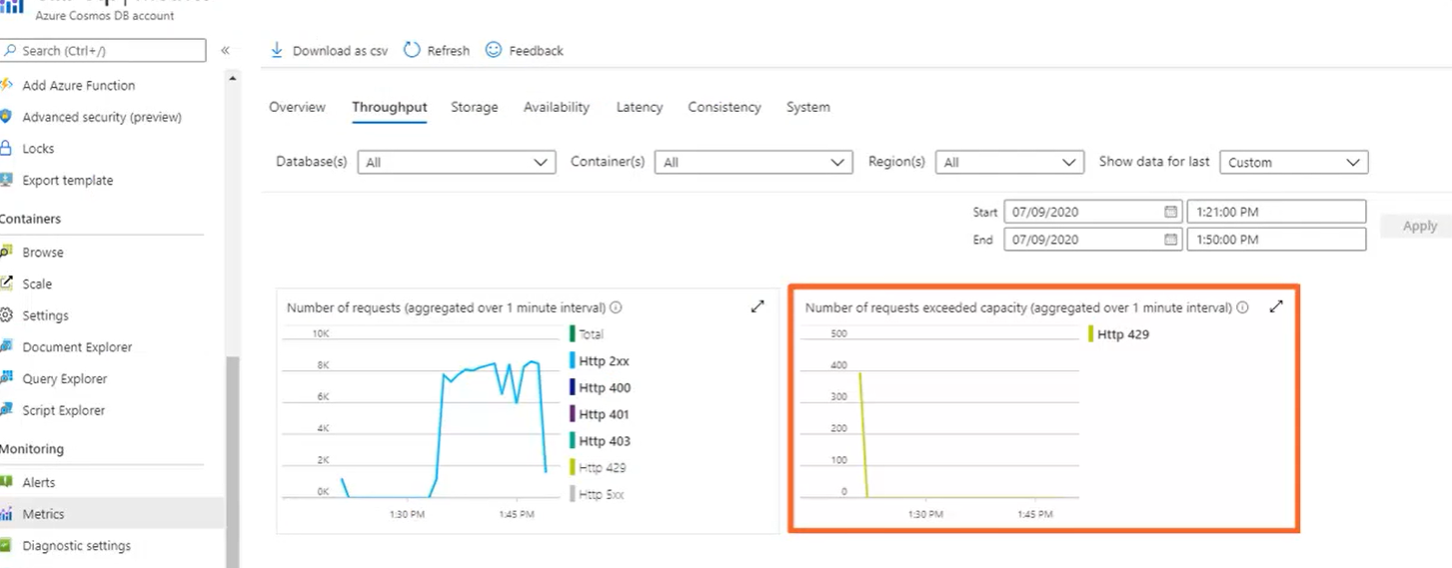

Right side graph shows throttle requests

**Provisioning database throughput:**

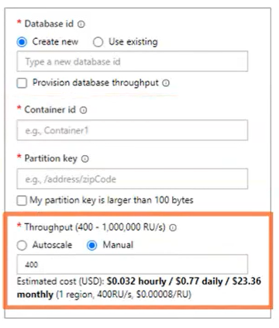

* While creating container, if you uncheck “provision database throughput”, it will drop the control of provisioning through put to container level. This is what you do in most cases.
* You using want to set throughput individually based on each container’s needs

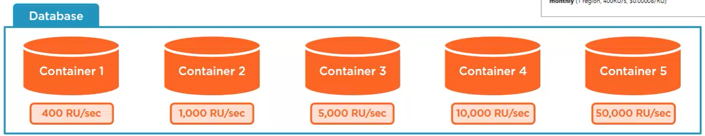

* But if **“provision database throughput” checkbox selected** and provision throughput at database level then that throughput distributes evenly across all containers

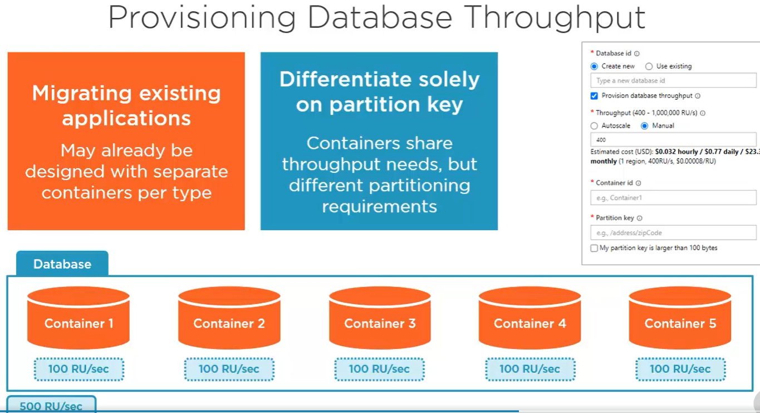

If you use only one and not other 4 containers then most of 5000RUs are allocated to that one container only.

* + **“provision database throughput”** is used in scenario like
    - 1.migration of existing NoSQL DB that already been designed with separate containers per type. You won’t redesign/reengineer the whole application.
    - 2.you don’t need separate containers but only because of different partitioning needs.so, you need different partition keys for different types of data and data access patterns, but otherwise all this data shares the same throughput needs.so provisioning throughput at DB let you achieve this.
  + You can have separate containers because of different partition keys but they all get treated as one from a throughput perspective
  + Even if you provision DB throughput, every container you create in DB gets below checkbox to let “provision dedicated throughput for just that new container” independent of what provisioned at DB level.

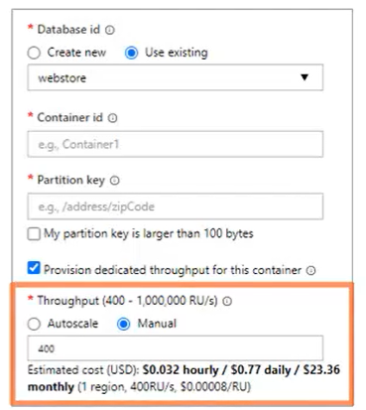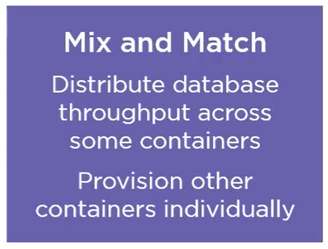

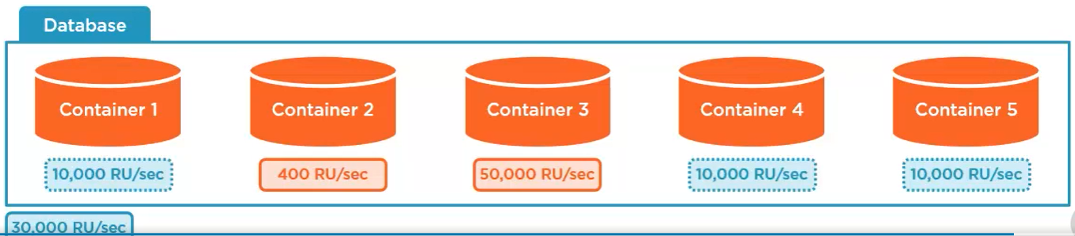

You can provision 3000Rus on DB throughput which normally shares evenly across all 5 containers in Db. But you could provision dedicated throughput for 2 of those containers like above. So rest of 30000 shared evenly across others. this is fine

But don’t provision DB throughput and keep dedicated throughput on all containers like below. This results in unused capacity

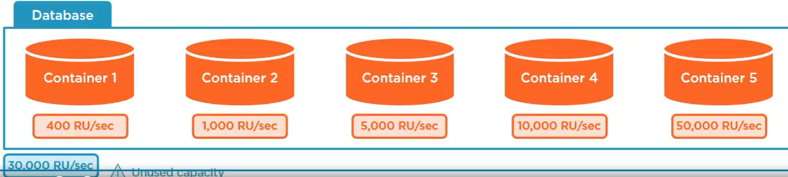

**Whiteboarding Cost:**

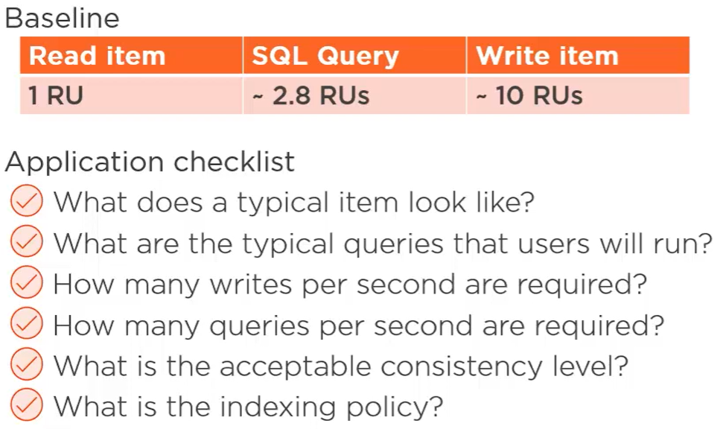

* Baseline
  + Cheapest > direct read of single document. If you know partition key and id of document and that document is <=1k, then that operation costs exactly 1RU. For SQL query which is cheapest query costs under 3Rus
  + Depending on Query complexity, indexing policy, whether or not cross-partition query cost increases
  + Writes are always distributed to multiple replicas > costs 10RUs. This also depends on document size, indexing policy which can be customized to lower costs of writes.
* How much throughput you need to provision? Depends on
  + How big/small the items in DB & how much variety is there?
  + What common queruies users run on DB?
  + How much right volume do you have to sustain?
  + How many queries you expect users to run at same time?
  + What consistency level is acceptable in your application (ie, how sure you wanna be you’re reading the latest written version of item in your DB)?
  + Indexing policy? (by default, cosmosdb indexes every property of every item in Db, but you can tune this which effects cost)

**Use Capacity Calculator:**

* <https://cosmos.azure.com/capacitycalculator/>
* It has expected average size of items, no of reads and writes you need, no. of regions you need geo replication, multi-master enabled for multi region writes
* Signin to get more accurate cost estimate

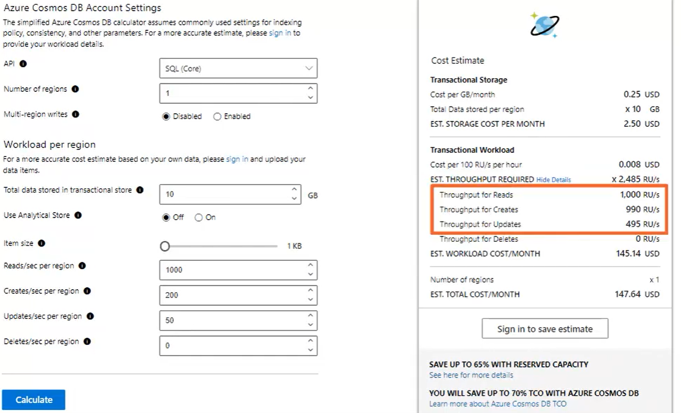

This estimate say, you need to reserve 2485 RU/s to accommodate our workload which is broken down to 1000 RUs for reads, 990 for creates, 496 for updates. 10Gb for storage

**Pricing:**

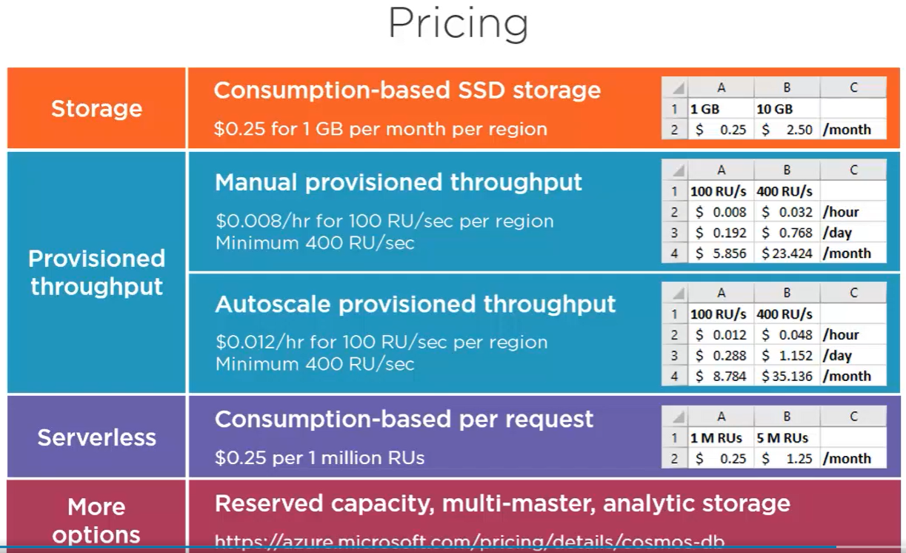

There is no limit on RUs to provision for container. Azure portal & SDK might keep some limit but contact Microsoft to increase

**HORIZANTAL PARTITIONING**

**Achieve Elastic scale:**

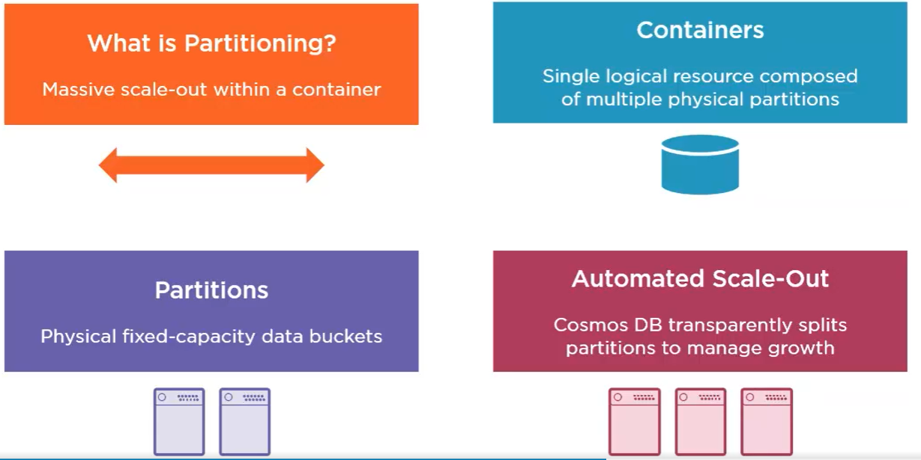

* Partitioning allows to massively scale DB, not just in terms of storage, but also throughput.
* You simply create a container and let Cosmos DB partition the data you store in that container to manage its growth.
* This means that you just work with the one container as a single logical resource where you store your data and run your queries. And you can just let the container grow and grow without worrying about scale because Cosmo DB creates as many partitions as needed behind the scenes to accommodate the growth and scale of your data.
* You can actually think of these partitions as individual physical computers, although in reality there's a little more to it than that because each of these partitions, and let's call them physical partitions, isn't just a computer, it's also a unit of replication. So every physical partition behind the container is itself distributed across multiple replicas, at least four within a single data center, in order to ensure high availability for your database. And it all just works automatically and transparently. So when a partition gets too busy, Cosmos DB automatically creates another, and another, thus adding more storage capacity and compute power to the container.
* So under the covers, Cosmos DB manages a cluster of servers for each container, which distributes the workload across multiple physical machines. just work with the one container. Meanwhile, Cosmos DB automatically maintains the cluster and dynamically adds more hardware as needed to accommodate your growth. And this is the essence of horizontal scale like below. Because, again, you can think of each of these as an independent physical computer. And so each one has its own disk storage and CPU, just like any machine. And that means that effectively, this design gives you both unlimited storage and unlimited throughput. There's really no practical limit to the number of physical partitions, meaning no limit on disk space or processing power for your container.

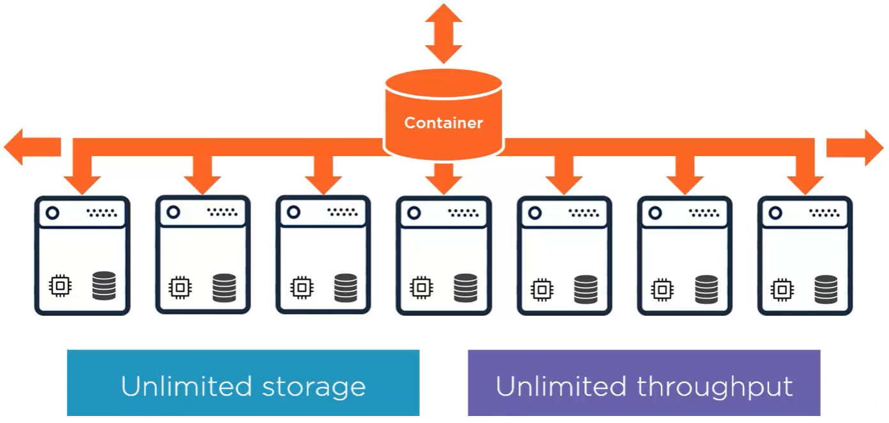

**Understanding Logical partitions:**

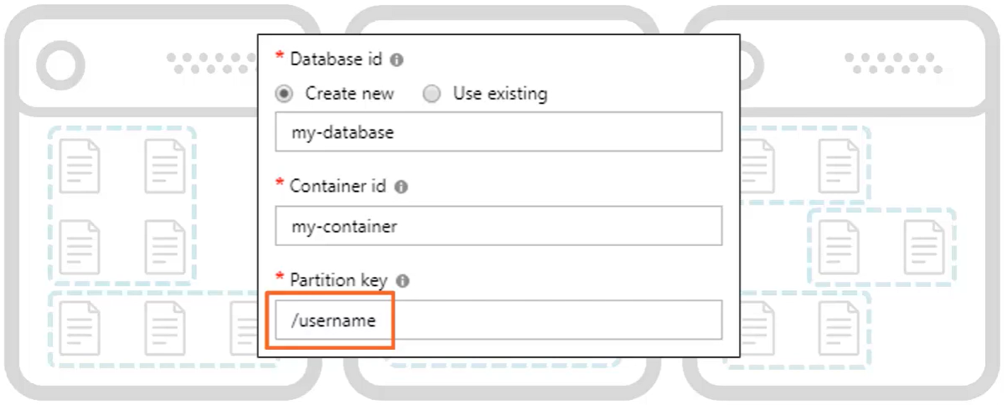

* You’ve bank of servers or physical partitions sitting behind every container. That means that every document you write to the container could land on any one of these physical partitions. So then how does Cosmos DB know which physical partition to use for any given document? Ans: Logical Partitions
* **logical partitions** :: Unlike physical partitions, which are managed transparently by Cosmos DB, we need to come up with a partition key, and that defines the logical partitions for the container.
* **partition key** is some property in the document, and that could be based on a composite, some combination of other properties, that's used to group multiple documents together within a single logical partition, those documents that have the same partition key value.
  + Eg, in a social networking database, imagine we've chosen the username as the partition key for the container. That would mean that all the documents belonging to the same user will belong to the same single logical partition.
  + Now let's just forget about the physical partitions altogether and think just in terms of logical partitions. If we do partition our container on the username, it means that all of Andrew's documents are in one logical partition, Tim's documents are in another logical partition, and so on.

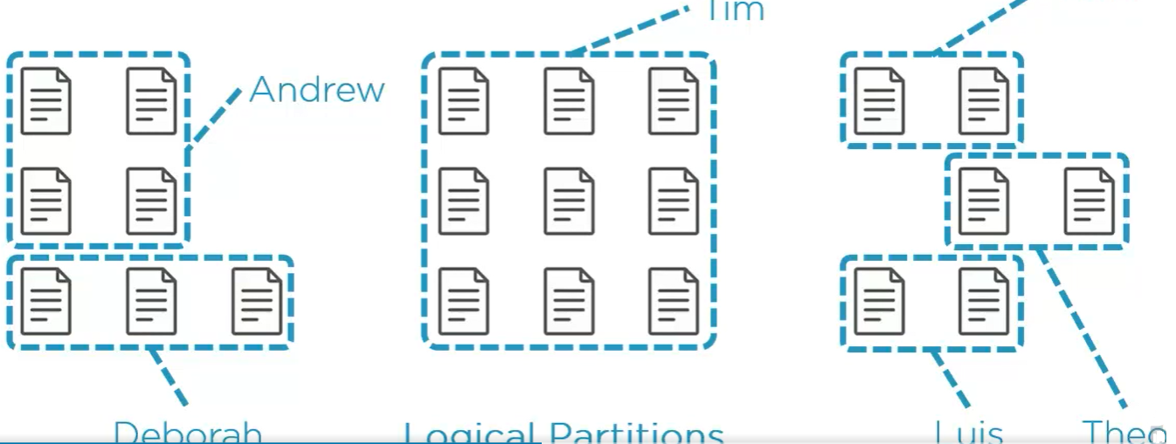

* + And because there's no defined schema in Cosmos DB, one logical partition can easily accommodate different types of documents that have the same partition key. So there could be one user document, a set of documents for that user's posts, and other document types for that user, such as their comments and likes, all inside a single logical partition.
  + how you plan to model your data in Cosmos DB? > there are two important constraints
    - 1. every document has a maximum size of 2 MB, and you need to consider that hard limit in terms of how much information is reasonable to embed inside a single document before you decide to reference data across multiple related documents instead.
    - 2. every logical partition has a maximum size of 20 GB, so you'll never want to choose a partition key where you get logical partitions that approach anywhere near this limit. In fact, it's usually best to choose a partition key that yields a large spectrum of values. Ie, mean it's better to have a great many number of smaller logical partitions because that will enable Cosmos DB to distribute your workload in the most uniform way across the container, giving you essentially unlimited scale.

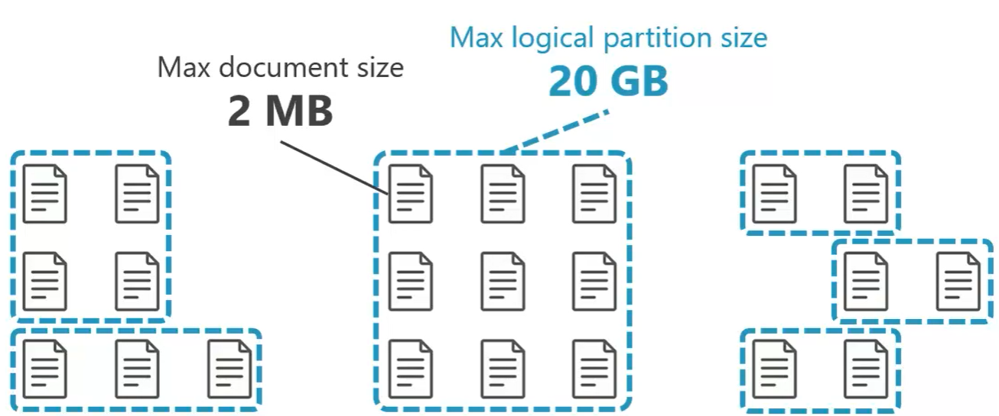

**Partition Splits:**

* you keep writing documents to the one container, and depending on the value of the partition key in each document, which we've chosen, these documents are grouped together in the same logical partition.
* Meanwhile, Cosmos DB manages the physical partitions. It decides which physical partition every logical partition is going to be hosted on. And at some point, Cosmos DB will decide to add a new physical partition to the container, either to accommodate more storage, throughput, or both, and the way that this happens is with a partition split.
* Cosmos DB simply brings a new **physical partition online and moves roughly half the data from an existing physical partition into the new one**. So half the logical partitions that used to be on one physical partition are now on the other, and the container can continue to scale.
* Now, the beauty is that these partitions splits happen instantaneously, automatically, and with absolutely no disruption.

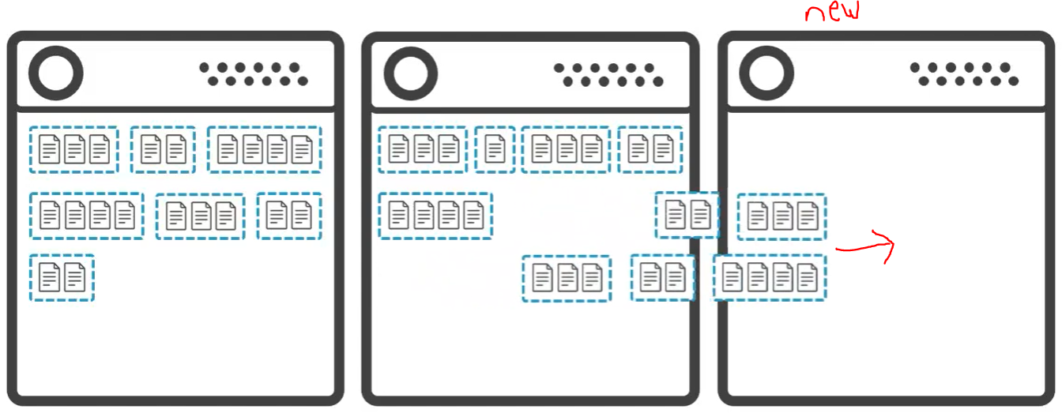

**Avoiding Hot Partitions:**

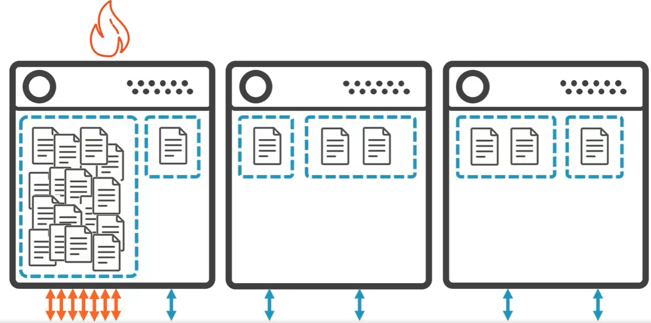

* do not select a partition key where you end up with some logical partitions that are really large and most that are really small. This imbalance creates what we call a **hot partition**, which means that Cosmos DB can't really scale your data out very well, since most documents are served by one partition, while the other partitions are only sparsely populated by many fewer documents.
* Instead, you want a partition key that gives you a much more uniform distribution much more evenly across all partitions of the container. But, horizontal scale isn't just about storage; it's also about throughput.
* So think about your access patterns, like how does your application read and write data? This is why, for example, **a creation date property is often a poor choice for the partition key**, because even though that'll give you an even distribution from a storage perspective, it doesn't do so from a throughput perspective. Because then all the writes of the day are always being routed to the same partition. And queries are also more likely to be looking at more recent data rather than older data, and again, this results in a hot partition, not on storage but on throughput.

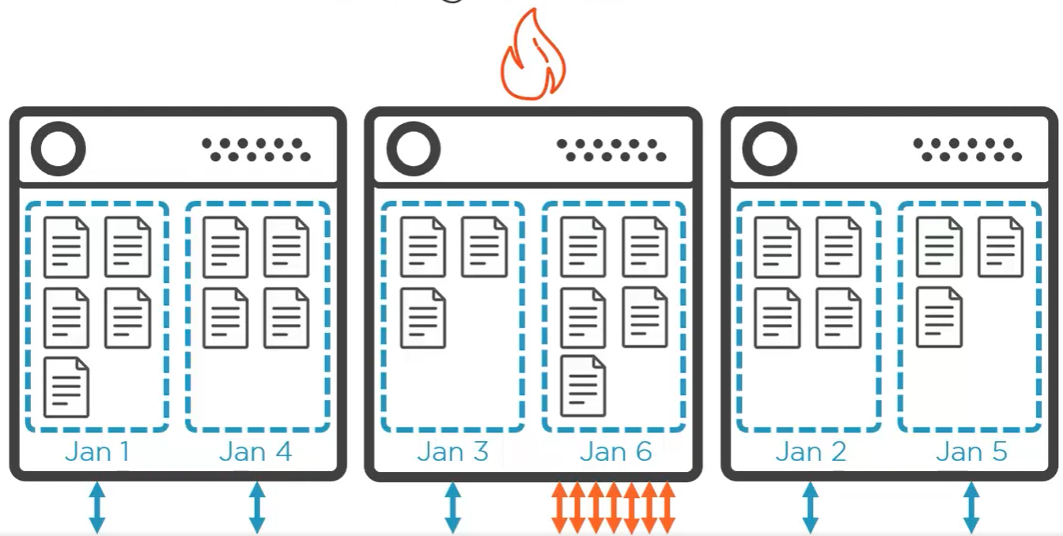

* So the best partition key is one that gives you the most uniform distribution of both storage and throughput because that's what's going to best utilize the cluster of servers behind the container. And for these reasons, again, in a social networking scenario, the username is often a good choice for achieving that goal.

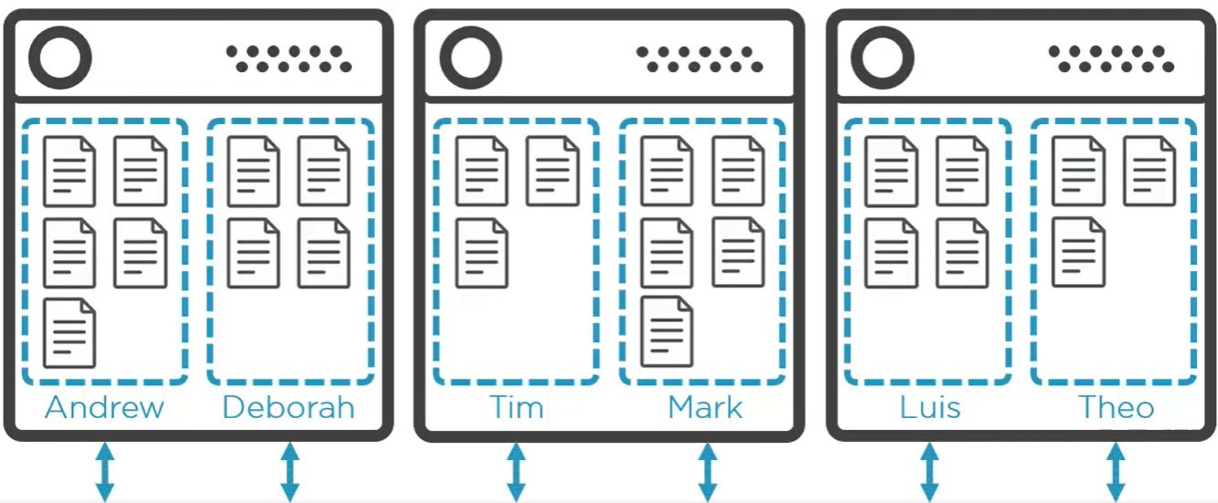

**Cross partition Queries:**

* difference between a single partition query and a cross‑partition query?
  + Eg: container for social network that we're partitioning by username. And so all the documents belonging to a given user are all living in the same logical partition. And these could all be documents of different types, like the one user profile, plus all the posts, comments, and likes for that user. So here's a simple query that just returns all of Mark's documents. Well, because the partition key for the query is known, Mark in this case, that makes this a single partition query. It means that Cosmos DB knows exactly which logical partition it should route this query to. Of course, this also means that ultimately, it also knows exactly which physical partition to use for the query, and any further filtering on Mark's documents, say by date, or by retrieving only Mark's comments or just his likes, those would also all be satisfied with a **single partition query**.

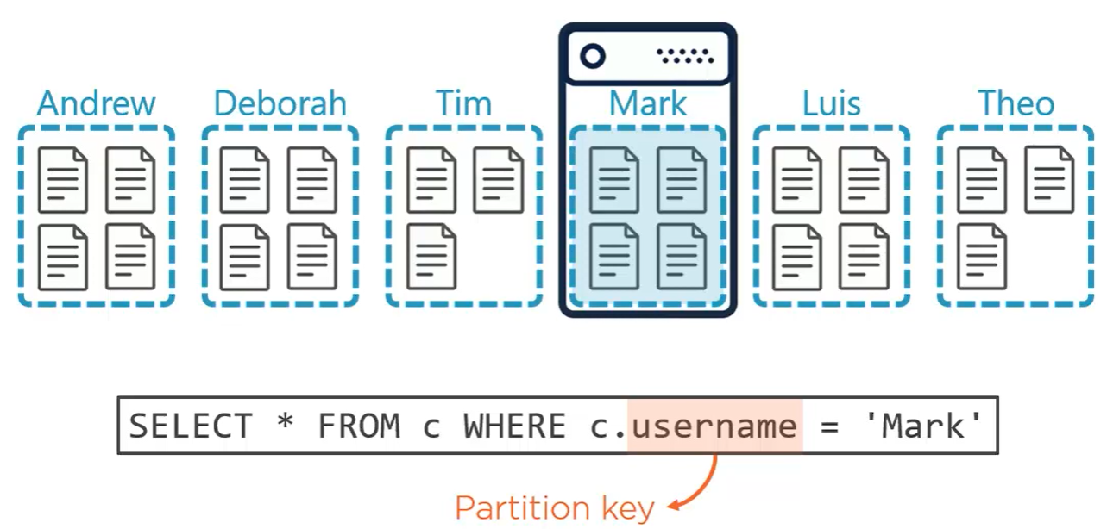

* + Now, Eg: to find users whose favorite color is red. It's just a simple query, but the partition key isn't known, because we're querying across all users. And of course, this means that we're querying across the entire cluster behind the scenes. This is called a **cross‑partition query** where Cosmos DB really has to run the query on each physical partition and then combine individual results into a single results set, which gets returned to us.

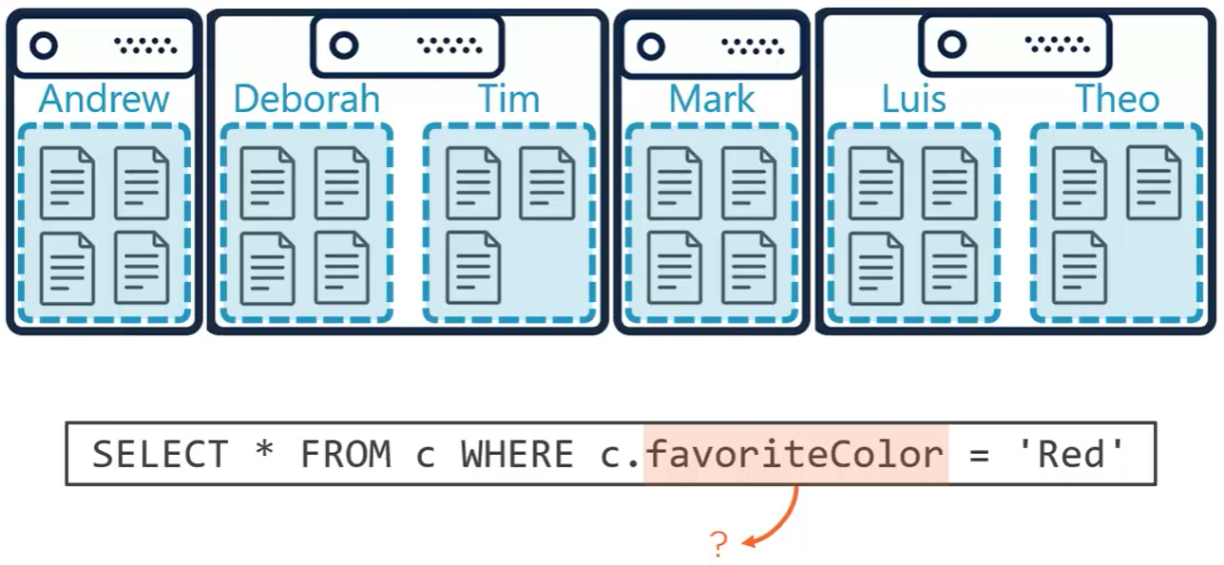

* + It doesn't mean that cross‑partition queries are necessarily evil, though. In fact, you'll never really be able to avoid them completely, without perhaps needlessly over‑engineering your data model. It's just that you want to avoid them most of the time, and by that, I mean using a really general rule of thumb, let's say you want to be running single partition queries, a good 80% or more of the time. The occasional cross‑partition query, that you need to run for the edge cases, let's say 20% or less of the time overall, these are usually harmless.

**Choosing Right Partition Key:**

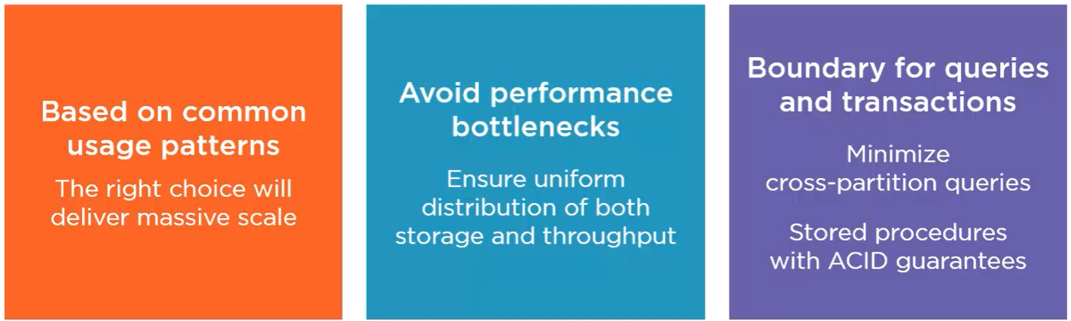

* partition key is important while creating container .This is done by understanding most common query patterns of your application.
* The **partition key** could be any property in your data, but making the right choice will scale the storage and throughput of your container in the most efficient way.
* some properties make very poor choice and impede your ability to scale. Ie, even though you don't need to handle partitioning yourself, you need to understand how Cosmos DB handles it, along with a clear understanding of how your data is most typically queried to make right choice.
* Another consideration: **transactions** are also scoped to a single logical partition. So we do want a partition key that will avoid cross‑partition queries in most cases, but we also might want to think about updates using stored procedures.
* you can write server‑side stored procedures, and those **stored procedures can update multiple documents in a single transaction** so that all the updates succeed or fail together as a whole, and **this is only possible within a single logical partition** where all the documents that you're updating have the same partition key value, and so that's another thing you need to think about when defining the partition key for a container.

**Common Partitioning Patterns:**

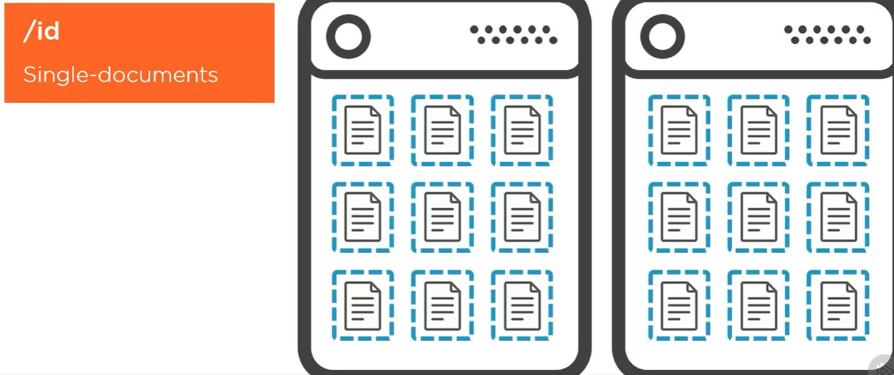

* **partition on the /id property** :: it could be a GUID which is globally unique, but it doesn't need to be. The /id could be any string value. normally, every document is unique across the container based on the combination of its /id property, plus whatever property you use for the partition key. So choosing the /id property itself as the partition key means that each document is unique in the container based on just its id. It also means that each document lives in its own logical partition, and a logical partition will never have more than one document in it. Its odd, but it's actually a very good approach when typically you're always reading or writing a single document at a time.

If you're mostly reading individual documents, then the most efficient way to do that is with a direct read, which costs only 1 RU, rather than running a SQL query. A direct read requires that you know both the id and the partition key, but if you're partitioning on the /id property, then you only need to know the id.

This can also be a good strategy for write‑heavy IoT scenarios where you're rapidly ingesting a high volume of device information into Cosmos DB at a very high throughput.

* + Eg: we could be storing **flight telemetry, speed, altitude, location**, and so on, in real time for all the planes we have up in the air. Or it could be any kind of sensor data where every device is sending you data once every 10 milliseconds. These are very write‑intensive scenarios, and Cosmos DB will scale best for these workloads when you choose a partition key with a large spectrum of values. And partitioning on /id will yield to the largest range of unique partition keys, giving you **one document per logical partition**.
  + in other scenarios where you're querying and updating multiple documents at a time, partitioning on the id would not be a very good idea. Any query for more than one document in this container will be a cross‑partition query and force Cosmos DB to check every partition for a result. So then, you should use another property to use for the partition key, one that will avoid cross‑partition queries, where in most cases, the documents satisfying your query are all in the same logical partition. And likewise, when you're updating multiple documents, they're also living together in the same logical partition.
* **/type property** :: Sometimes you just need to store a small lookup list in the database. In this case, you'll have a /type property with the same value in every document of the lookup list, and then partition on that /type property.
  + Eg: we might manage a list of flights for airline. A logical partition can't exceed 20GB, so it could never hold all of the IoT telemetry that you might be ingesting in real time, but the complete list of flights, that's a relatively small lookup list, where you'll never need to worry about the 20GB limit on logical partition size. So we could say that every flight document has a type property with the value flight, and then by partitioning on the /type property, you can query for any number of flight documents, and that query will always be satisfied by a single logical partition.

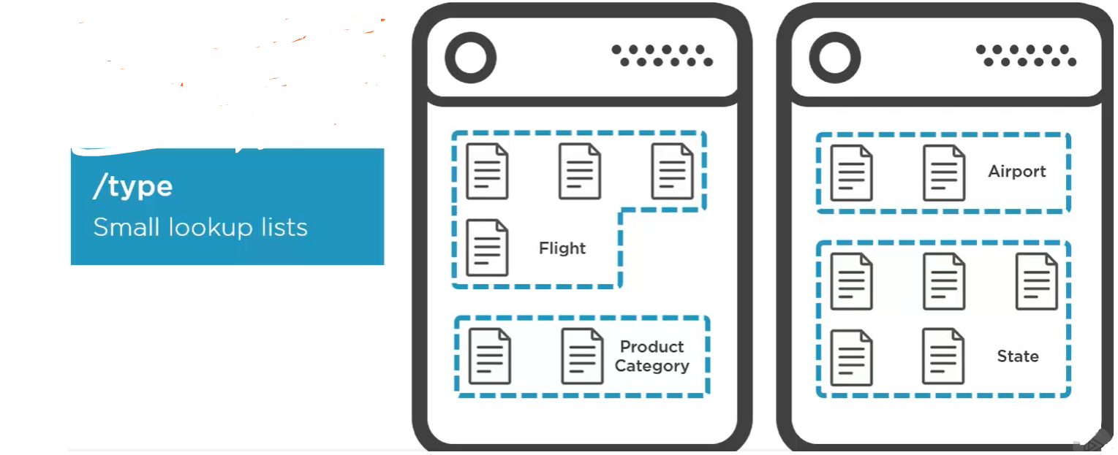

* + Same thing if you had a list of airports where the **/type property** in each airport document is set to Airport. An **e‑commerce website could store a lookup list of product categories,** again, all in one logical partition using a /type property set to Product Category. And what database doesn't have a list of **states and provinces,** which can also be partitioned on a /type property, using a common value to store that lookup list in the database.
  + In a relational workload, for example, where you might be storing customers and orders for an e‑commerce website, you will very often be querying for a customer with their orders. In this case, you would partition on the **customer /id property**, which is present in both customer and order documents. Now, customers and orders have completely different schemas, but that's not an issue for Cosmos DB, which is designed to be schema‑free. So there's one customer document, and all the order documents for that customer in each logical partition, and querying across those types for the same customer does not require a cross‑partition query. And being in the same logical partition, we could also use a stored procedure to update a customer document along with any of that customer's order documents, and run that as a single transaction.

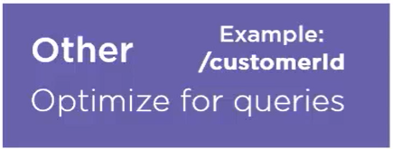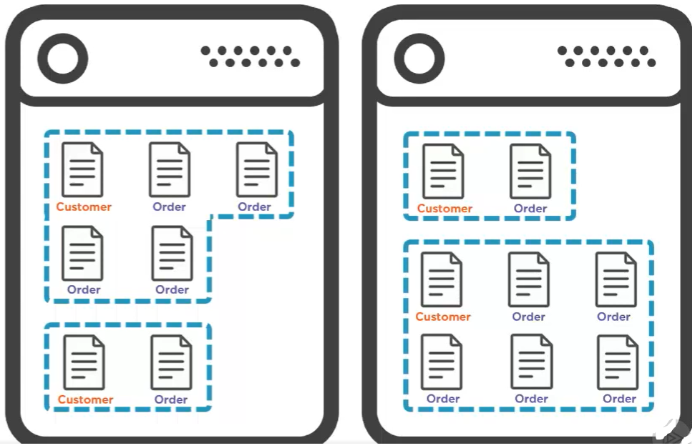

**Changing the Partition Key:**

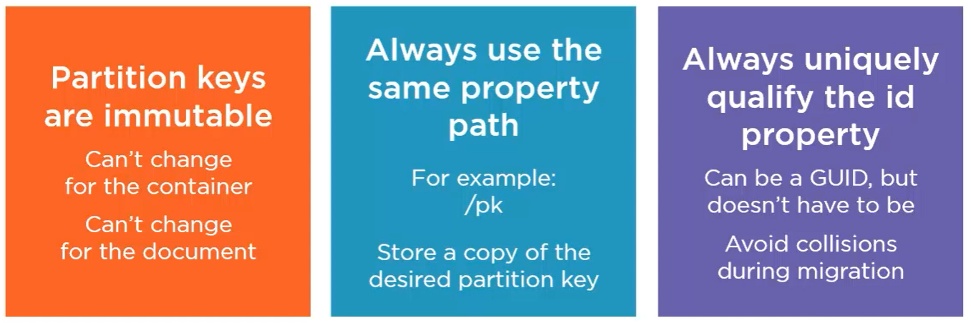

* partition key path on the container cannot be changed and you cannot replace an item in the container with a different partition key value. They're immutable .Obviously
* if you want to change because maybe your usage pattern is changing, then typical recourse is to take down your applications, create a new container with the right partition key, and migrate all your data over from the old container. Then you need to modify your applications to start using the new partition key and bring them back online.
* However, there are two things you can do to help ease that whole process and even perform the migration in place using the one container if you need to.
  + 1. you can't change the property path, so then always use the same path for every container that you create. A common practice is to **always use /pk as the partition key.** Like just the way Cosmos DB makes you always call the Id property id, well, always call your partition key property pk. Now, you'll still have a copy of this value elsewhere in the document.
    - Eg:, if we're partitioning on zip code, then we'll still have a zip code property, but we'd also have a copy of that zip code in the partition key property, pk.
  + 2. and these two go hand in hand. always use Ids that are unique across the entire container even though Cosmos DB does allow you to use the same Id in two documents as long as they have different partition keys and therefore live in separate logical partitions. Now, this can be a GUID, but certainly doesn't need to be.
    - Eg: if you're migrating data in from a relational database that has unique primary keys per table, then you can continue using those keys as the Id, but then you should prefix each one with a unique string for each type. With this strategy, you'll be able to migrate from one partition key to another in place. Now, by in place, I mean without copying across to a new container. But to update the partition key at the item level, each document needs to be deleted and readded since you can't do a replace to change the partition key value of an existing document. Now, when you delete and read each document with the changed partition key value in the pk property, you need to be sure that the new value in combination with the existing Id value doesn't collide with another document now that the partition key is different. Using a unique Id value container‑wide will provide this guarantee so you can update the partition key of your documents without any possibility of collisions.

**Global Distribution**

**Replication – why? :**

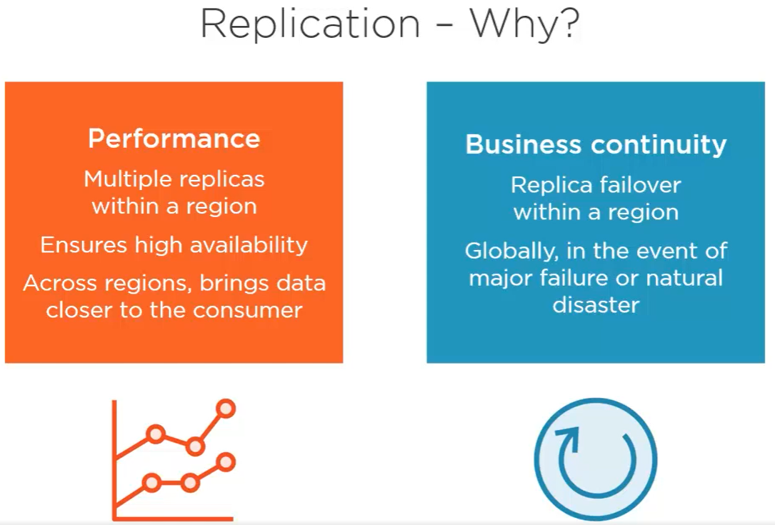

* Global distribution of data can be done by cosmos db
* **Performance:** it’s a benefit. CosmosDB synchronizes each physical partition of your container across multiple replicas, 4 infact.
  + This helps CosmosDB to meets its Service level Agreements(SLAs) for the RUs that you purchase, Since data can be served from any physical partition by any one of its replicas.
  + It also makes data more available in azure data center that’s hosting CosmosDB account.
* CosmosDB have global apps with consumers all over world not just one region.
* Replication in one region is great if all yours are nearby. but if users on other side of planet that data has to travel all the way.with Global distribution, avoid this.
* Global distribution geo-replicates data in azure data centers across multiple regions.
  + This brings data close to user. So, low latency, high availability all planet.
* **Disaster recovery:** if replica fails on a physical partition, the other replicas are there to make sure your container runs with no downtime. Meanwhile cosmosDB automatically brings new replica for the physical partition that lost one.
  + By global replication, you can spread it across multiple data centers in different regions.this ensures business continuity in event of huge catastrophe that takes out entire region.

**Enabling Global distribution:**

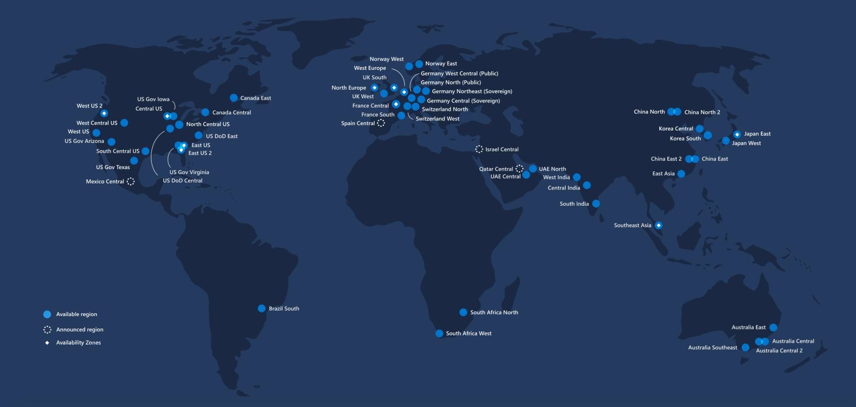

* When you enable global distribution , CosmosDB automatically replicates your data in regions you choose
* Start by choosing one region for CosmosDB account and associate additional regions when needed.



* You can replicate to any regions but some are restricted by “geo-fencing policies”
  + Eg: Germany, china restricts sharing outside those countries which limits geo replication to only those countries.

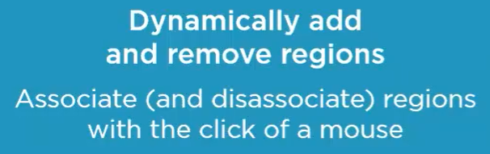 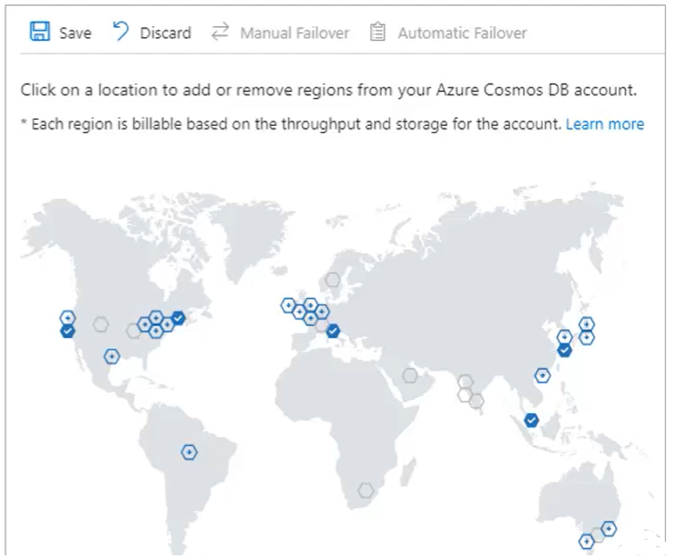

* Regions can be added and removed from azure portal just by clicking on map +save. CosmosDB replicates all data to all regions you select. Then, data can be read from any region, but all writes still need to be directed to that one region you selected when creating account, unless you enable “multi-master”

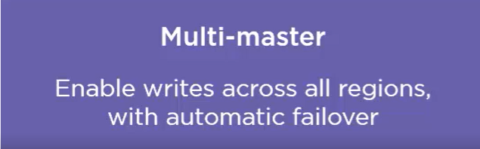 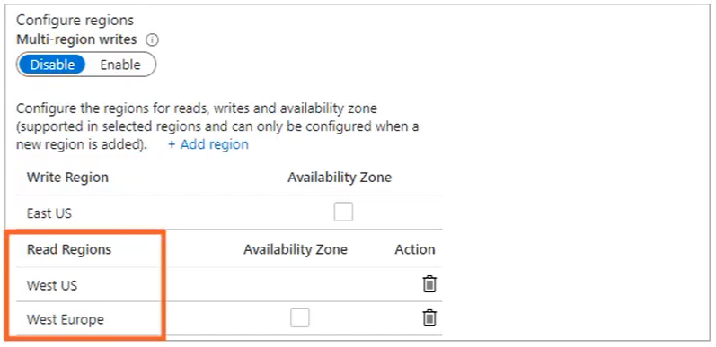 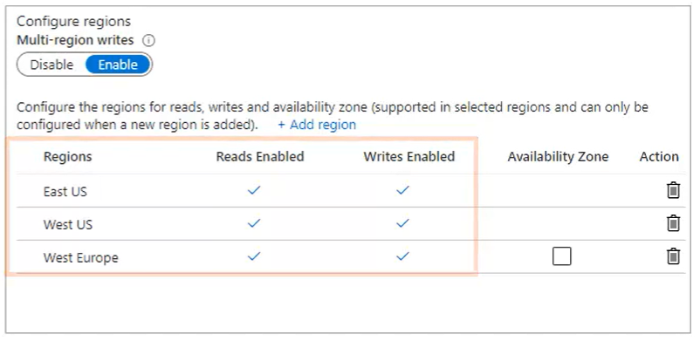

Enable multi-master from multi region writes.

If entire regions goes down then you get automatic failover

**Global replication Demo:** see the difference of latency and throughput

* **Scenario 1:** create 2 virtual machines (EastUS , South East Asia). The CosmosDB account is created at EastUS. So you observe low latency and high throughput in EastUS and opposite in southeast asia
  + Use Console project “Global Distribution” and run inside VMs at eastUS and southeast asia simultaneously
  + In the project: Q>query, R>read, W>write and type iterations number(say 100).it will perform all this operations on single json document whose id=”sample”, partitionKey=ZipCode
  + Query: latency is high in SEA due to long travel. Throughput is same in both 2.83RUs. time taken to run 100 queries in SEA=10* that is WUS (west us)

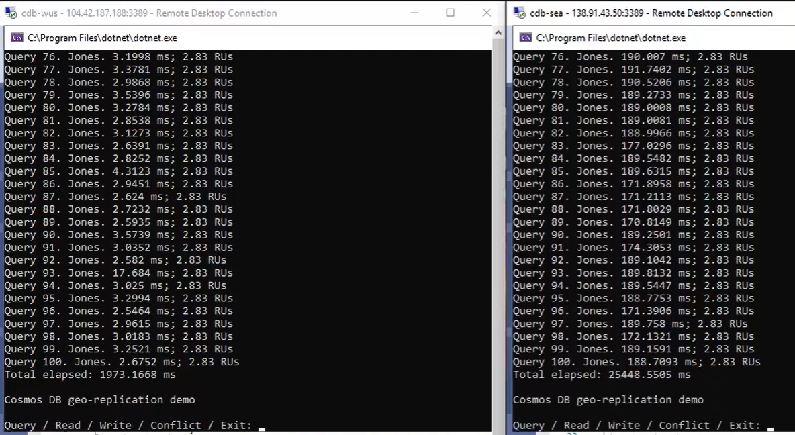

* + Direct Read (R): when you know document id and partitionkey they direct read is more efficient than SQL query for that single document. WUS latency <2ms total 433ms with 1RU each (single read of <1kb document is cheapest operation in CosmsoDB at cost of 1RU). Slow in SEA

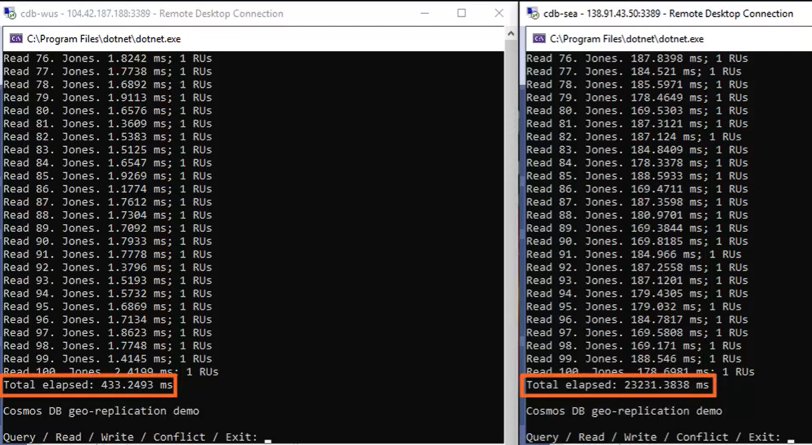

* + Writes(W): repeatedly update lastname. WUS> more latency and high RUs for write operation

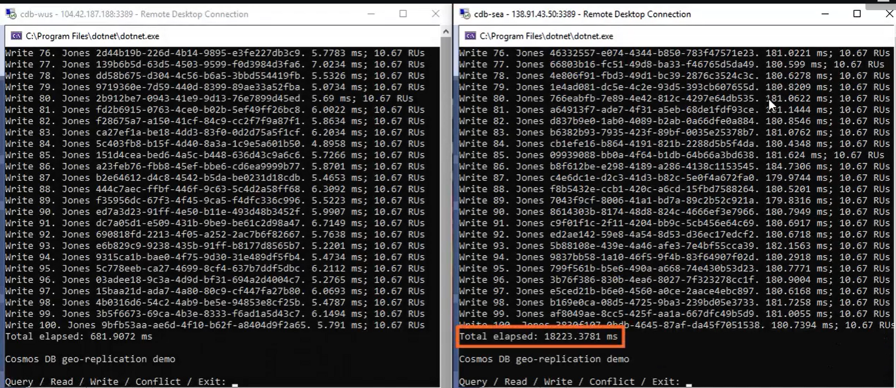

* Writes in South east asia automatically reflected in reads from West US

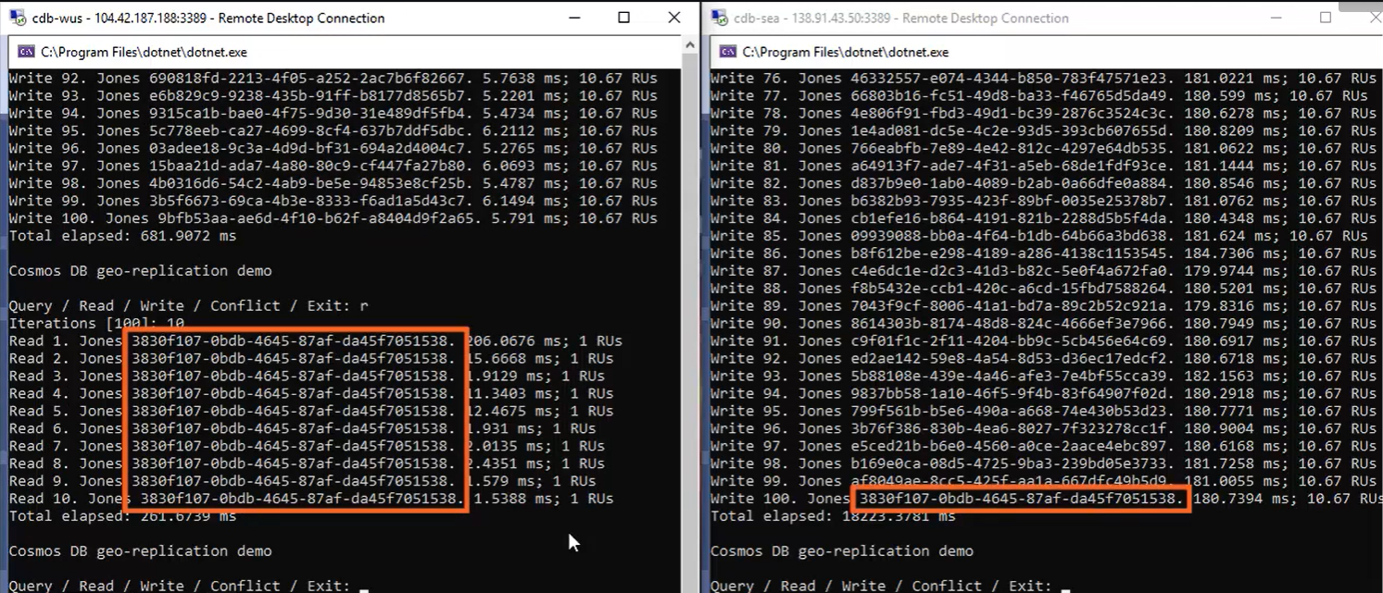

* From above Query, reads, writes we can observe that southeast asia VM has high latency and EastUS has low latency since your CosmosDB account is in EastUS. To resolve the issue for south each asia globally Replicate CosmosDB data

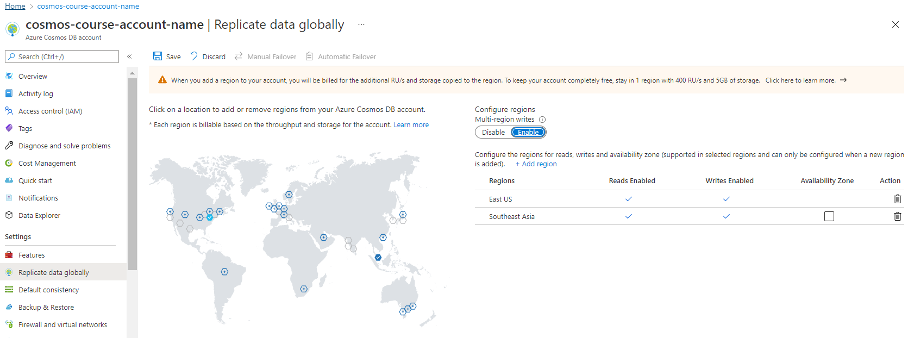

Since our account is in EastUS, click on Southeast asia and enable multi-master writes for both regions and click Save. So it replicates data from eastus to southeast asia with both regions as read and writes

* **Scenario 2:** After replication
  + In the code (Global distribution project) specify preferred region in a config. So, each region is able to failover to the other if either one of then goes down. Since there is only 2 region in the demo, there is only 1 possible failover.if you have more region then .NET SDK is smart enough to **automatically failover to the next nearest region** that is available based on geo proximity.
  + Set prefrred region to match same region of the application.

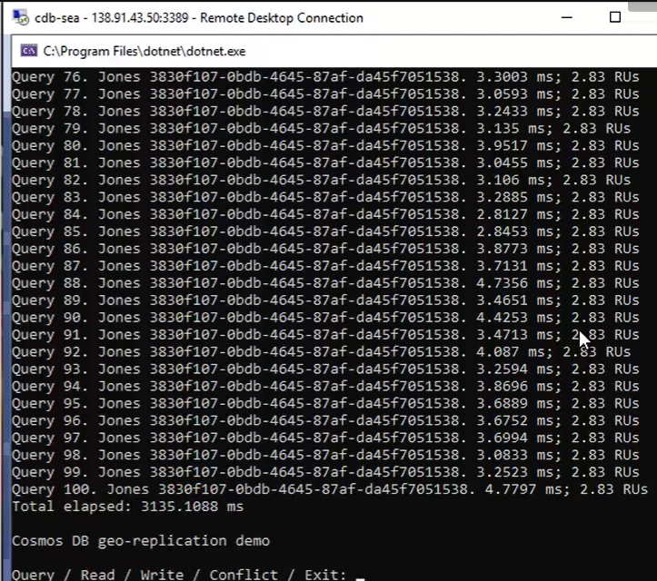

Unlike before, Now low latency is got by VM in southeast asia since global replication. So southeast asia gets same speed as WestUs. Latency is low, but RUs not changed 2.83RU for same query over and over again. So, **global distribution won’t impact throughput of your containers but greatly reduce the latency of requests**

* + Reads:

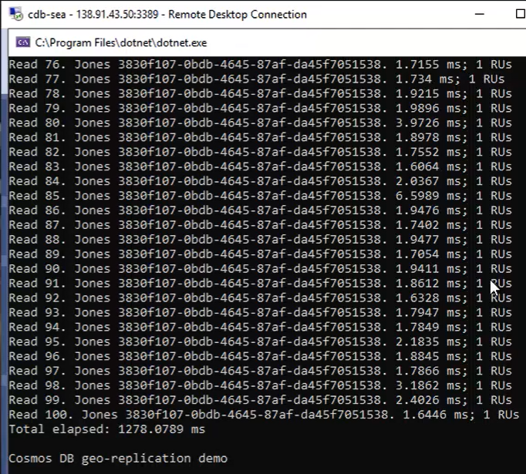

* + Writes:

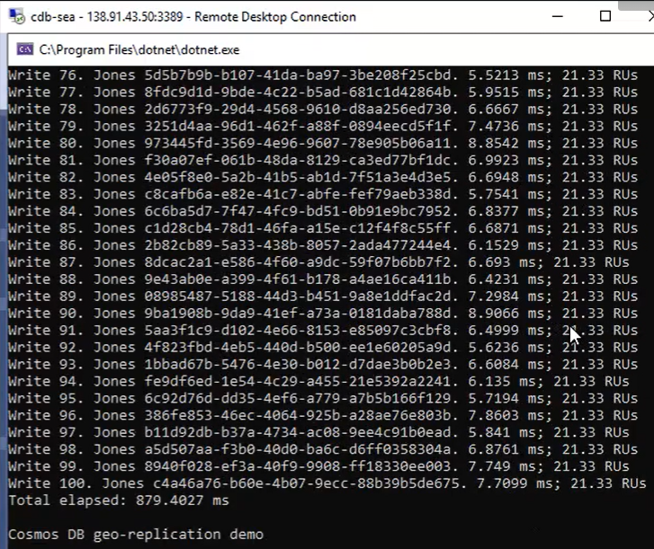

* **Geo-replication Impacts Pricing:** there is no addition fee for this feature, but standard azure networking rates will apply for all outbound data during replication. These are called **“Egress Charges”**
  + Standard CosmosDB pricing get replicated just like data does.
  + If you provisioned 1000RUs/sec for container in one region and then geo-replicated to second region, then you pay 2000RUs/sec altogether. But if you only need 1000RUs globally then scale both container down as 500+500RUs to load balance your requests across region.
  + If you enable multi-master, all write charges will be multipled by no. of regions.

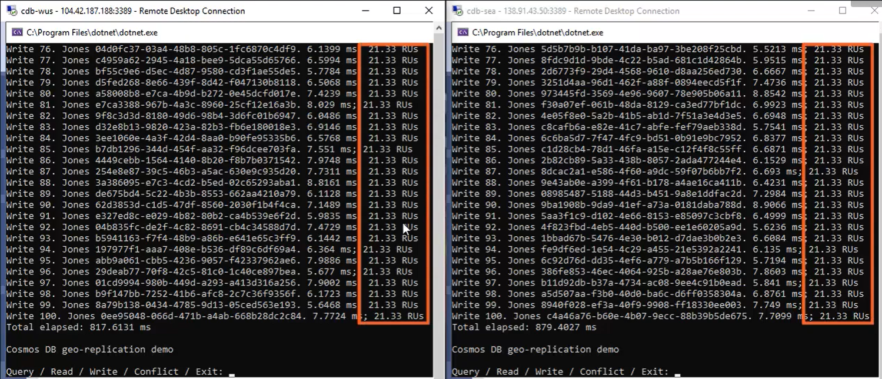

After global distribution with multi-master 2 regions, now writes are costing 20RUs instead of 10RUs because it has to replicate in another region.

**Multi Master Conflict resolution:**

* Multi master gives inherent failover along with high availability and low latency for writes and reads. But is also gives conflicts.
  + Eg: what if, user in WestUs and user in Southeast asia update the same document at the same time before Cosmos DB gets the chance to geo‑replicate the changes? 3 ways to cope this
    - 1. **last writer wins (default):** the winner is picked based on **_ts** property, which is the timestamp value that Cosmos DB stores in every document when you create or update it., and the last writer will always have the highest value in its timestamp.

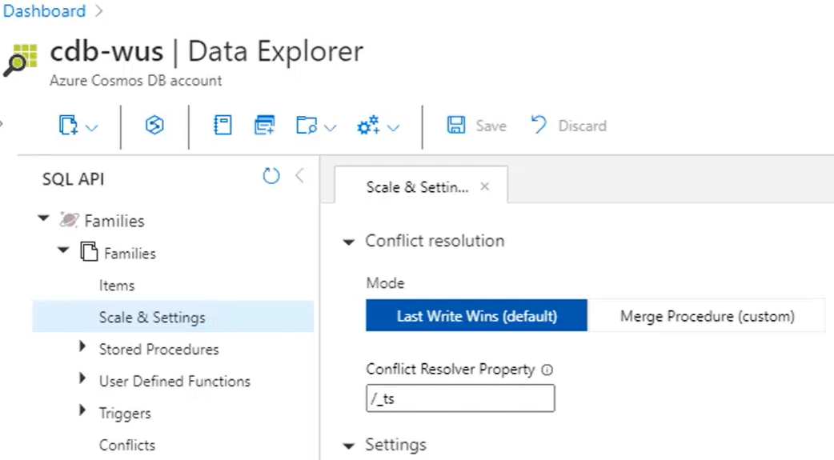

Conflict resolution policy on portal. at least, you can't set this policy on a container using the Azure portal. It needs to be done programmatically, using.NET SDK. And then once you set the policy, you can't change it later.

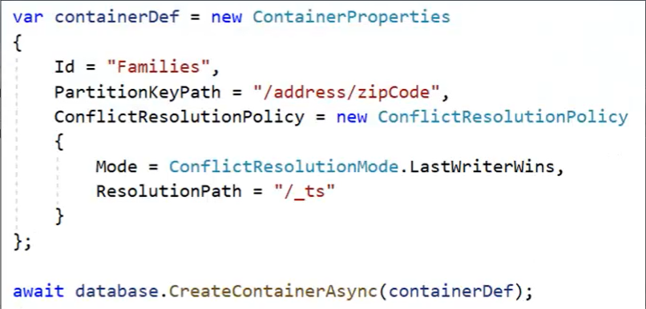

This is how to set conflict resolution policy.

* + - Also.you can base this policy on any numeric property in your document, not just the timestamp “_ts”, although this capability is supported only with SQL API and in none of the other APIs. So it doesn't necessarily need to mean that the last writer wins. It's more like the writer with the highest value in this property wins. And of course, if that's the timestamp property, then the last writer will always have the highest value, and so the last writer will always win.
    - Eg, here's a conflict on the same document for the Jones family with an id of Sample and partition key 60603 In the zipCode. One user has changed the address to 456 Harbor Boulevard, and another one changed it to 789. the timestamp property of second user has the higher value, so they win as the last writer.

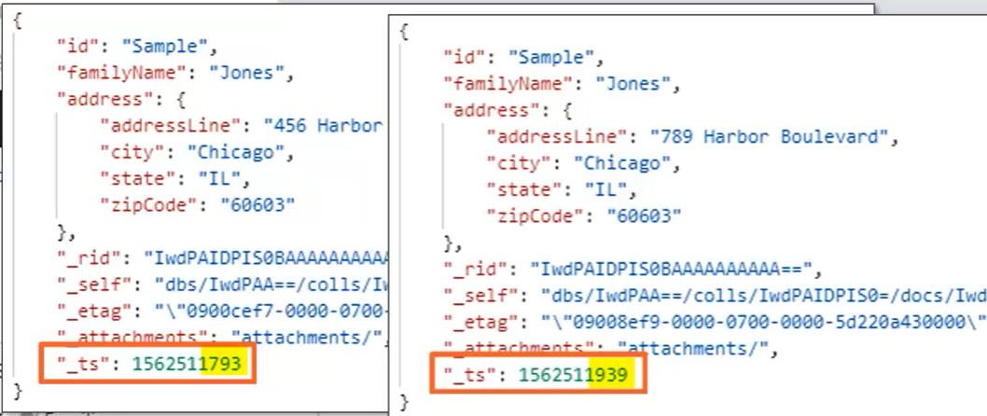

* **2. stored procedure** to resolve the conflict:: Cosmos DB will call your stored procedure, sending in the conflicting documents, and your stored procedure decides the winner. And since it's your own custom logic, the stored procedure could even perform an automatic merge that combines different parts of the conflicting documents. Here the policy shows that conflicts will be sent to a custom procedure, which we've named resolveConflict.

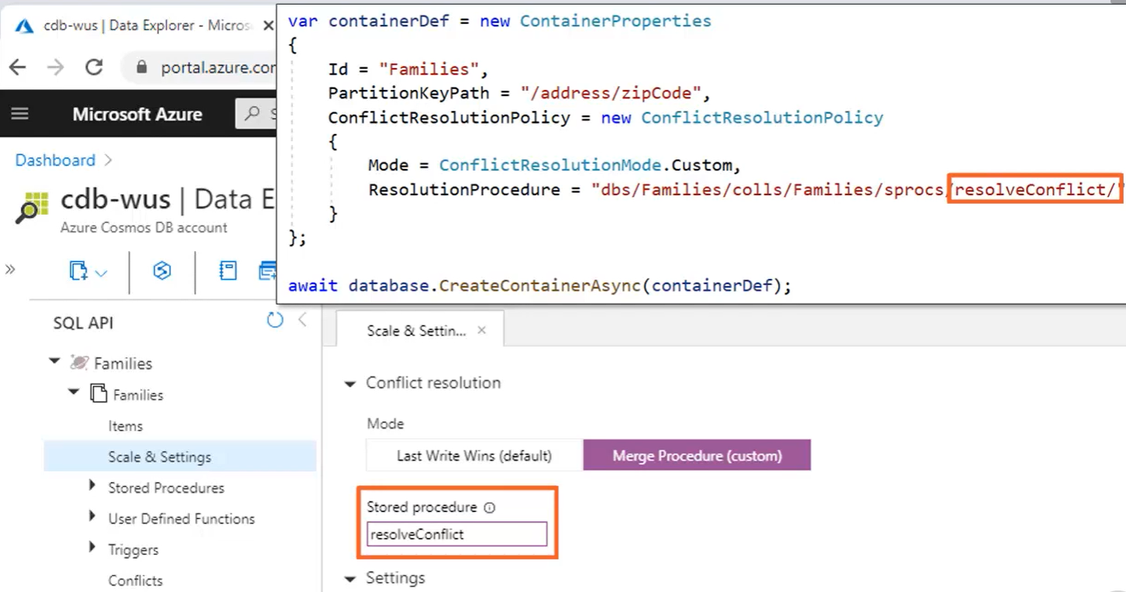

* + The stored procedure can examine the competing documents and even consider other documents in the container with same partition key and decide the winner. Both of these options run in real time. At the moment of conflict, either the last writer will win or a custom stored procedure will decide the winner.
* 3. **leverage the conflicts feed and resolve the conflict later::**  this is the offline option. Cosmos DB writes to the conflicts feed if you choose the custom stored procedure option, but don't actually specify the name of a stored procedure.

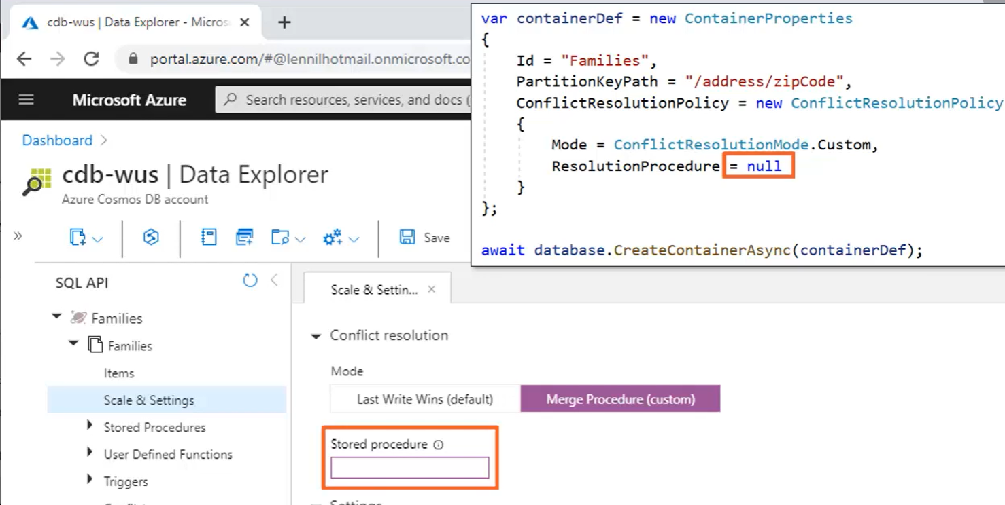

* + even if specify name of stored procedure, conflicts will still be written to the conflicts feed if the stored procedure doesn't exist, or if it does, but throws an error during execution.
  + With the conflicts feed, there's still a winner, but it's based on the quorum majority, which is fastest, but somewhat arbitrary. The loser gets pushed into the conflicts feed, which can be viewed in the Data Explorer > Conflicts. You can also programmatically consume the conflicts feed and take any action that you want, such as recovering data from the documents that didn't win and then remove those documents from the feed as resolved.
* Conflicts Feed demo: run conflicts code in GlobalDistibution project attached. Run console app simultaneously in WestUs and southeast asia.

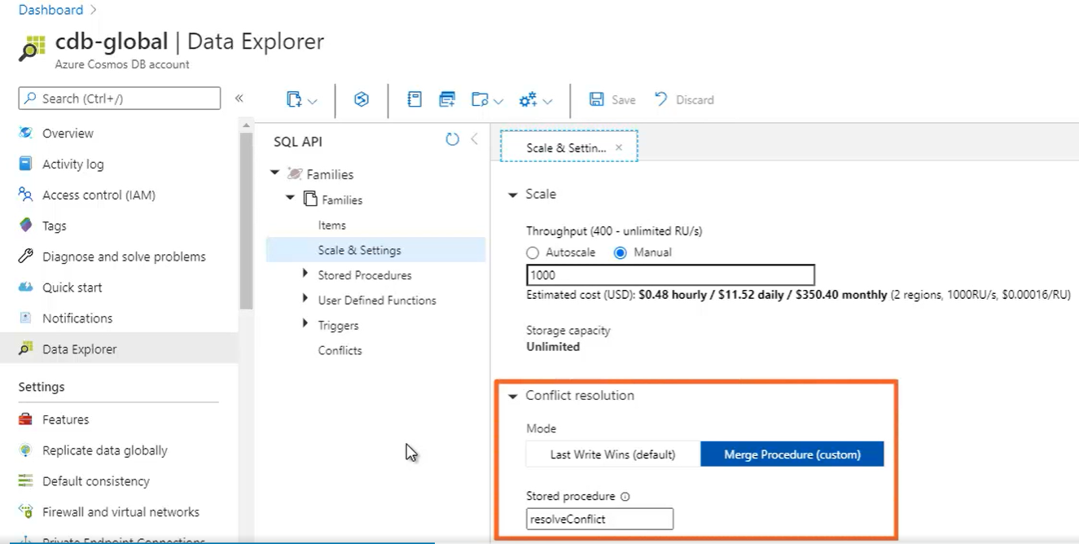

Above shows stored procedure. Even if that SP doesn’t exist, each conflict is sent to conflict feed. If SP didn’t exist, any conflict that cause an exception in that SP will also written into conflicts feed.

Demo: WestUs,Southeast Asia, both regions writing 100 documents at the sametime with two different values at lastname property.

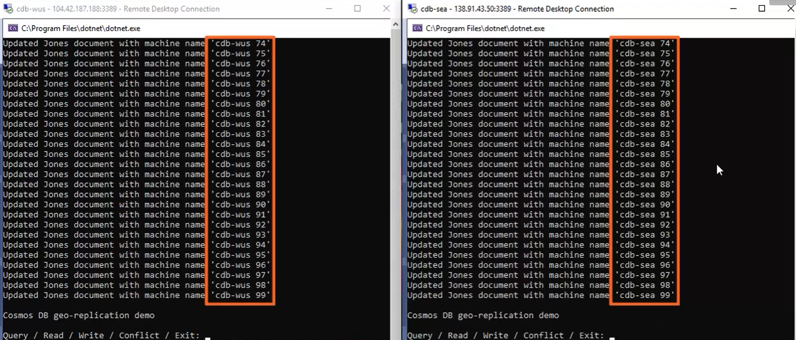

Now check the document

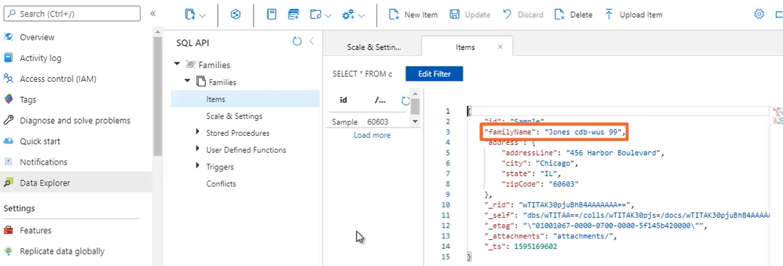

From above, you observe WestUS won the conflict for 100th update (which are numbered from 0-99). Now check conflicts feed between 2 regions.

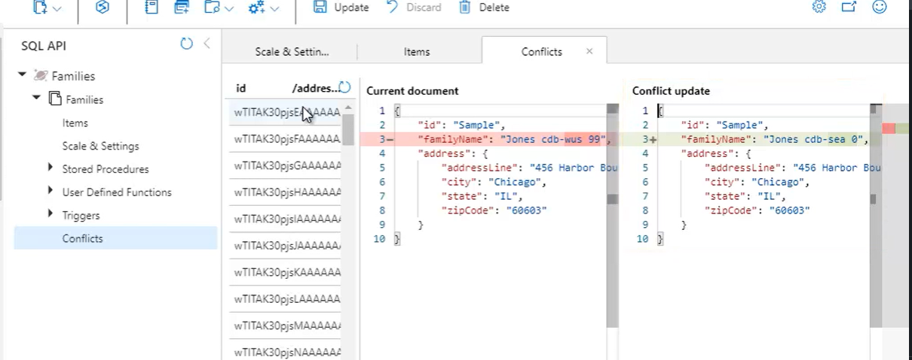

Left: current document (100th WestUS Update)

Right: document that lost

You can see first southeast asia document that lost to replace document, second, third,fouth,…

* As long as documents remain in conflicts feed, those lost updates are always available for recovery.
* Click delete> to delete from the feed
* Click Update> to recover the lost document. This will update the document from “Jones cdb-wus 99” to “jones cdb-sea 0” or 99 if you update last one.

**Replication and Consistency:**

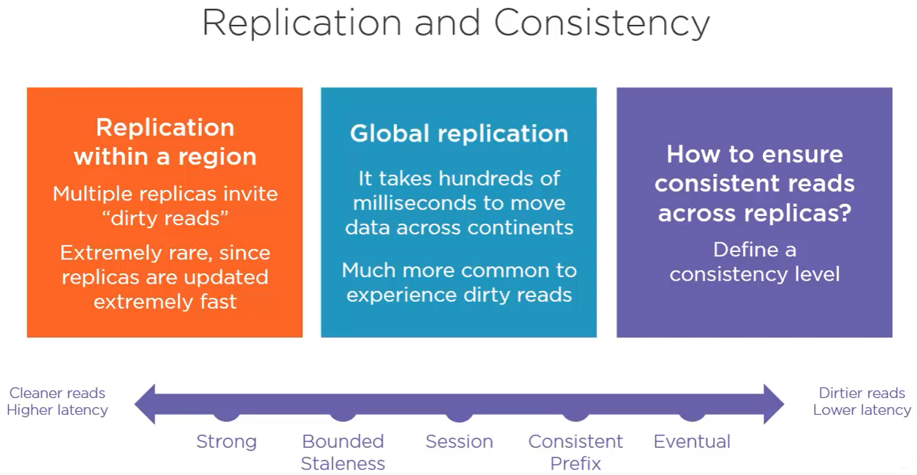

* Within each region, your data written out to multiple replicas, and that gives you high availability.
* **consistency** is all about whether or not you can be sure that the data you are reading at any point in time is in fact the latest version of that data. Because you can be reading from any available replica, and if that replica hasn't yet been updated with the latest version, then this is known as a **dirty read**.
* In reality, it's extremely rare to ever experience a dirty read within one region, and that's because the replicas within the data center are located very close to one another, and data moves extremely fast between them, typically within 1 ms.
* But once you're replicating your data globally, you already observed above how long it takes to move data across continents, 100s of milliseconds, and there is much higher chance of experiencing dirty reads when you spread across multiple regions, and this makes consistency a big concern.
* So the way you control this behavior is by defining a consistency level. Cosmos DB supports five consistency levels ranging from **strong to eventual**.
* depending on the consistency level, there's some tradeoff between performance and dirty reads.
* On the one extreme, **strong consistency** guarantees that you'll never experience a dirty read, but this guarantee comes with a cost of **higher latency** on writes because Cosmos DB will force writers to wait for a quorum, that is a majority of the replicas to acknowledge the change before committing the write.There is slightly **higher RU charge on reads** because now they need to be resolved from the quorum rather than a single replica.
* On the other end of the spectrum, there's **eventual consistency**, which offers no guarantees whatsoever, and you never know with certainty whether or not you're reading the latest version of data. This gives Cosmos DB the freedom to commit writes instantly as soon as the first replica acknowledges the change. And likewise, your **reads will have a** **lower RU charge** because they can be served from any available replica. And this, in turn, results in the **lowest latency** and gives you the best performance at the cost of potentially experiencing dirty reads.

**5 Consistency Levels:**

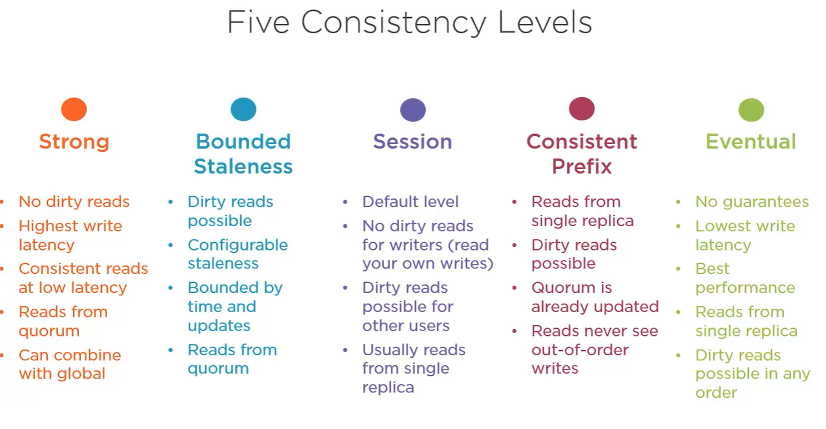

* **strong consistency**:: it is certain that you always reading the latest data, but you pay for that certainty in higher latency on writes because when somebody writes to the database, they're going to wait for Cosmos DB to acknowledge that the write was successfully saved to the quorum majority of replicas.
  + And this lets Cosmos DB serve up consistent reads guaranteed at low latency, but the reads still need to be resolved from the quorum, they can't be resolved by a single replica, so strong consistency will also raise the RU charge on your reads.
  + You can combine strong consistency with global distribution, but that means that the write latency that increases marginally within a single region will rise dramatically once your replicas are globally distributed. And if you can tolerate this, then Cosmos DB can guarantee low‑latency reads that return the very latest committed version of any write, and it doesn't matter which region issued the write.
* **bounded staleness**:: one step away from strong. As the name implies, this means that you can tolerate stale data, but only up to a point.
  + so you can actually configure how much out of date you want to allow for dirty reads. Think of it as controlling the level of freshness, where you allow dirty reads, but only if the data isn't too much out of date.
  + Otherwise*, for data that's too stale, Cosmos DB will switch to strong consistency*. In terms of defining what stale means, you can either specify lag in terms of time, like no stale data older than X number of seconds, or update operations, as in no stale data that's been updated more than Y number of times.
  + Like strong consistency, bounded staleness requires reading from the quorum rather than a single replica.
* **session consistency**: ( default). With this you maintain a session for your writer by supplying a unique session key that the writer includes in their requests. Cosmos DB then uses the session key to ensure strong consistency for the writer, meaning that a writer is always guaranteed to read the very same data that they wrote and will never read a stale version from some out‑of‑date replica while everyone else may experience dirty reads.
  + In almost all cases, reads could be satisfied by a single replica rather than a quorum, resulting in a lower RU charge for reads when using session consistency. This balance works very nicely for many types of applications, which is why it's the default consistency level.
* **consistent prefix**:: in this reads are always satisfied by a single replica, and so dirty reads are always possible; however, you do get some guarantees. First, when you do get stale data from a dirty read, you can at least be sure that the data you get has in fact been updated to the quorum majority of replicas, even though it's not yet the most up‑to‑date version of that data.
  + you'll never experience reads out of order. Eg: say the same data gets updated three times. So there are versions A, B, and C, where C is the most up‑to‑date version, and A and B are stale versions. Now assume A and B have both been replicated, but C hasn't yet. You can be sure that until C does get replicated, you'll never read versions A and B out of order, that is, you might first get version A and then get version B, but then you'll never again get version A. You can only get the stale versions in order, and so you'll only continue getting version B until eventually version C gets replicated.
* **Eventual consistency**: is the weakest consistency level. It offers no guarantees whatsoever in exchange for the lowest write latency and the best performance compared to all the other consistency levels.
  + With eventual, you never wait for an acknowledgment before committing writes, and reads can be serviced by any single replica at any given time. So you can get inconsistent results in a seemingly random fashion until eventually all of the replicas get updated, and then all the reads become consistent, until the next write operation, of course.
  + this is really the polar opposite of strong consistency because now there's no guarantee that you're ever reading the latest data, but there's also never any waiting, which delivers the fastest performance.
* *Important Note,* when the bounded staleness and session consistency levels don't apply strong consistency, they fall back to consistent prefix, not all the way down to eventual consistency. So for bounded staleness, which gives you strong consistency when the data is too stale, you'll still get consistent prefix guarantees when the data isn't too stale. And likewise with session, which gives you strong consistency when reading your own writes, you'll get consistent prefix when reading other writes.

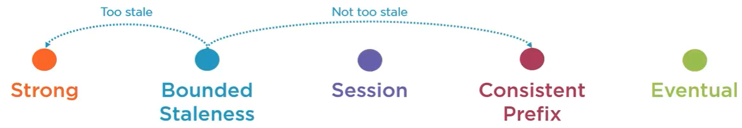



**Setting The Consistency Level:**

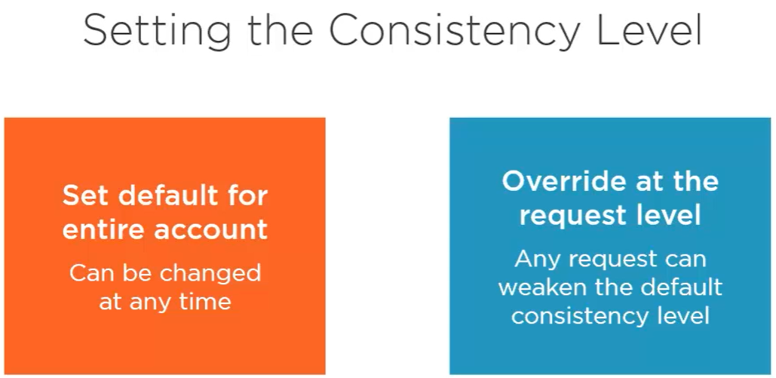

* To set the consistency level, you choose one of the 5 options and set that as the default for the entire Cosmos DB account. Then every operation across all the containers under the account will use that consistency level until and unless you change the account by default, which you can do at any time.
* In Portal go to default consistency, and then you can choose from the five available consistency levels.
  + session consistency by default.
  + If you choose bounded staleness,

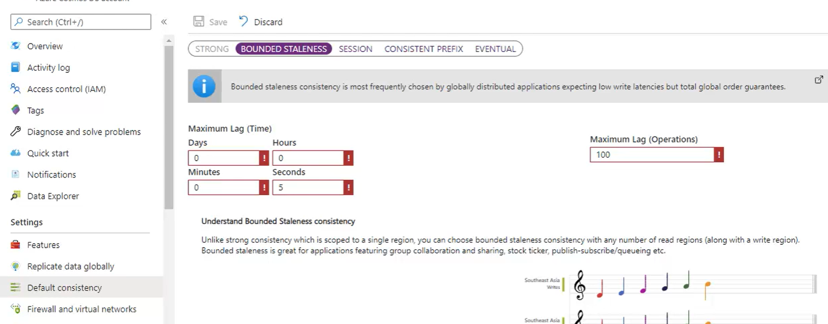

set these inputs to set the acceptable level of freshness. You can specify the maximum number of operations behind and the amount of time that you want to allow for stale results. Above Eg: we're tolerating dirty reads that are up to 100 operations behind and not older than 5 seconds.

* *you can override the default consistency level on a per request basis, but then you can only weaken it*. Weakening the consistency of the request level is useful for those times where you want the best performance and don't care about stale data and dirty reads.
  + So in the case of the default session consistency level, you can only override that to use consistent prefix or eventual consistency on any given request, because those are the only two levels weaker than session consistency.

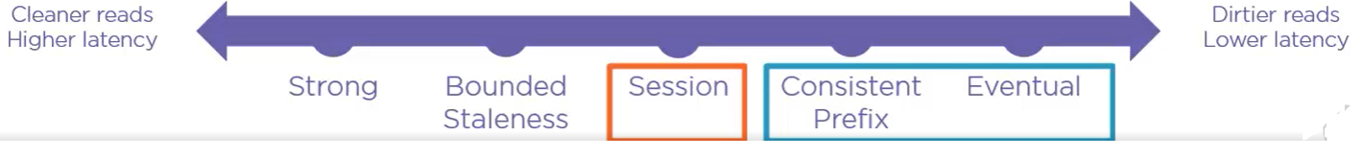

* + But if you set the account‑wide default to be strong consistency, then you can override to use any other consistency level.

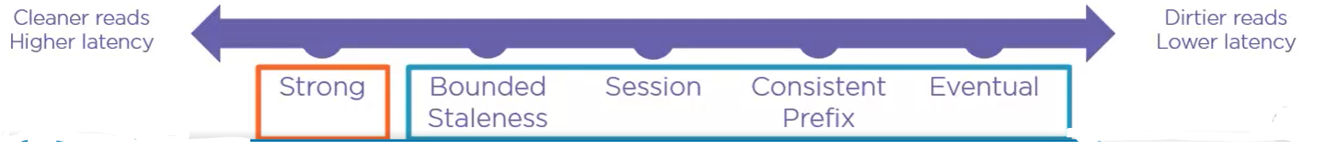

* + The .NET SDK makes it very easy to weaken the consistency level on a per request basis. it will need to be weaker than the default consistency level for the account or else you'll get an error.

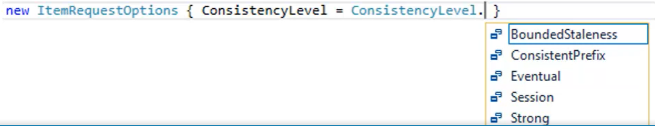

**Data Modeling and Migration:**

**Document Database?:**

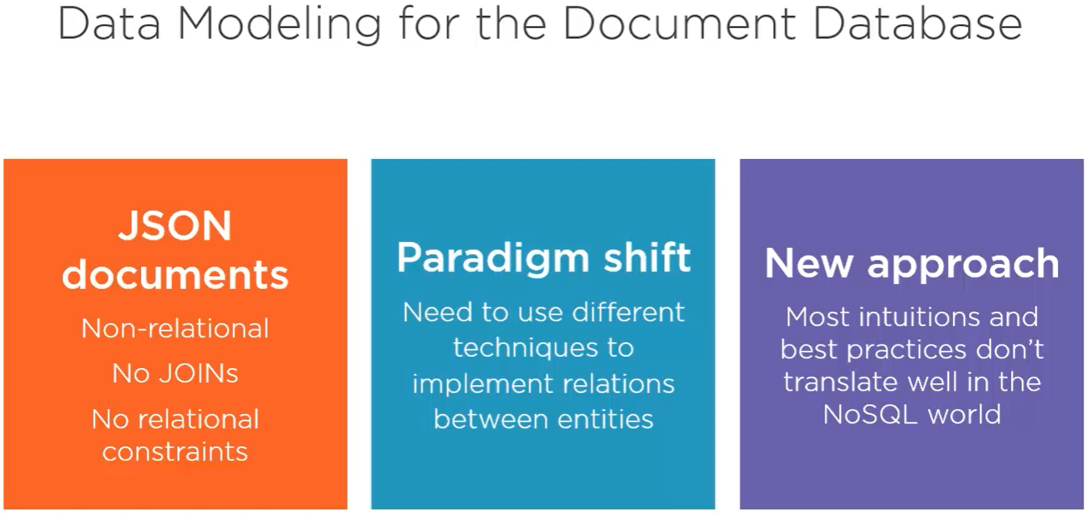

* how do you model your data as JSON documents, which is very different to data modeling with the relational database like SQL Server?
* how do you migrate data into Cosmos DB and get it to fit your data model?
* The SQL API gives you a document database, which is a database where you store your items as JSON documents. Cosmos DB is a non‑relational database, which means, first of all, there is no concept of joins between related documents. Because we're horizontally partitioned, every document can live in a different physical partition.
* so Cosmos DB won't join related documents together on some key for you like a relational database will do for rows across different tables. Nor will it enforce any relational constraints on the keys that it used to reference separate related documents.
* So without joins and without relational constraints it's reasonable to question if Cosmos DB is suitable for relational data models. And the answer is yes.
* It's just a bit of a paradigm shift in the way you need to think about data modeling. So, because Cosmos DB is horizontally scalable and non‑relational we use different techniques in order to materialize relationships between our entities. a whole different approach to designing your data model. And in some cases it's radically different to how you do things with a relational database and can run contrary to the best practices that some of us have been following for decades by now.
* Fortunately, though, while it is very different, it's not really very difficult. I'll cover the most important concepts in this module, but if you'd like to dive deeper on the topic then have a look at my other course on data modeling and partitioning patterns in Cosmos DB.
* For more info check <https://app.pluralsight.com/library/courses/data-modeling-partitioning-patterns-azure-cosmos-db/table-of-contents>
  + In that course we walk step by step through the process of refactoring AdventureWorks, a normalized relational SQL Server database, into a de‑normalized, non‑relational document data model for Cosmos DB.

**Relational vs Document:**

* 1. while the relational database stores data in rows in a table, a document database stores JSON documents in a container.

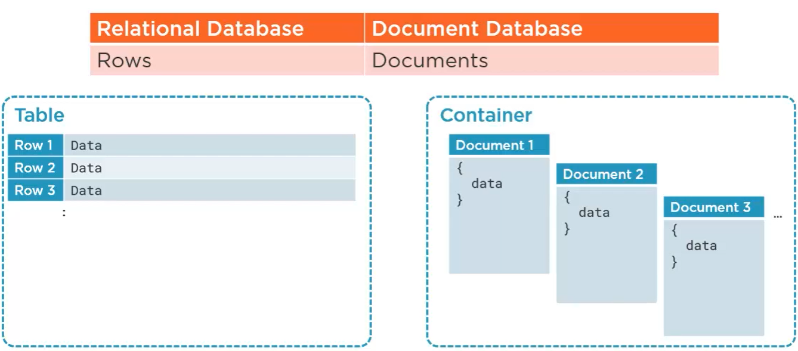

* While rows in the relational world are made up of columns, documents contain properties. In this example our documents aren't hierarchical, so it's easy to see some correlation here where pivoting the columns in a row projects a document with scalar properties.

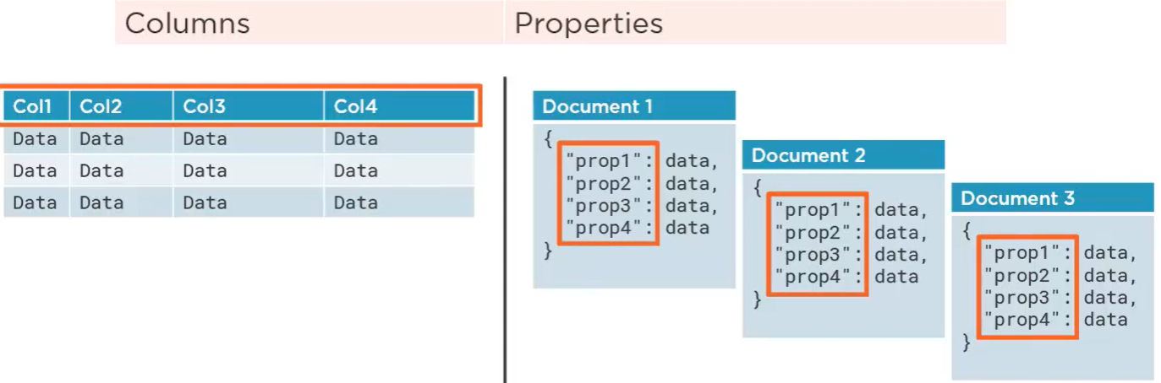

* In the relational world, every table has a schema that defines the columns and data types that every row in the table must conform to. a document database has no defined schema and every document in a container can be structured differently.

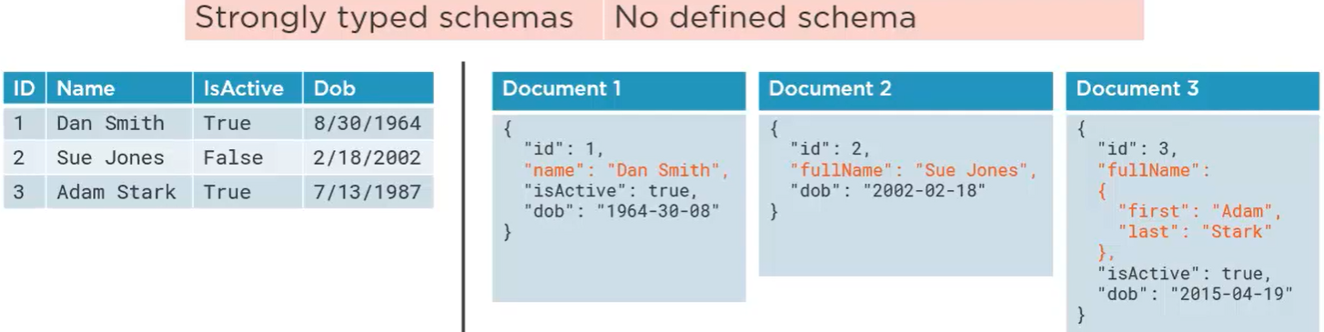

on left there are four columns defined for a table. we would need to alter the schema of this table if you wanted a fifth column or if you wanted to change the maximum length on the Name column or if you wanted to allow nulls and date of birth. You get the idea. But because document databases have no enforced schema they aren't subject to these constraints. And this makes them ideal for today's rapidly‑evolving schemas in modern applications. Right side shows document with the name property, another with a fullName property, and one more with a fullName property that has first and last names nested inside it rather than a simple string. And the database is more than happy to accept all these variations.

* Of course this is just an example and it wouldn't normally make sense to mix things up like this just because you can. Instead, imagine that these are three different versions of a schema that has evolved over time. It started with name, and then at some point it was determined that fullName was a better choice than name. And then at some later point the fullName property was enhanced to distinguish between first and last names.
* Now compare this to the strongly‑typed world of relational databases where keeping pace with an evolving schema is far more disruptive.
* Now, sure, when your schemas do vary like this then it falls on you to present a unified view of the data when you need to. you can easily write a query that returns the full name consistently, first by testing for the presence of a property called name or a property called fullName, if there is no name property, and then by testing if the fullName property is an object or not. If it is then you'd concatenate the embedded first and last name properties, otherwise you would just return the string in that fullName property. Again, unlike a table in the relational database, you're able to store different entity types in the same container.
  + That's why it's also a best practice to include a type property on every document so you can easily distinguish between all your different types. And you could similarly standardize on a version property instead of relying on little assumptions about a document schema like we was just describing for the name and fullName

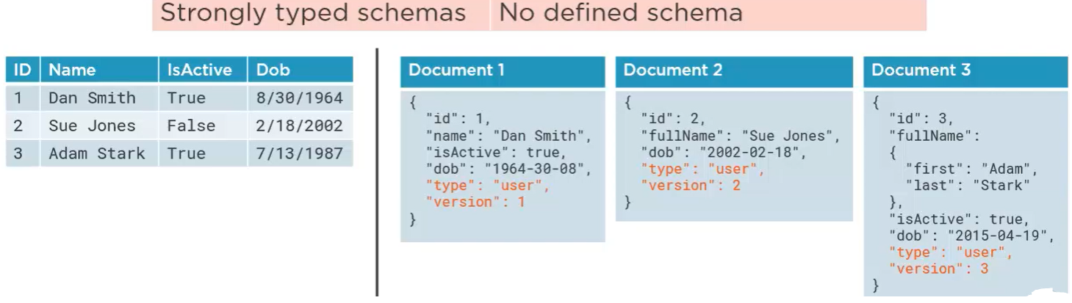

**DeNormalizing the Model:**

* Another fundamental difference between relational databases and document databases has to do with denormalization.
* In the relational DB, we strive to normalize data as much as possible. This means, first and foremost, avoiding data duplication, and we do that by maintaining separate tables for our distinct, yet related, entities.

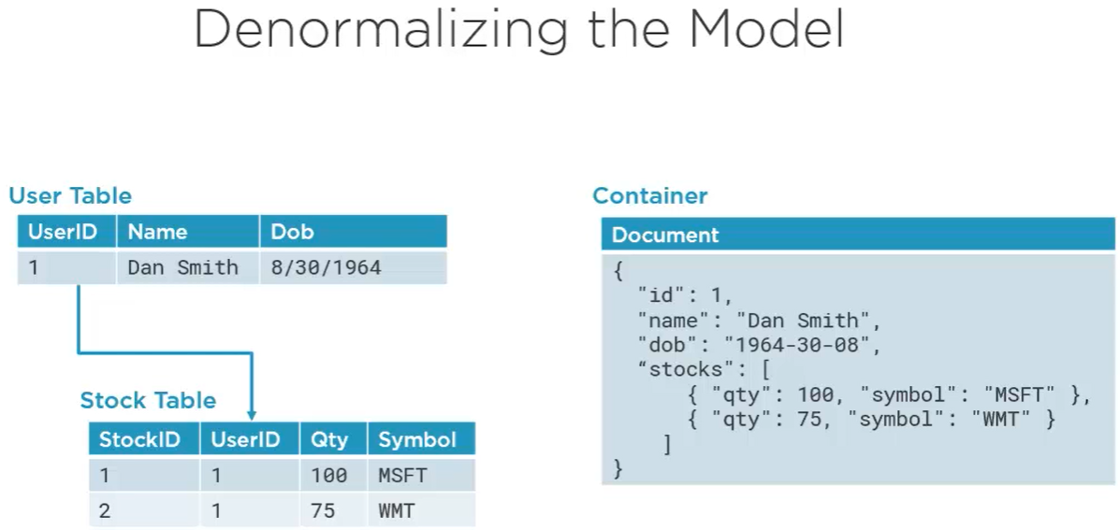

* + Eg: we have a user table with a row for Dan, and we have a separate stock table with multiple rows for all of Dan's stock. The two tables are related on a user ID, which is 1 for Dan, and so we're not repeating Dan's name or other user information about Dan in each stock row. Now, consider what the database engine has to do when your application needs to work with this data, it needs to read two separate rows and join them together when you're retrieving data and then each table needs to be updated separately when the user makes changes and click save. Now this is a really simple example, but in the real world we'd be joining and updating more than just two tables, it could easily be 10 or more, and even if you get an object relational mapper like Entity Framework to help , it's still work and a lot of overhead.
  + In a document database, we typically do the opposite and strive to denormalize. So here we've got a single document that encapsulates a user with all of their related child entities where one‑to‑many relationships are easily expressed in JSON as an object array. Essentially, we pre‑join the user's related stock items by embedding them in an array, so there simply isn't any need to join things together when you're reading, nor do changes need to be written out to multiple tables. In fact, no need for an ORM layer at all, you can just serialize and deserialize objects directly between the database and your application. Of course, there's no silver bullet that handles every scenario, so it's fine when you have a reasonable number of child objects in your JSON array, but what about unbounded data?
    - Eg: say you've got a blog post with a potentially infinite number of related comments. It would not be possible to store a single post with all of its comments inside a single document. there's a 2‑MB limit on document size in Cosmos DB, so this simply won't work. Instead, you'll need to figure out how to break this up into separate documents. Now, you can certainly have one document for the post and then keep each comment in its own separate document, much like you would do with separate rows in a relational database, and then you can think of the post ID as a foreign key, but again, Cosmos DB will certainly not join things together for you on the post ID like a relational database would join rows using a foreign key. Instead, you'll need to query individually for posts and comments, and while this theoretically works, it would not be optimal when you want to get a post with all of its comments.

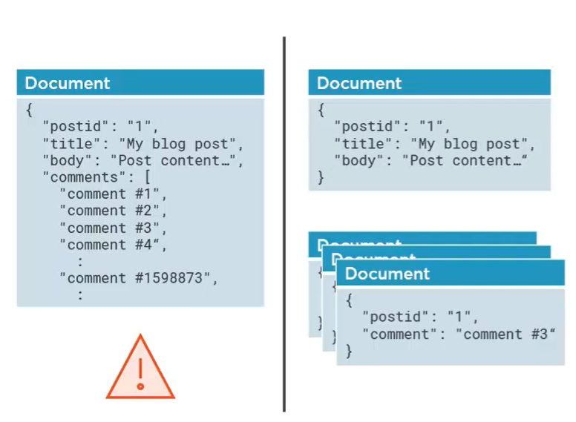

Don’t do above instead do below

* + - Since CosmosDB is schema free, so it's like the Wild West, there are no rules and you're completely free to model things however it makes sense to you and your application. So in this case, you could design a data model where you have one document for the blog post that can also accommodate the first 100 comments. If a post never exceeds 100 comments, well, then you've got everything in one document. But if it spills over, you can create another document for the next 100 comments, and then, if needed, another for the next 100.

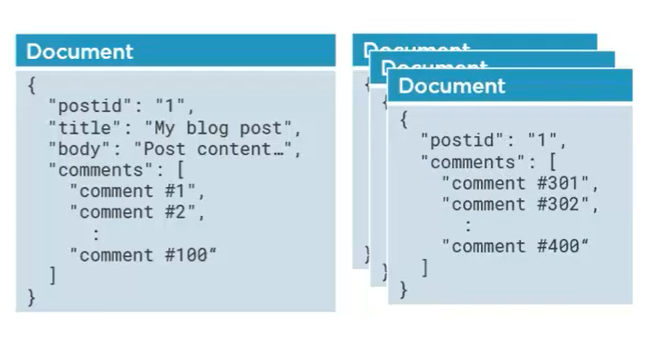

* Data duplication is another very big part in all of this. Take products and orders, for example. Here we got a document for each product and each one's got a code, a short description, and a longer description in this info property. Now each order document has this details array, so we're embedding order details inside each order rather than storing them as separate one‑to‑many documents like you would do in a relational database. But, each detail has just the product code, which links it to a product document. So if I need any information about a product, say I always want to display the short product description and in order of summary view, then I need to fetch each related product document as well, and that is definitely not what you want to do.

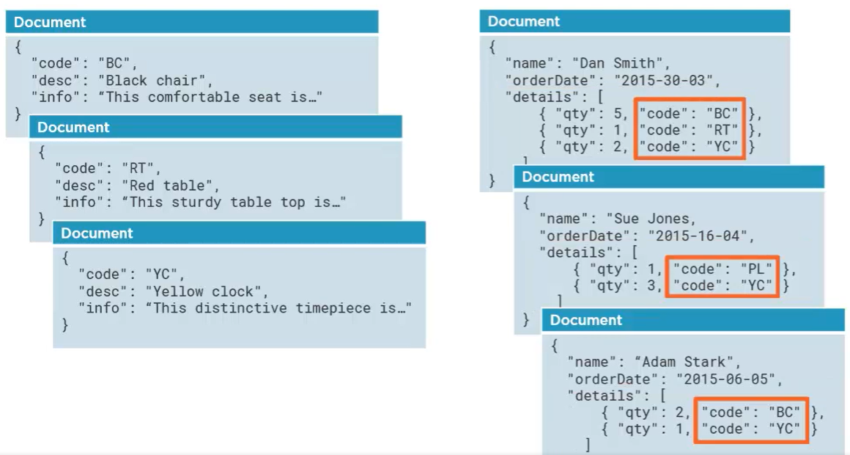

Instead, and we know this is a sin in the relational world, we're going to duplicate the data that we need, so we'll actually store a copy of that short product description in each order detail. And then, by retrieving a single order document, we'll be able to display the product descriptions for that order without having to fetch the related product documents.

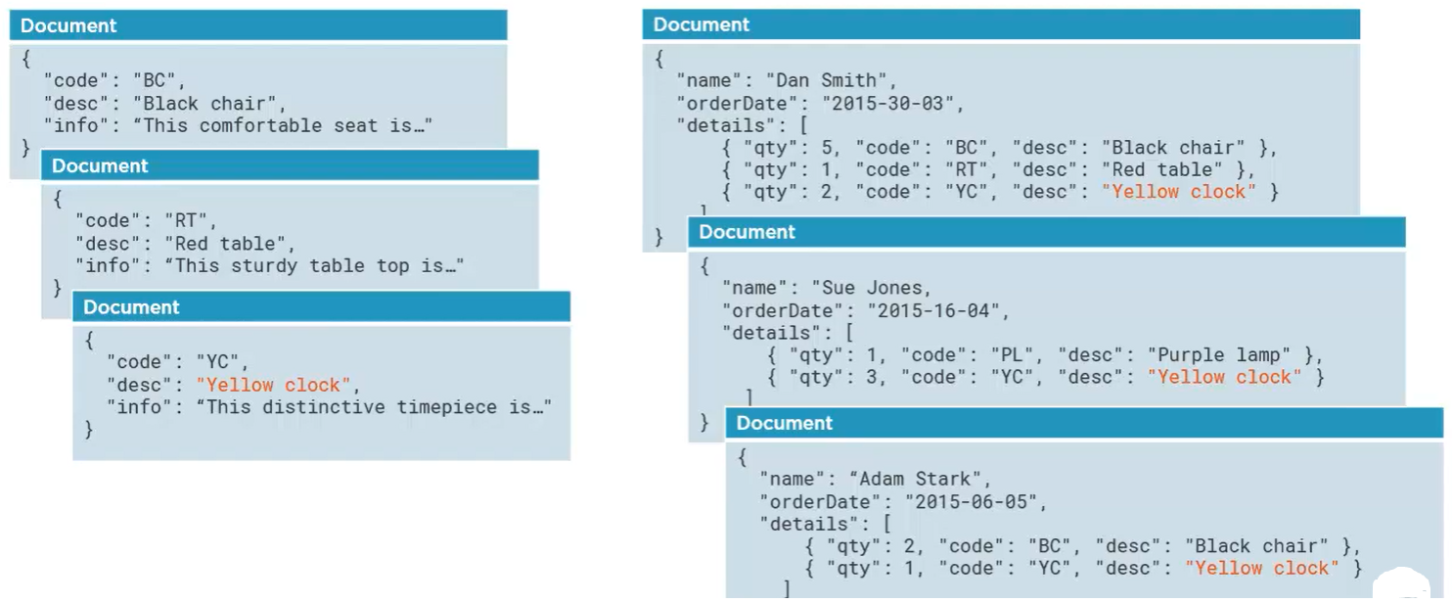 Of course the only issue now becomes how to keep things in sync when a product description changes. One easy way to do this is to **use the change feed** in CosmosDB. Every container has a change feed you can watch so that you can process changes to the container as they occur. This means you can easily detect when a description has changed (on left side ) in the product document and then cascade that change to all the related order documents (on right side).

**Data Migration Options:** to migrate data from existing DB to cosmosDB data model.

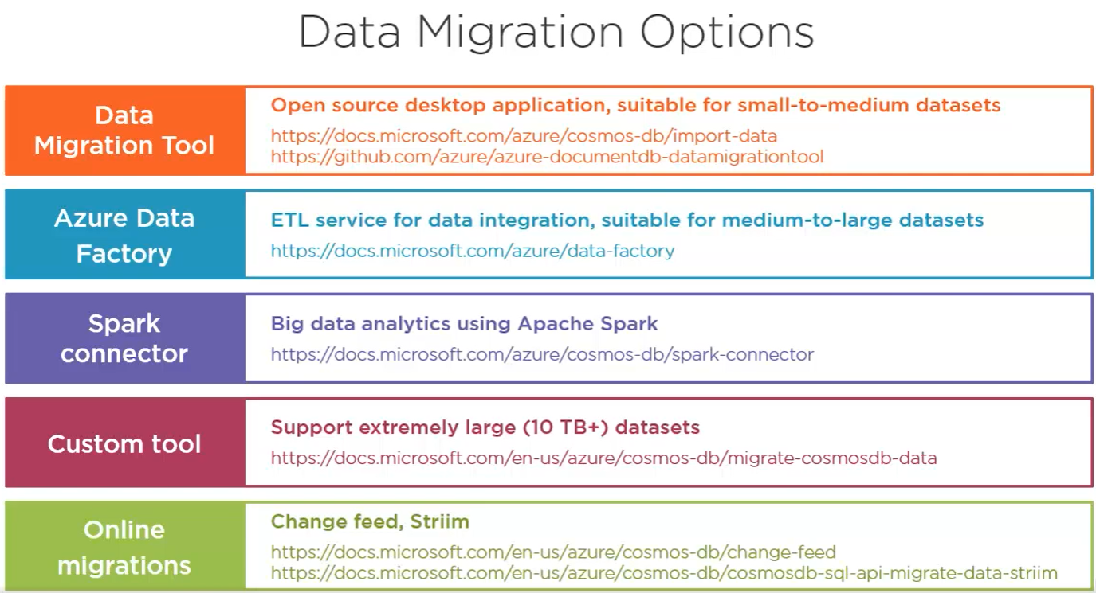

* 1. **Data Migration tool::**open‑source WPF desktop application .besides the desktop GUI, the tool also has a command line interface and supports a number of data sources, including raw JSON files, MongoDB, SQL Server, raw CSV files, Azure Table Storage, Azure, DynamoDB, HBase, and Cosmos DB itself. This utility works well, but it's designed for migrating only small to medium sized datasets. Also, Microsoft is no longer developing or extending the Data Migration tool
* 2. **Azure Data Factory (recommended)**:: ADF uses the Cosmos DB BulkExecutor library, so it can handle much larger datasets than the Data Migration tool. ADF is a full‑featured ETL service that lets you run very sophisticated transformations over the data as it's being migrated. With this capability, you can not only move data into Cosmos DB you could de‑normalized data that's normalized at the source as you move it.
* 3.**Spark Connector:** If you're using Azure Databricks or HDInsight for big data analytics, you can use the Cosmos DB Spark connector to batch reads and writes to and from Cosmos DB on your Spark cluster. Like ADF, the Spark connector also uses the Cosmos DB BulkExecutor library, so it's equally well suited for large datasets and big data analytics.
* 4. **Custom Tool:** as mentioned that ADF and the Spark connector both used the Cosmos DB BulkExecutor library. Well, you can also leverage that same library in your own applications to build custom migrations. The BulkExecutor library has features that make it very resilient to failures and can support extremely large datasets, and easily 10 TB or more.
* All these options I've mentioned are offline operations, where there's downtime during the migration, but there are also options available that support online migrations, where data gets migrated in real time as your applications are up and running. You can achieve this by consuming **the change feed**, and then migrating those changes to another Cosmos DB container or any other downstream system. There's also service on Azure called **Stream that supports online ETL migrations**, although this is a third‑party tool that needs to be purchased from the Azure Marketplace.

Simple Data Migration using ADF:

* Create new DB and container

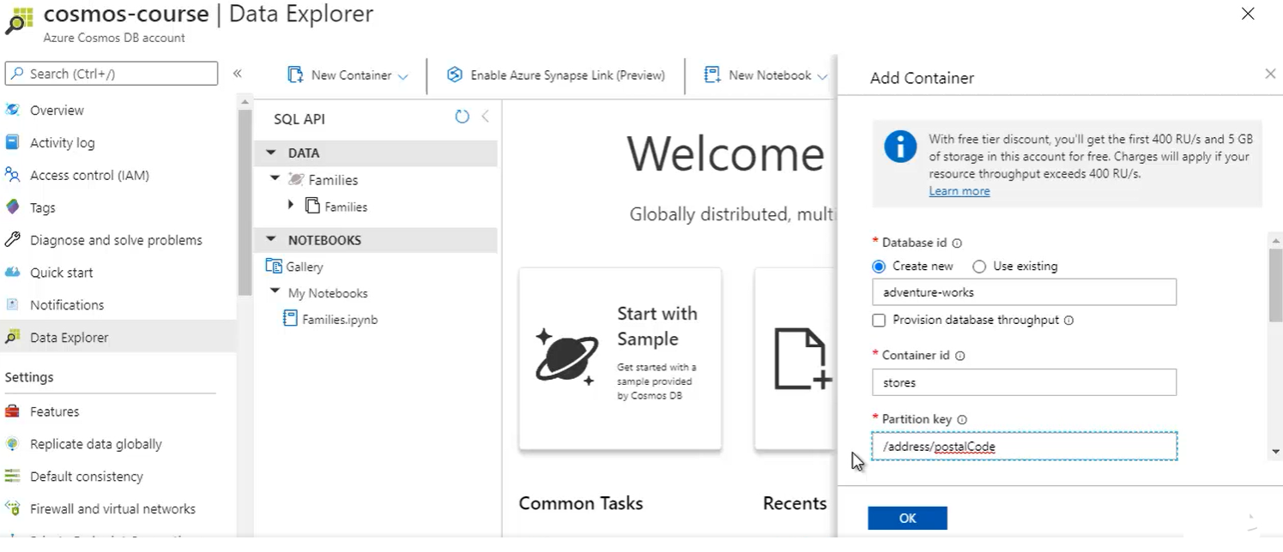

* Create ADF

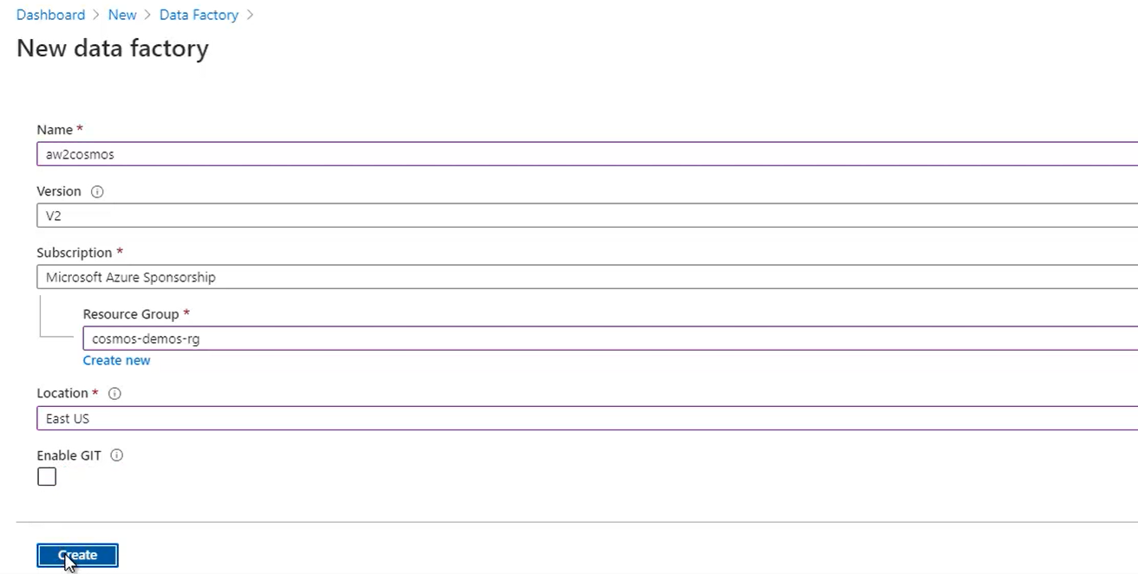

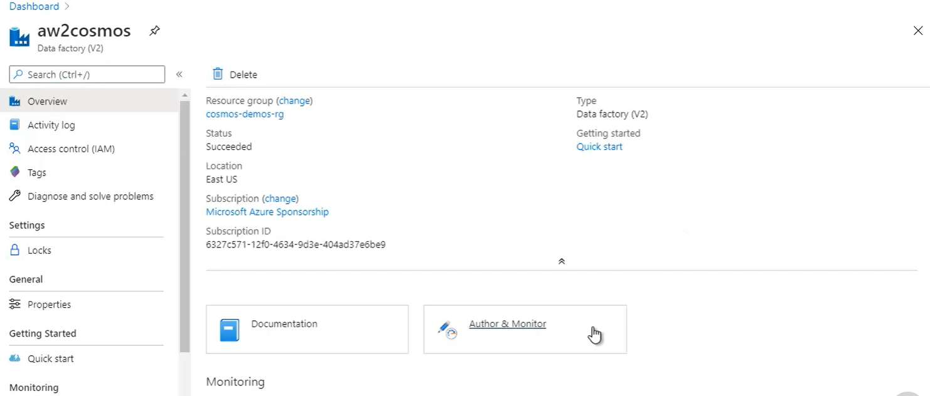

Goto ADF resource > author and monitor > autor >pipelines> new pipeline

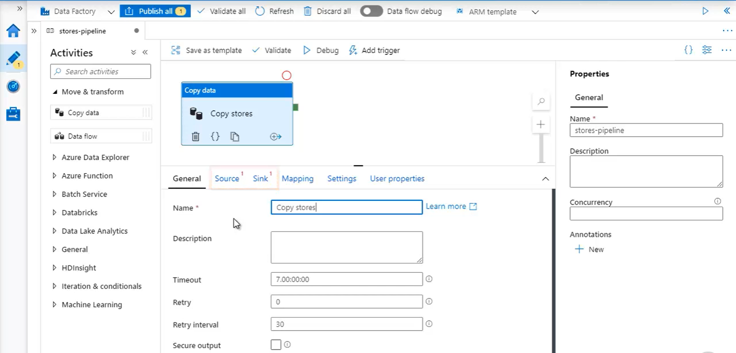

Now set source and sink

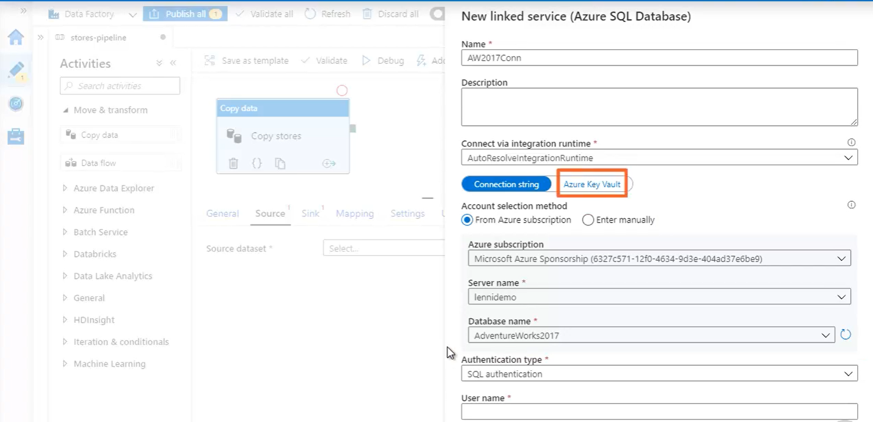

Above is source. Setup and create. Link to Azure SQL DB 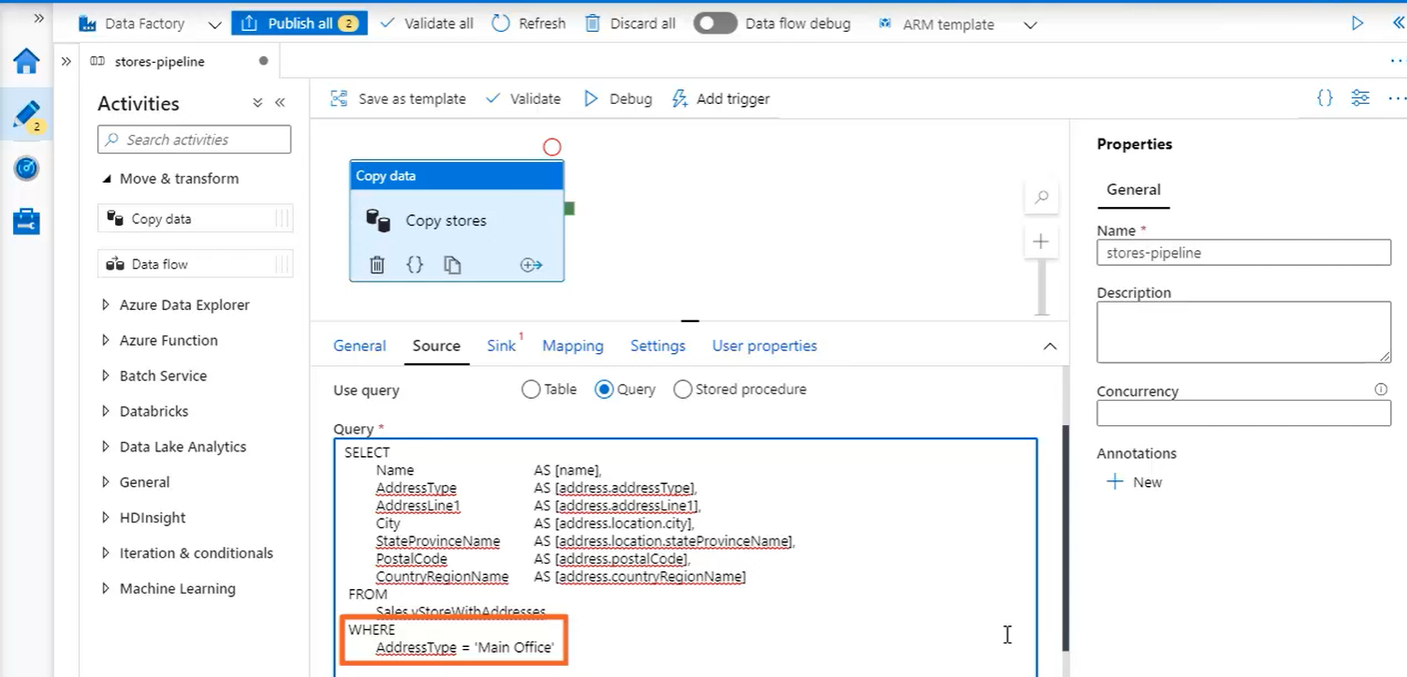

Above> query the data from source and preview

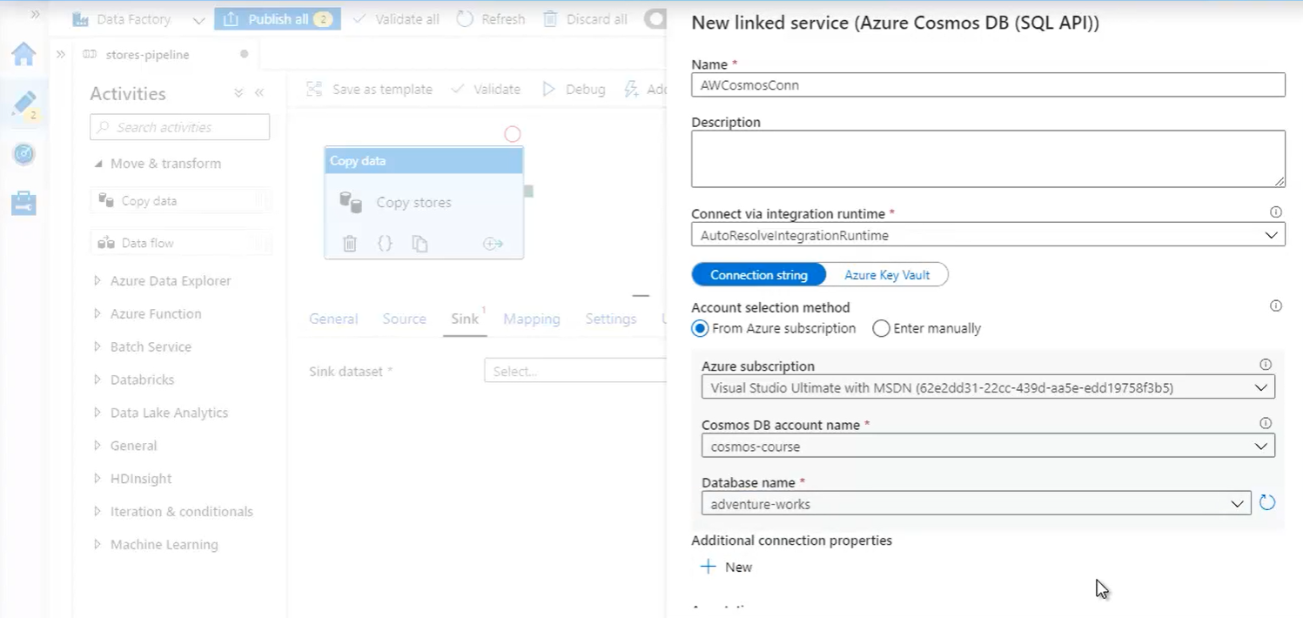

Sink data to cosmosDB SQL API.

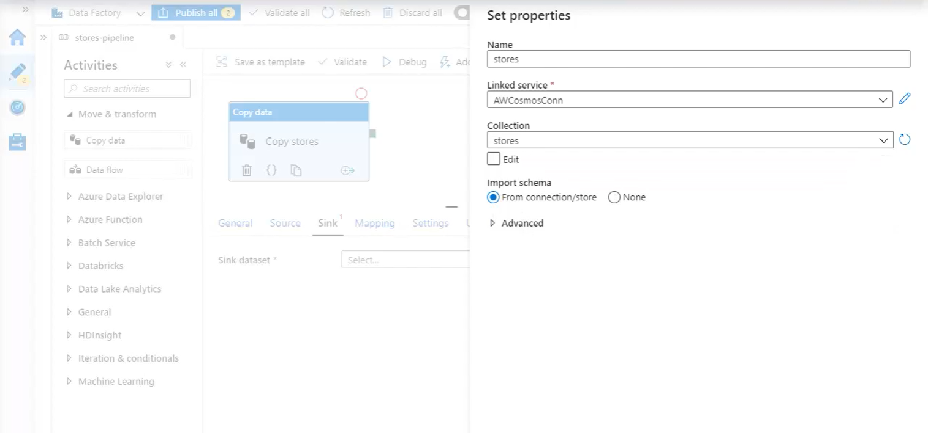

Click Publish All

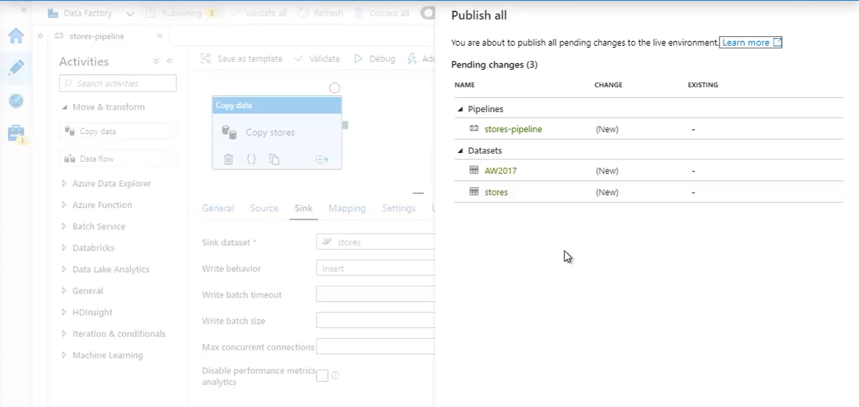

Click Add Trigger > Trigger Now

Now monitor

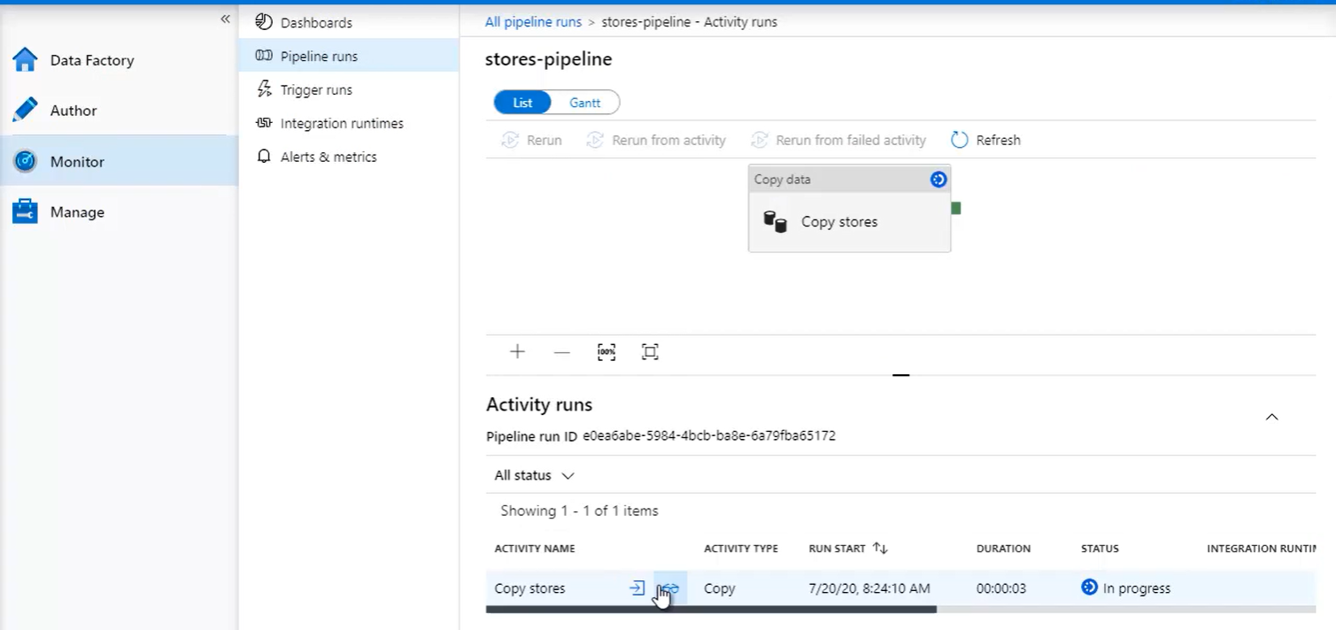

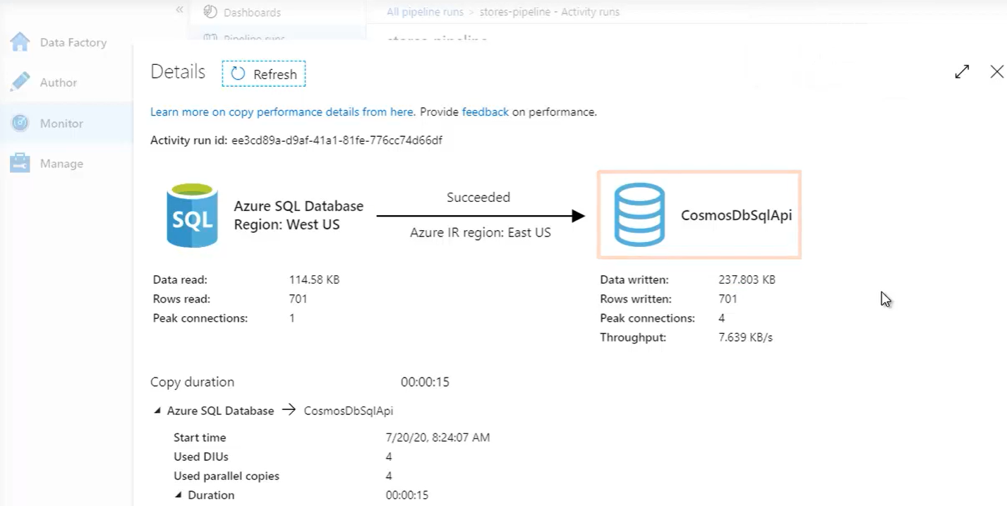

* Now Data Migrated to cosmos DB

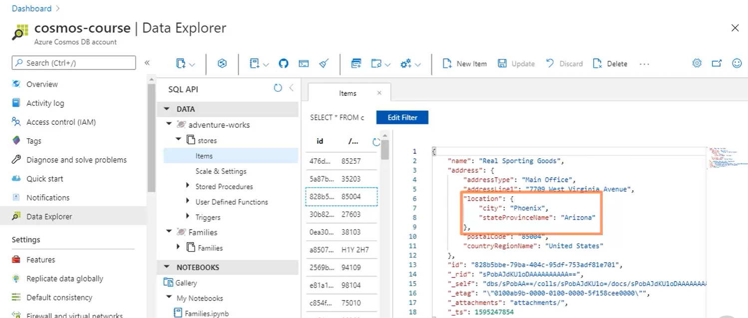

**Migration with denormalization:**

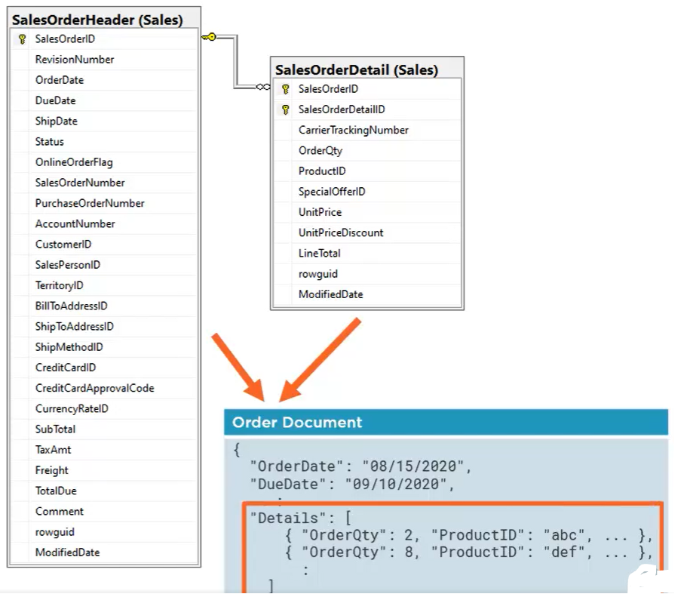

* Create new db and container in cosmos. Partion container with “costomerId” to be able to pull back multiple orders for the same customer using single partition query.

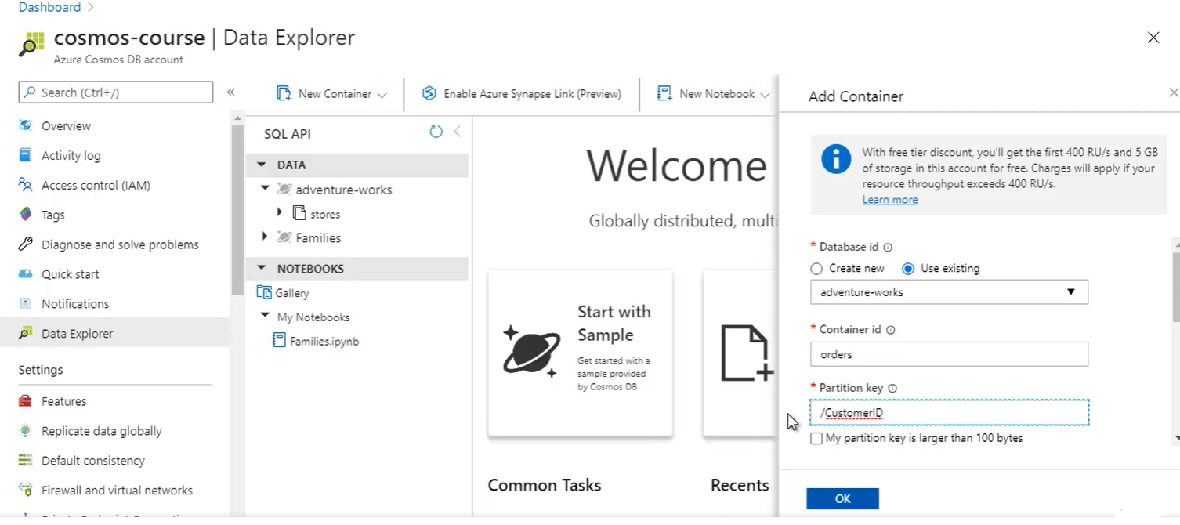

* Create orders-pipeline in ADF

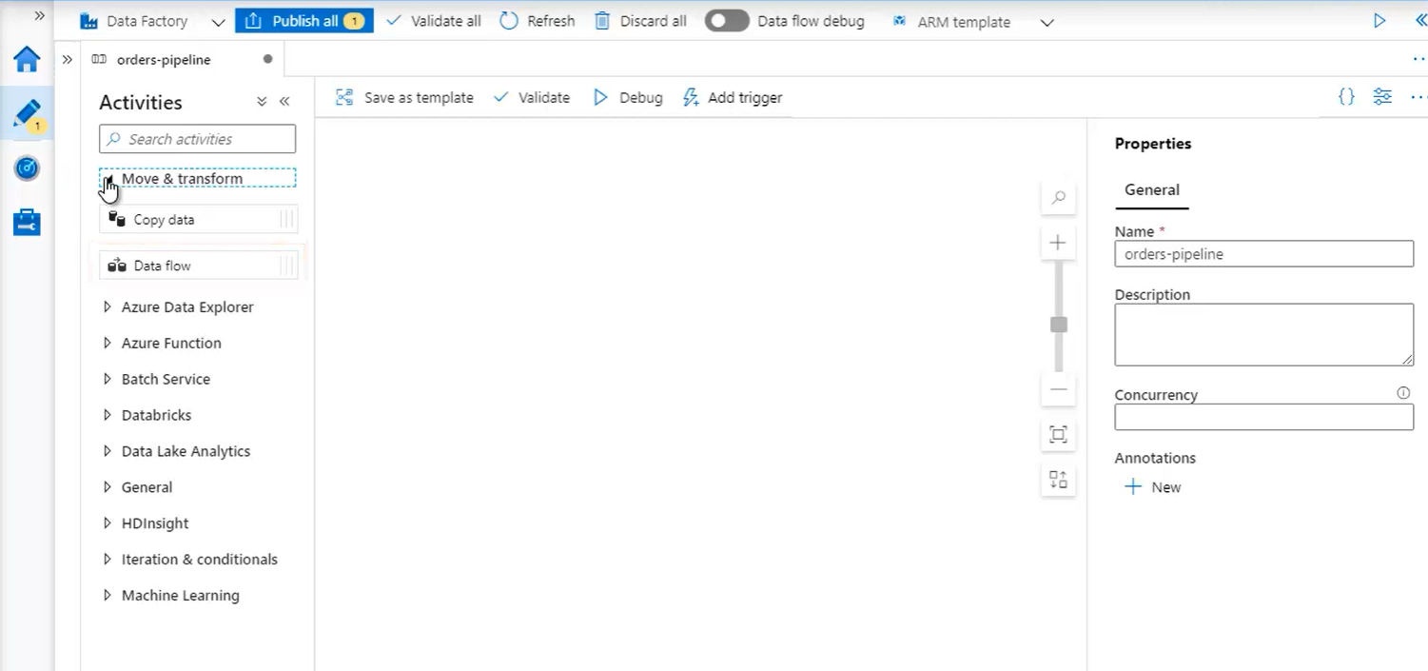

* Add data flow

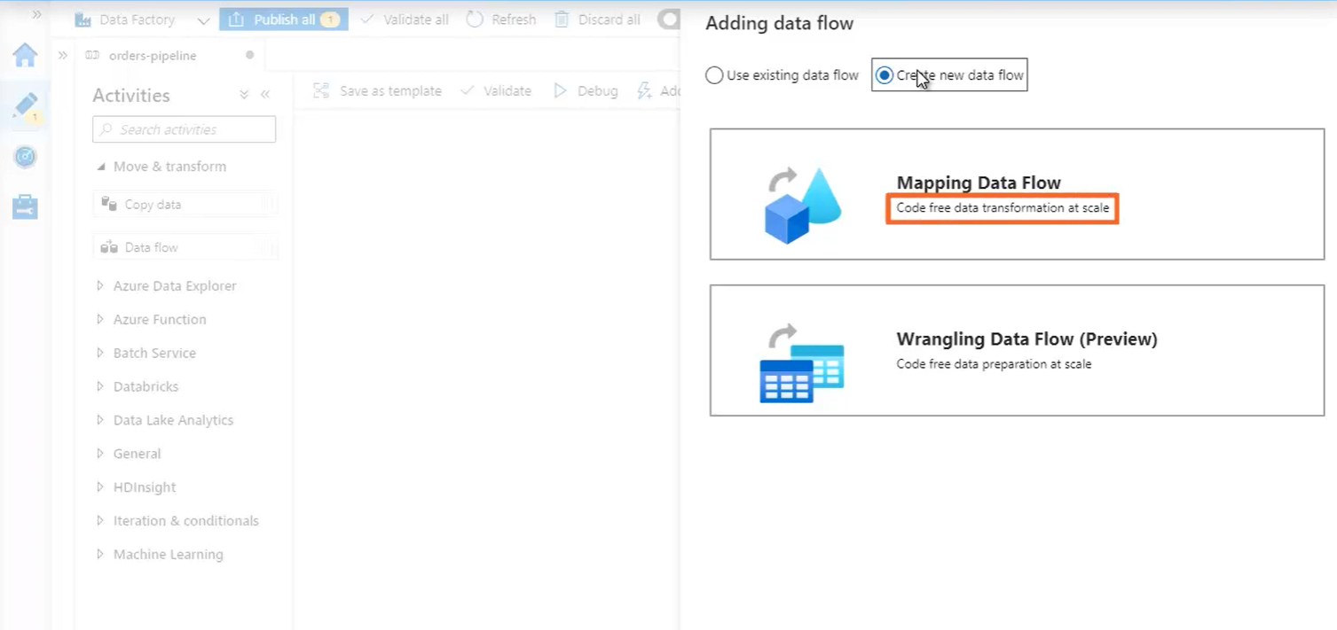

* Create OrderHeader Source from Azure SQL

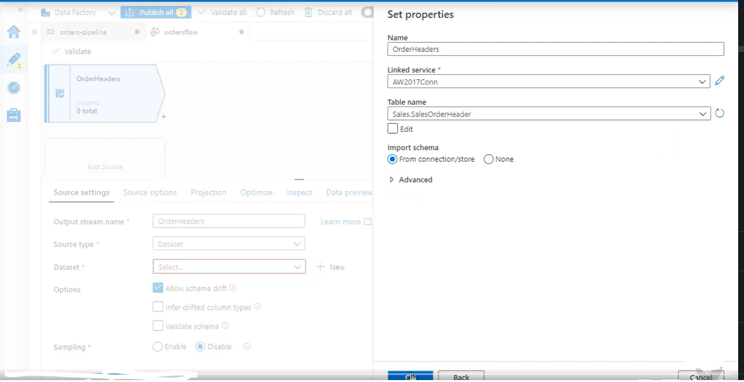

* Create OrderDetails Souce from Azure SQL

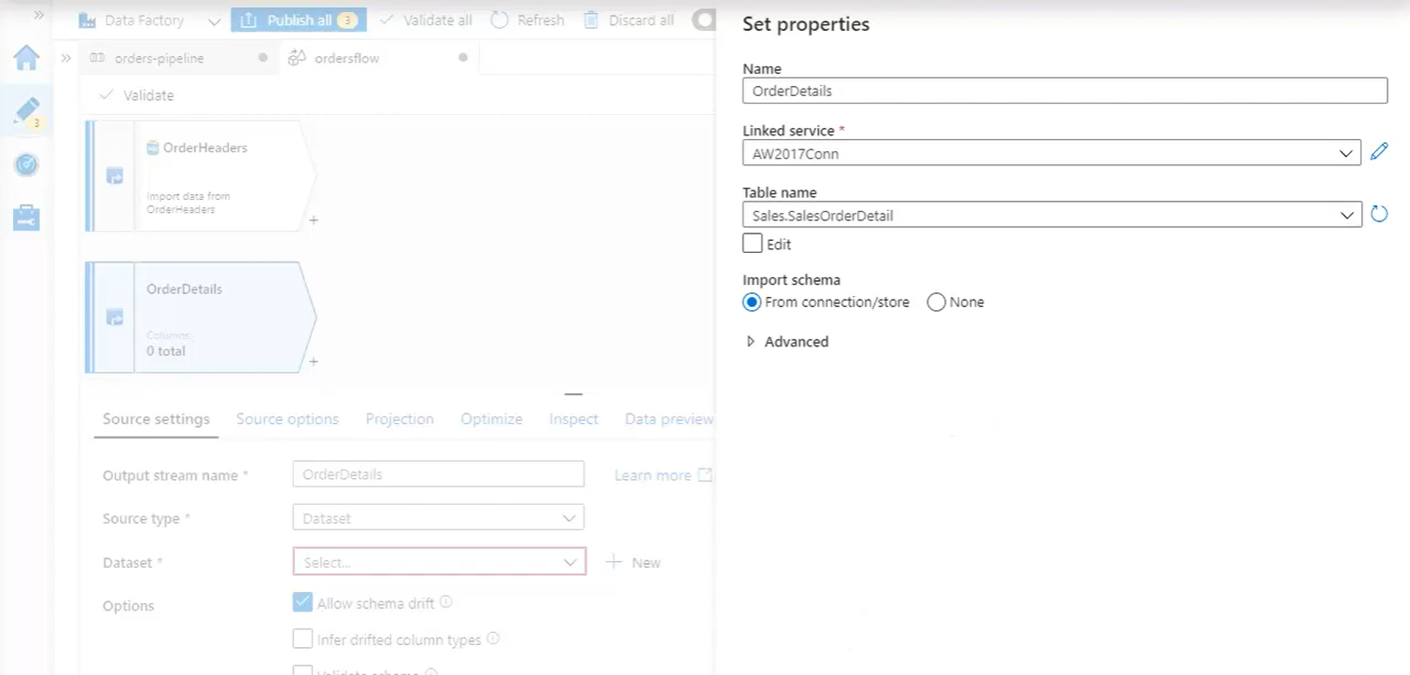

* Add Aggregate on order details

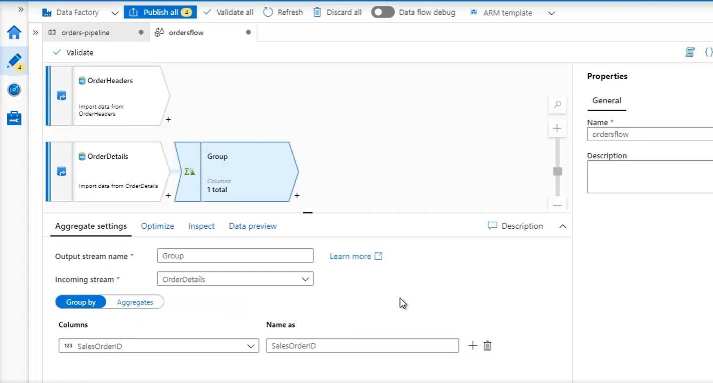

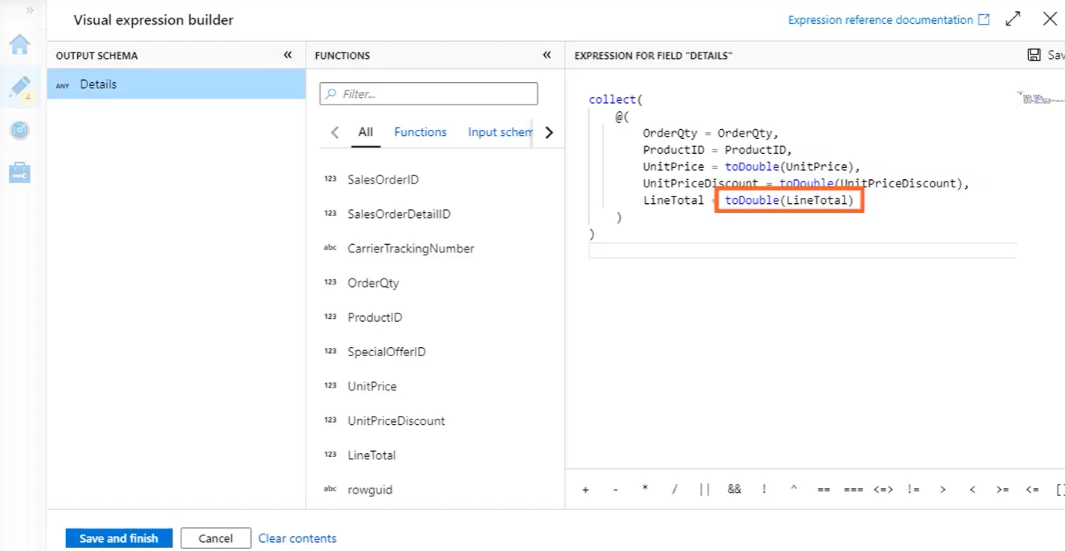

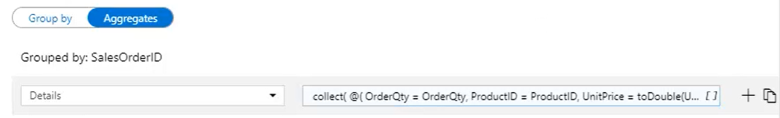

* Add Join to OrderHeaders

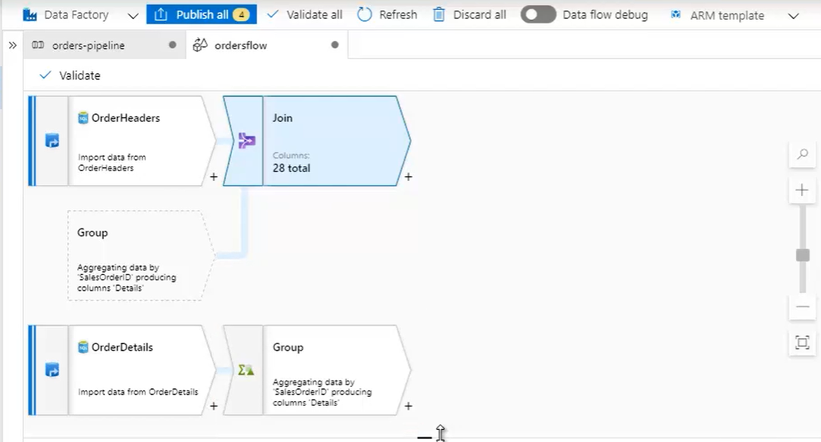

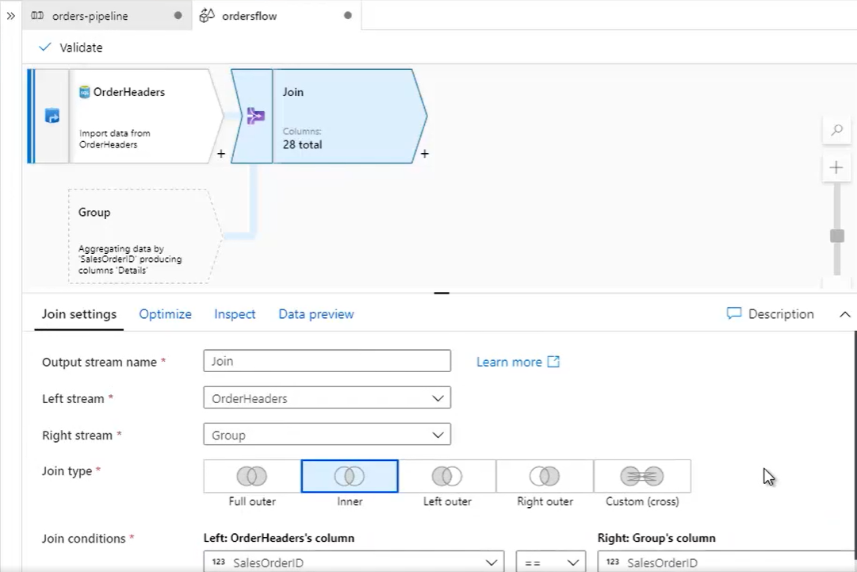

* Add derivedColumn to covert all header columns that use money data type in Sql server to double data type in cosmosDB

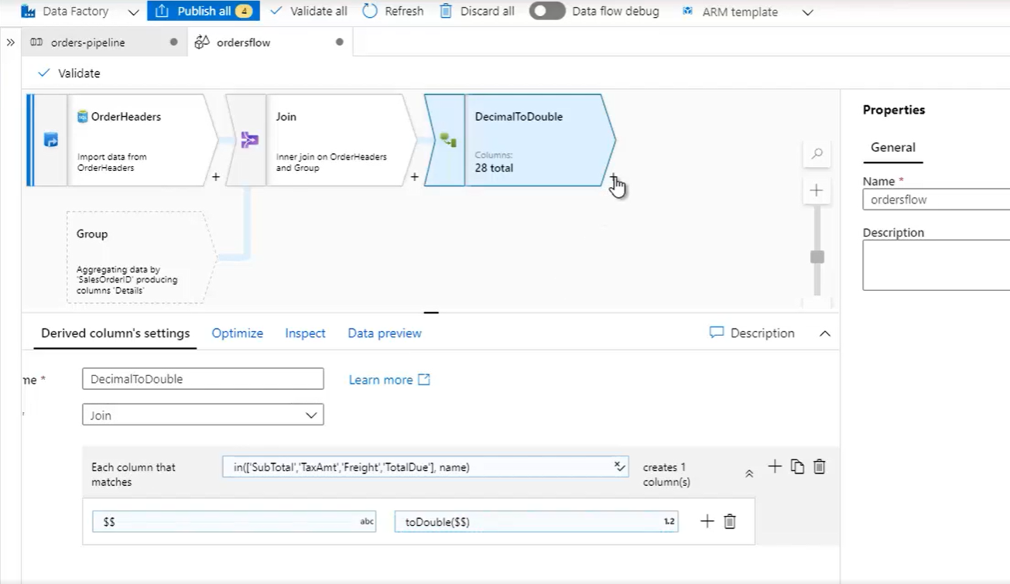

* Send this stream out to cosmosDB by clicking sink to Azure cosmosDB SQL api

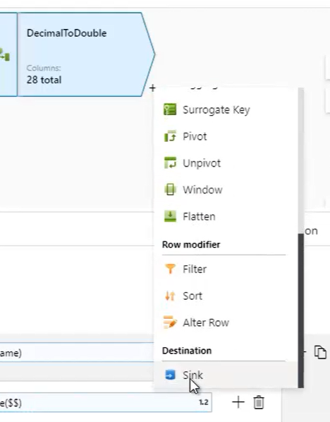

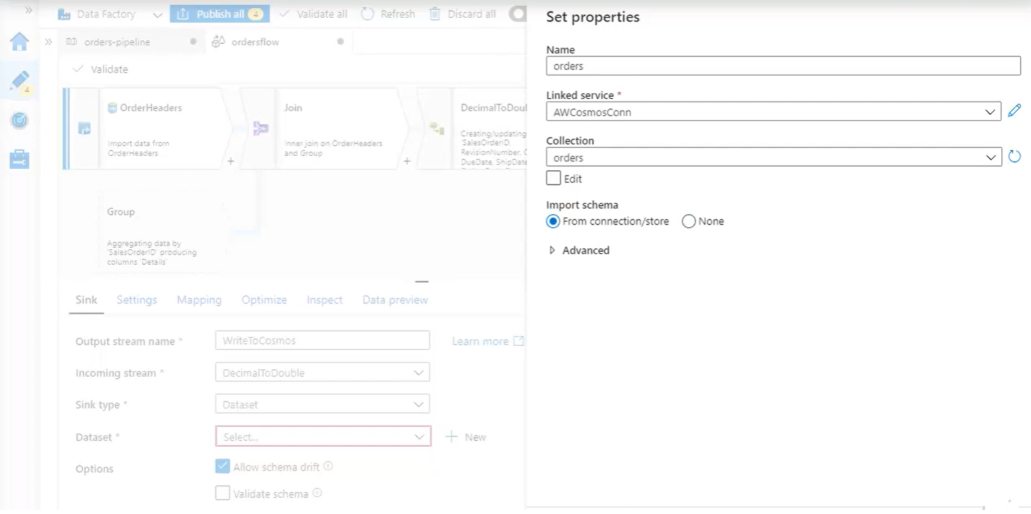

* Publish and trigger now

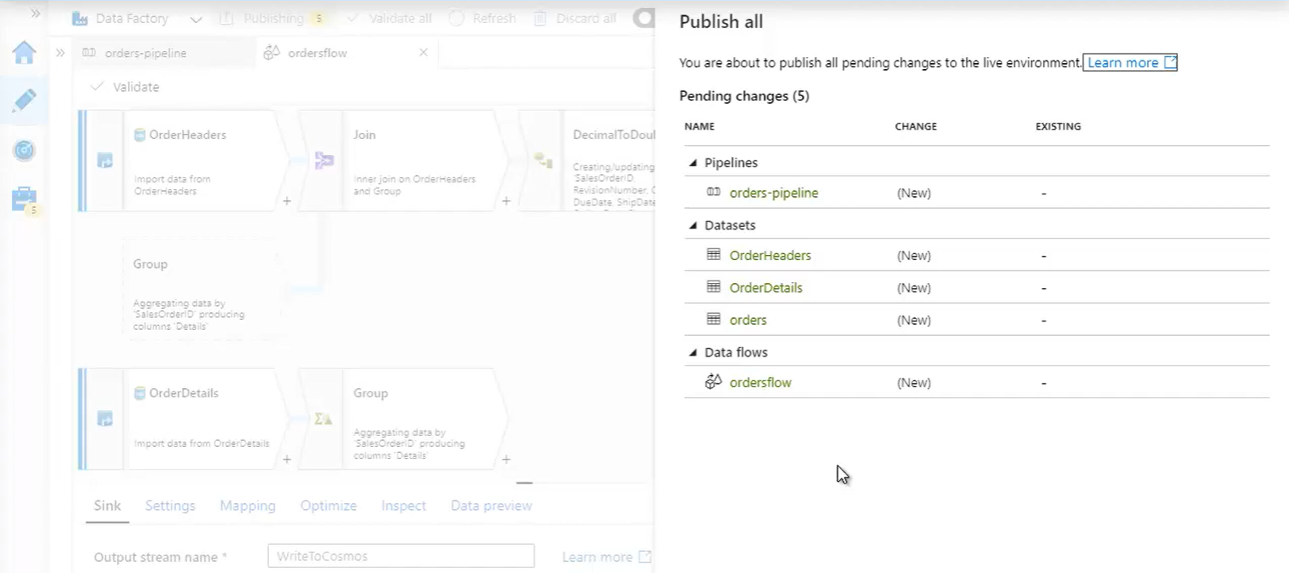

* Monitor

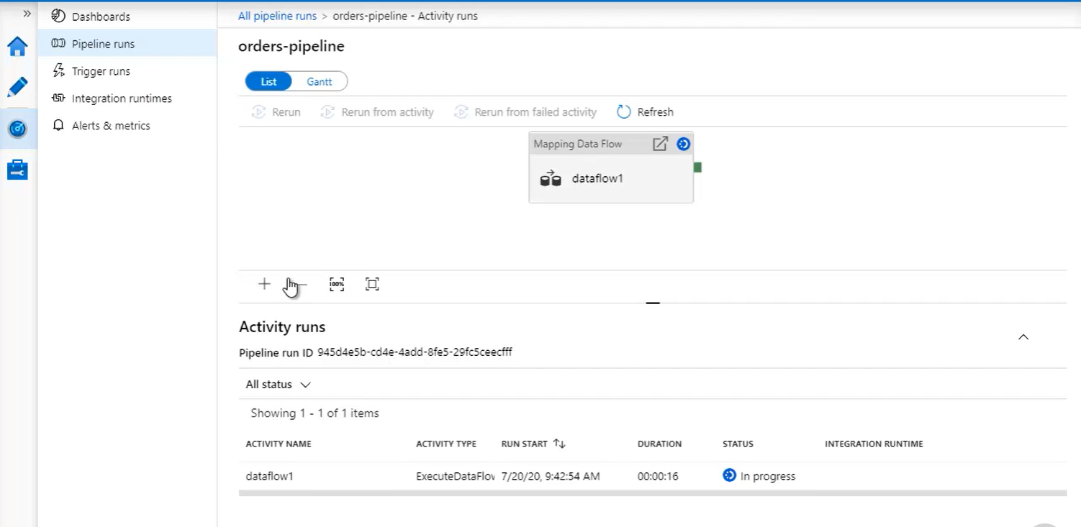

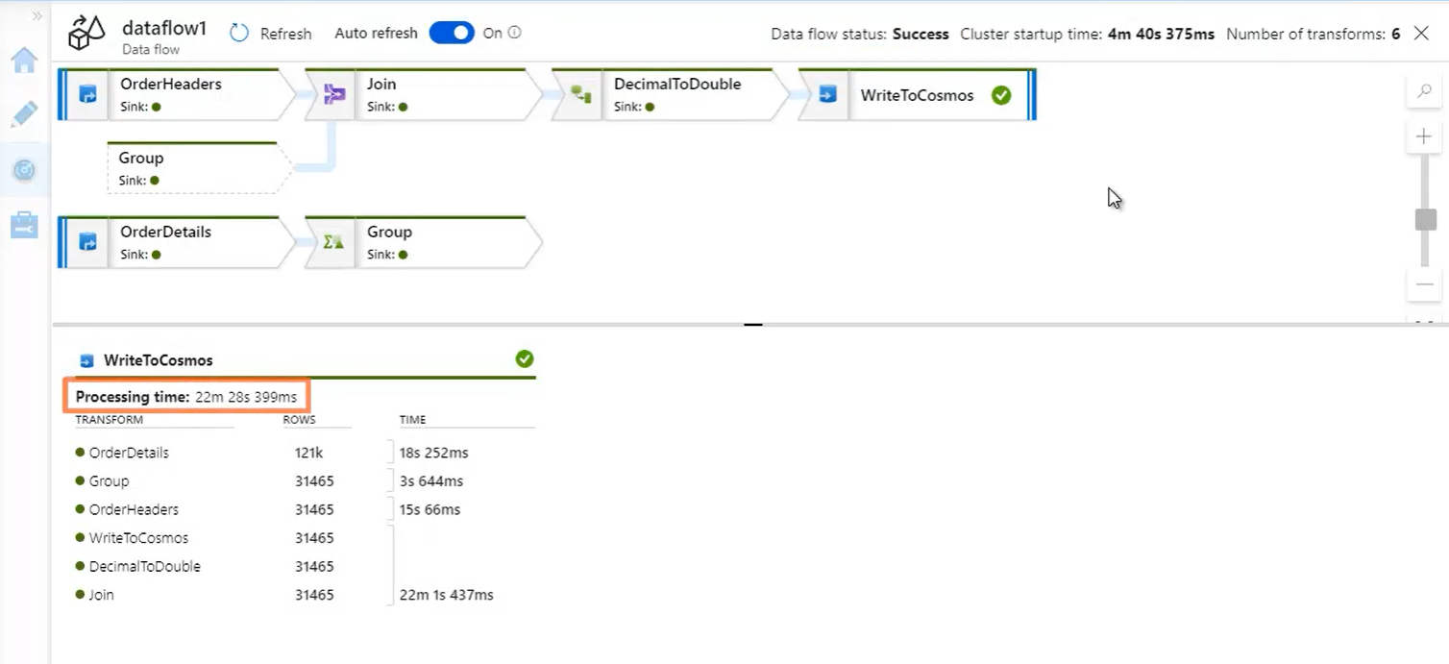

* Check documents

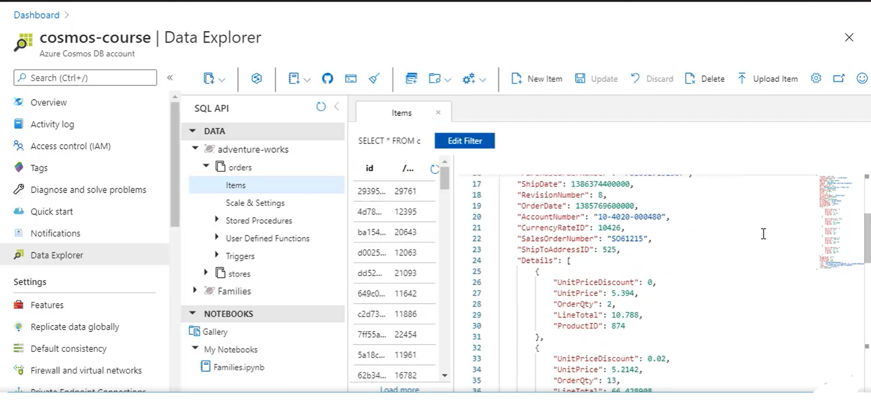

**Special Document Properties:**

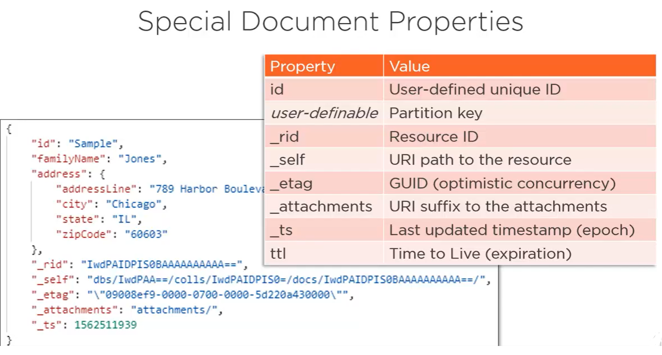

* **ID and partition key::** these two values combined are what makes every document unique across an entire container. The SQL API lets you choose any property for the partition key, and you can set any value you want for the document's ID. And then Cosmos DB attaches a few more properties to every document, which are these system properties that all start with an underscore.
* **_rid** : resource ID. So, just like the id property that we assign to every document, even if it's a GUID, Cosmos DB also assigns its own internal ID, and that's the resource ID. But unlike the id property, and actually like the partition key, this resource ID is immutable, and its value will never change when a document is replaced in the container.
* **_self :** self link. The self link represents the full path to the document expressed as these resource IDs. So the database and container each also have their own resource ID. And together with the document's resource ID they get strung together to form a self link. So, resource IDs and self links can help uniquely identify any resource in Cosmos DB. But in practice you'll rarely, if ever, use them. Instead, you'll almost always be reading individual documents by partition key and ID or retrieving multiple documents by running a SQL query.
* **_etag** : used internally by Cosmos DB for concurrency checks. The ETag is a binary value that always changes whenever the resource changes. And so Cosmos DB can tell when one user is going to override changes by another user by detecting a change in the ETag. And when this happens, the second user's update gets rejected, which protects against overriding the changes of the first user.
* _**attachments** : when you append it to the self link, points to the attachments for the document. Now, this refers to the native attachments feature that's been around in perpetual preview since the very beginning, and that's actually not recommended for use. So if you do have images or blobs that you need to associate with your documents in Cosmos DB you should save them elsewhere, like Azure Blob storage or OneDrive, and then store the path to those attachments as just another property in your document.
* **_ts** : time stamp. And it's expressed as an integer known as the epoch value. That's simply the number of seconds elapsed since January 1, 1970 where the timestamp always tells you when each document was created or last updated. This value gets converted into a standard .NET date/time data type when retrieving documents using the .NET SDK. so you'll probably never need to work directly with the raw epoch number.
* **ttl** : time to live. Notice no underscore in front because this really isn't a system property. Rather, this is a property that you can set with an expiration in seconds, after which Cosmos DB will automatically delete the document. Now for this to work, you first need to enable TTL at the container level. In Azure portal

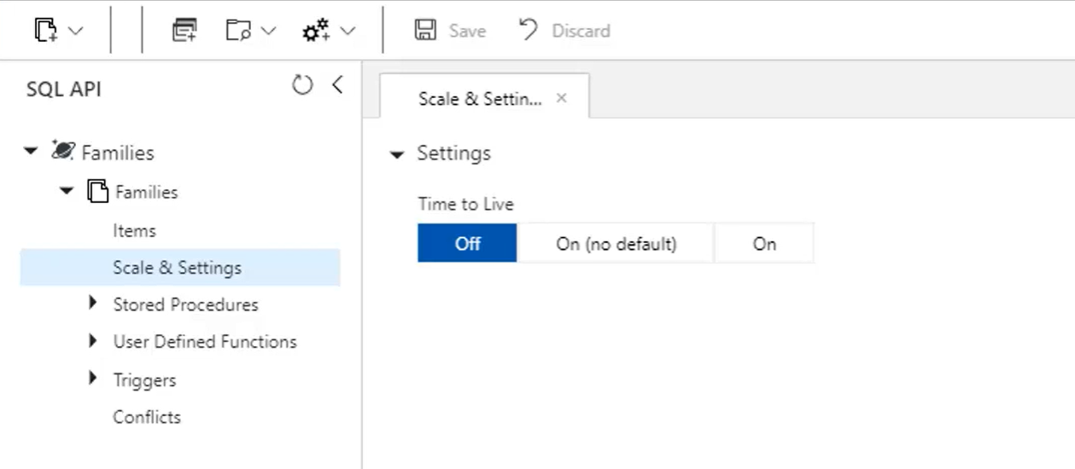

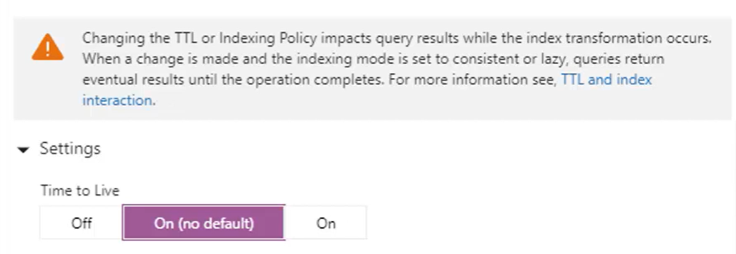

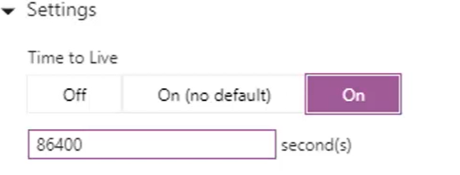

* + **Off**: (default) documents will never expire and a property named ttl in your document will have no special meaning.
  + **on (no default) :** If you turn it on, but with no default, then that means that TTL is enabled for the container. But documents won't expire unless you explicitly set the ttl property on them, which specifies the number of seconds before they get deleted automatically by Cosmos DB. This is a good setting if you generally want to retain documents in the container, but occasionally wish to expire some.
  + **On:** where you generally want to expire documents in the container but would occasionally like to override the expiration at the document level, then you can enable TTL on the container with the default. And here, every document written to the container expires in 24 hours, which is 86,400 seconds by default unless you override that with the ttl property at the document level. So now you can expire documents sooner or later than 24 hours by using a different ttl property value than you've set for the container default. Or you can set TTL to ‑1 on those documents that should never expire even though TTL is enabled by default at the container level.

**QUERYING WITH SQL** (refer files in Query with SQL)

**Rich Query with SQL API:**

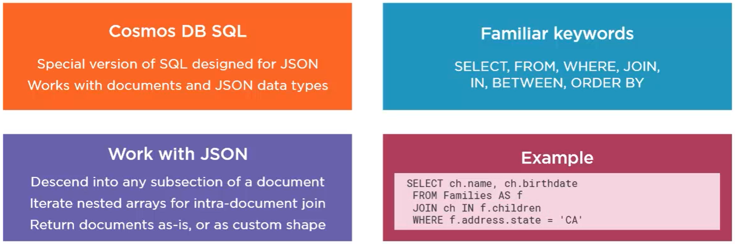

* SQL API uses a special version of Structured Query Language that lets you query JSON documents in a container.
  + This version of SQL has some unique syntax designed specifically for the non‑relational world of Cosmos DB. The language still reads as familiar SQL, but is all based on hierarchical JSON documents, not relational tables, and you work with JSON data types, not SQL data types. So familiar keywords like SELECT, FROM, WHERE, etc., but using JavaScript types and JavaScript expressions.
  + So how does SQL work in a world of JSON documents?
    - 1. you'll use dotted notation in your queries to navigate a path to any property, no matter how deeply nested it may be within the document.
    - While Cosmos DB doesn't support joins across documents, you can perform what's called an **intra‑document join**, so you can turn a single document that's got an array of four objects into four separate documents, kind of how an inner join in the relational world turns a single row on the left into as many rows as you join on the right, and your queries can return documents from the database as is, or you can project any custom JSON shape that you want based on as much or as little of the document data that you want.
    - Above example:its not ordinary SQL. It uses dotted notation to query the state property nested beneath the address property and we're performing an intra‑document join.

**SQL Operators and Functions:**

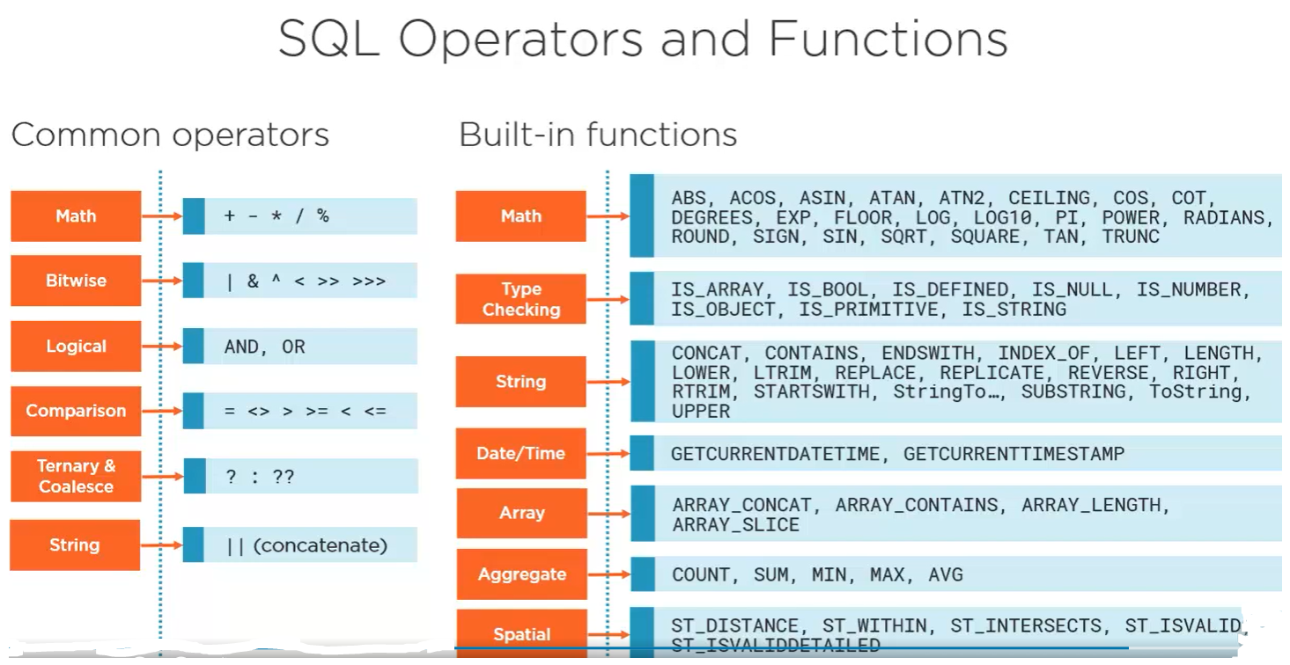

* arithmetic and bitwise operators
* and an or logic, equality and range comparisons, ternary and coalesce expressions, and string concatenation
* The query language also supports a host of common built‑in functions, including standard mathematical functions.
* You also have type checking functions that are extremely useful when you're working with varying schemas. These functions can test if a certain property exists, and if it does, whether it's a number, or a string, Boolean, or object, whatever.
* functions for parsing and manipulating strings and obtaining the current datetime.
* functions for working with arrays, letting you do things like concatenate arrays, extract arrays, and test to see if an array contains a particular element.
* aggregate functions for basic aggregations over your documents
* spatial functions that support distance and intersection queries over geocoded documents, that is, documents that includes spatial data in geo‑JSON format.

**Demo: Simple SQL Query:**

Families Container

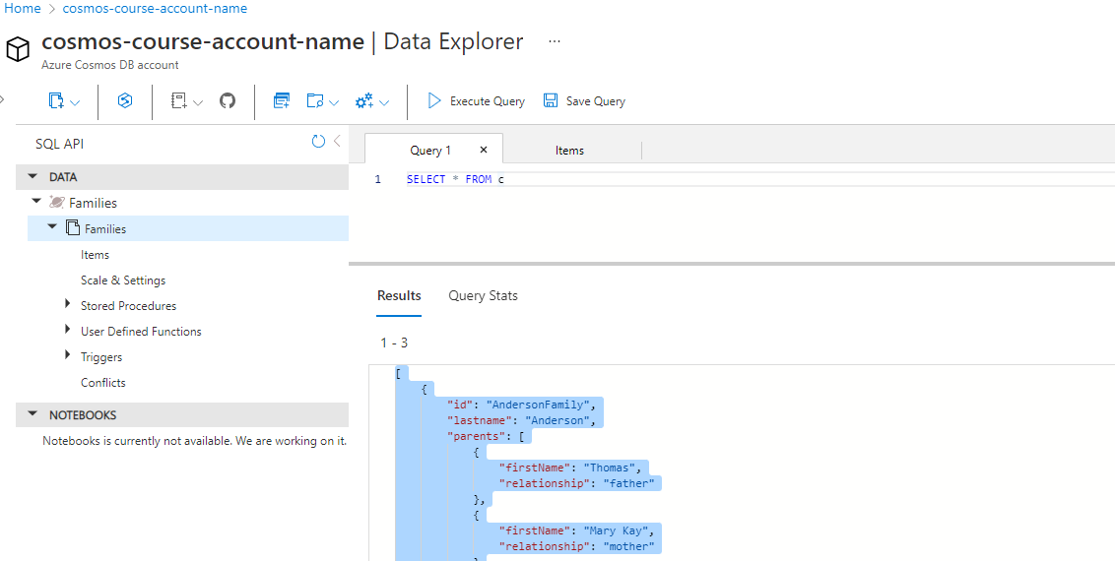

[

    {

        "id": "AndersonFamily",

        "lastname": "Anderson",

        "parents": [

            {

                "firstName": "Thomas",

                "relationship": "father"

            },

            {

                "firstName": "Mary Kay",

                "relationship": "mother"

            }

        ],

        "children": [

            {

                "firstName": "Henriette Thaulow",

                "gender": "female",

                "grade": 5,

                "pets": [

                    {

                        "givenName": "Fluffy",

                        "type": "Rabbit"

                    }

                ]

            }

        ],

        "location": {

            "state": "WA",

            "county": "King",

            "city": "Seattle"

        },

        "geo": {

            "type": "Point",

            "coordinates": [

                -122.3295,

                47.60357

            ]

        },

        "isRegistered": true,

        "_rid": "QyE1AJJEd90EAAAAAAAAAA==",

        "_self": "dbs/QyE1AA==/colls/QyE1AJJEd90=/docs/QyE1AJJEd90EAAAAAAAAAA==/",

        "_etag": "\"8600b351-0000-0100-0000-61d93e9a0000\"",

        "_attachments": "attachments/",

        "_ts": 1641627290

    },

    {

        "id": "SmithFamily",

        "parents": [

            {

                "familyName": "Smith",

                "givenName": "James"

            },

            {

                "familyName": "Curtis",

                "givenName": "Helen"

            }

        ],

        "children": [

            {

                "givenName": "Michelle",

                "gender": "female",

                "grade": 1

            },

            {

                "givenName": "John",

                "gender": "male",

                "grade": 7,

                "pets": [

                    {

                        "givenName": "Tweetie",

                        "type": "Bird"

                    }

                ]

            }

        ],

        "location": {

            "state": "WA",

            "county": "King",

            "city": "Forest Hills"

        },

        "geo": {

            "type": "Point",

            "coordinates": [

                -73.84791,

                40.72266

            ]

        },

        "isRegistered": true,

        "_rid": "QyE1AJJEd90FAAAAAAAAAA==",

        "_self": "dbs/QyE1AA==/colls/QyE1AJJEd90=/docs/QyE1AJJEd90FAAAAAAAAAA==/",

        "_etag": "\"8600b057-0000-0100-0000-61d93fd40000\"",

        "_attachments": "attachments/",

        "_ts": 1641627604

    },

    {

        "id": "WakefieldFamily",

        "parents": [

            {

                "familyName": "Wakefield",

                "givenName": "Robin"

            },

            {

                "familyName": "Miller",

                "givenName": "Ben"

            }

        ],

        "children": [

            {

                "familyName": "Merriam",

                "givenName": "Jesse",

                "gender": "female",

                "grade": 6

            },

            {

                "givenName": "John",

                "gender": "male",

                "grade": 7,

                "pets": [

                    {

                        "givenName": "Charlie Brown",

                        "type": "Dog"

                    },

                    {

                        "givenName": "Tiger",

                        "type": "Cat"

                    },

                    {

                        "givenName": "Princess",

                        "type": "Cat"

                    }

                ]

            },

            {

                "familyName": "Miller",

                "givenName": "Lisa",

                "gender": "female",

                "grade": 3,

                "pets": [

                    {

                        "givenName": "Jake",

                        "type": "Snake"

                    }

                ]

            }

        ],

        "location": {

            "state": "NY",

            "county": "Manhattan",

            "city": "NY"

        },

        "geo": {

            "type": "Point",

            "coordinates": [

                -73.992,

                40.731

            ]

        },

        "isRegistered": false,

        "_rid": "QyE1AJJEd90GAAAAAAAAAA==",

        "_self": "dbs/QyE1AA==/colls/QyE1AJJEd90=/docs/QyE1AJJEd90GAAAAAAAAAA==/",

        "_etag": "\"8600655d-0000-0100-0000-61d941050000\"",

        "_attachments": "attachments/",

        "_ts": 1641627909

    }

]

SELECT * FROM c returns 3 documents in an array

* these are same type of documents (family) but they have slight difference in schema . ie, AndersenFamily has a lastName property and objects in the children array have got a property called firstName. the second document is for the SmithFamily, and notice it's missing that lastName property, and it uses givenName in the children array rather than firstName; and here's our third document for the WakefieldFamily, which has the same schema as the second document.
* Although it is simple query it's still quite different than the equivalent query in a relational database.
  + **SELECT \*** :: In relational databases, SELECT * means return all columns, and for a number of reasons, SELECT * is generally considered bad practice in the relational world, where it's always preferred to explicitly list the columns that you want returned rather than using the * symbol. But here things work differently. In Cosmos DB SQL, SELECT * *means that you want each document in your result to be returned exactly as it's stored in the database.* Unlike relational databases, using SELECT * is not at all discouraged with Cosmos DB, in fact, that's the only way you can retrieve documents as they're shaped in the database. Because some family documents have a slightly different schema than others, using SELECT * returns those different schemas in the result set. But when you select specific properties instead of simply issuing a SELECT *, then you're projecting a new shape that you want for each document in the results, and this will define a consistent schema for every document returned by the query that could, as you'll see, resolve the difference between child objects that have a firstName property versus those with a givenName property.
  + **FROM clause ::** Queries always run within the context of a specific container, like the way we opened this query window attached to the Families container. So the container is always known from outside the query, and you certainly can't join documents in the container or across other containers, and so that can make you wonder why you even need a FROM clause at all in your query. Well, the fact is that you don't, although if you don't include it, then you won't be querying documents in the container. Instead, you'll just be querying with expressions that return scalar values, these are called **scalar expression queries**,
* Run queries in notebook using SQL magic

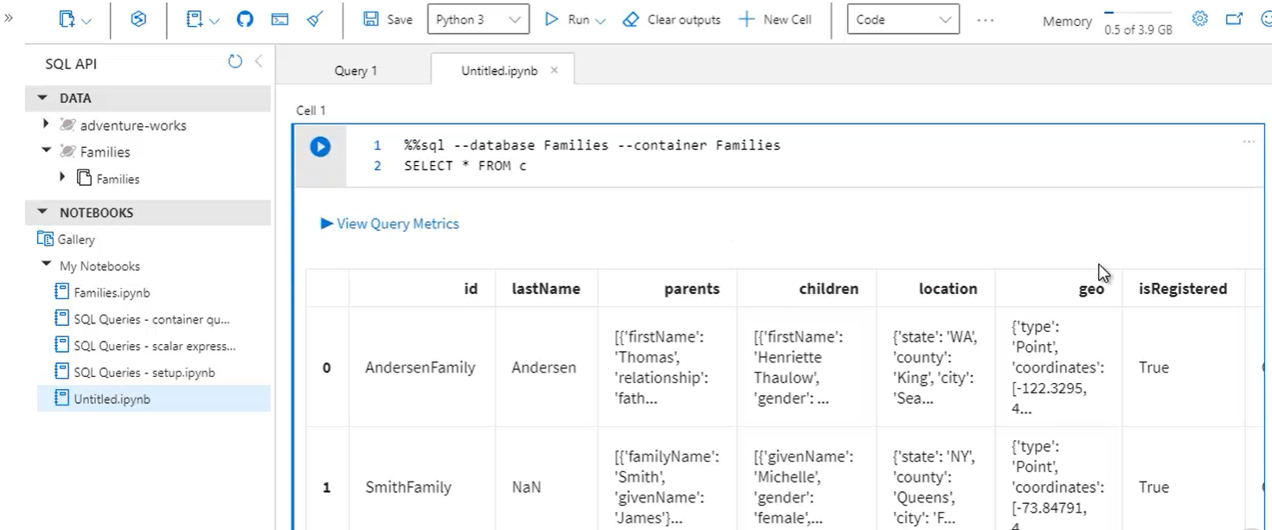

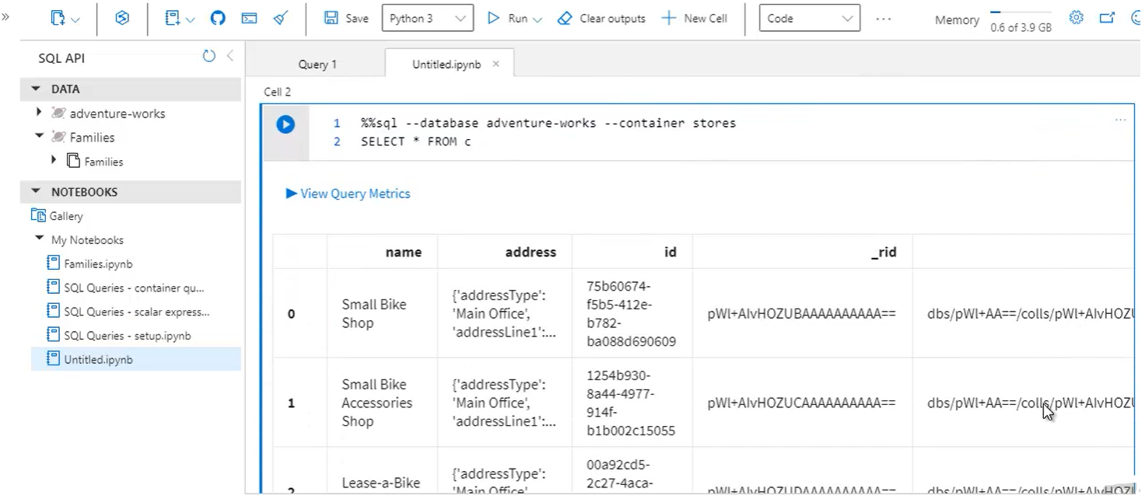 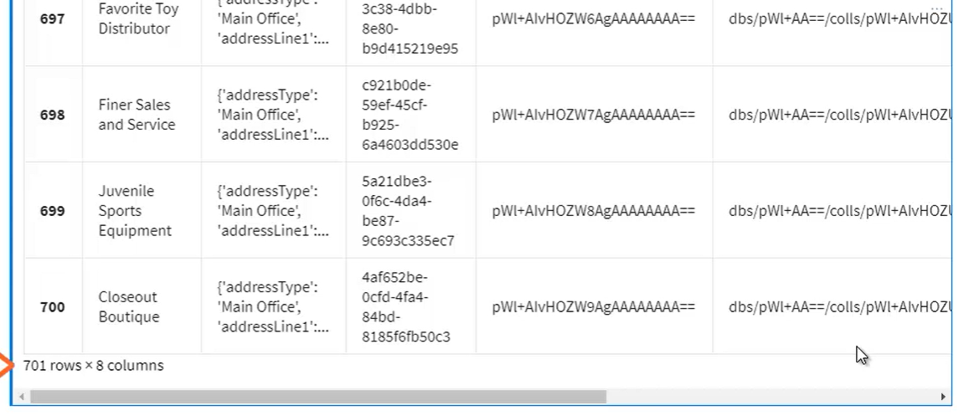

* To see only raw Json (run python code)

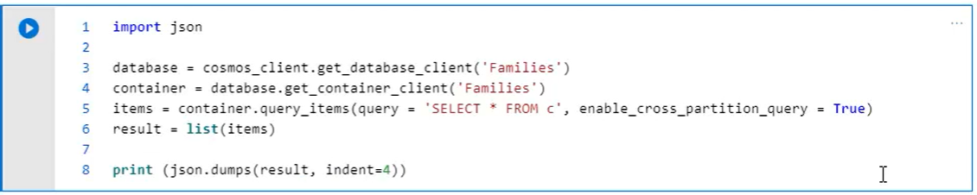

**Demo- Scalar Expression Queries:**

* Setup notebook > SQL Queries -setup.ipynb

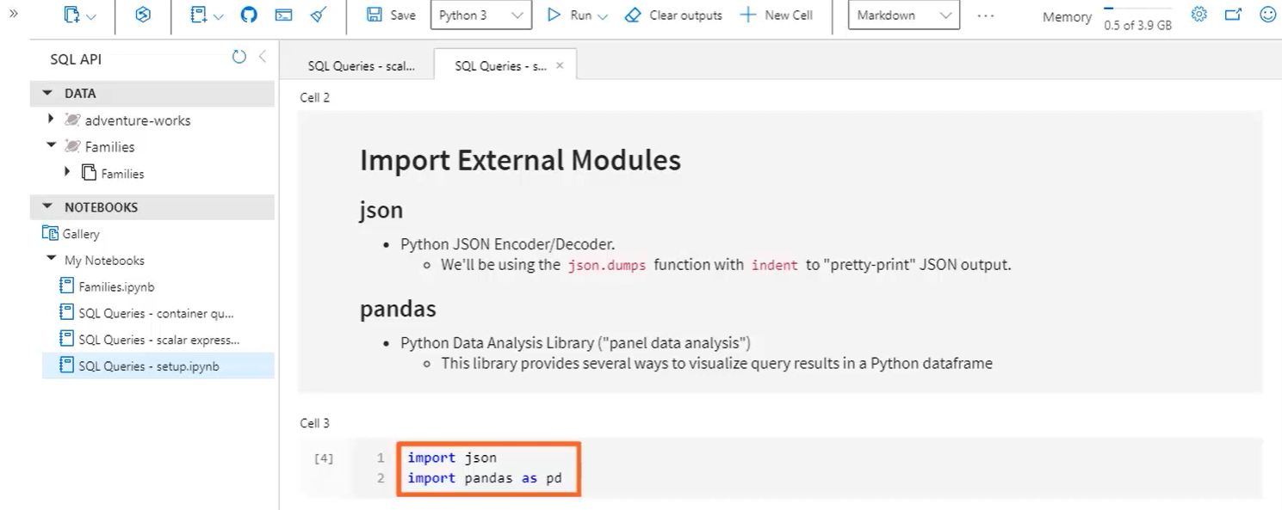

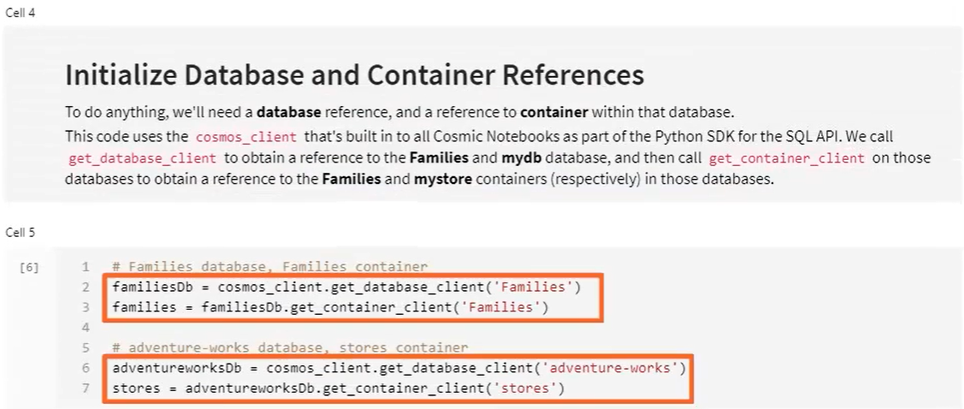

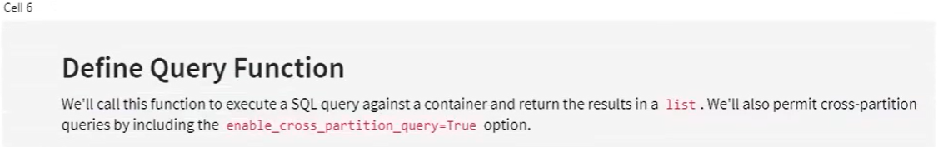

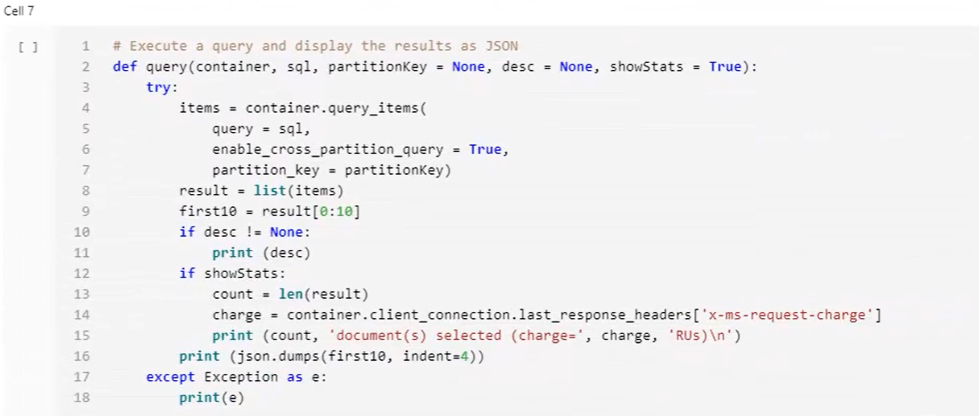

* Scalar Expressions notebook > SQL Queries -scalar expression.ipynb

Run setup nobook inside this to get access to ‘query’ function.

Scalar Expressions have no FROM clause.

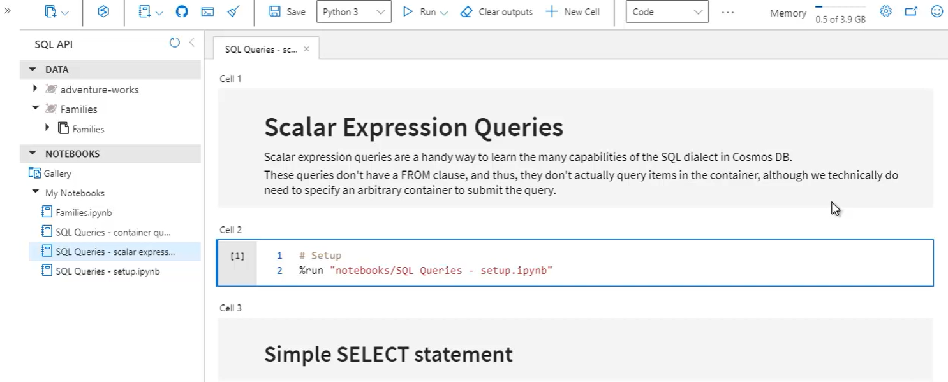

* Query results are always contained in square brackets [], because they returned as JSON array, even if results only return a single document

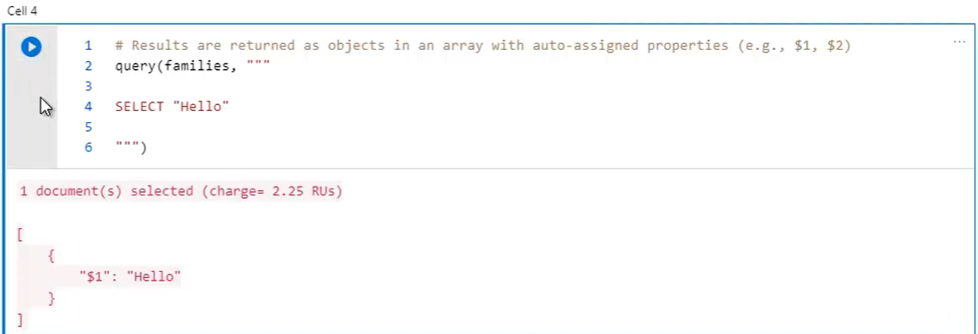

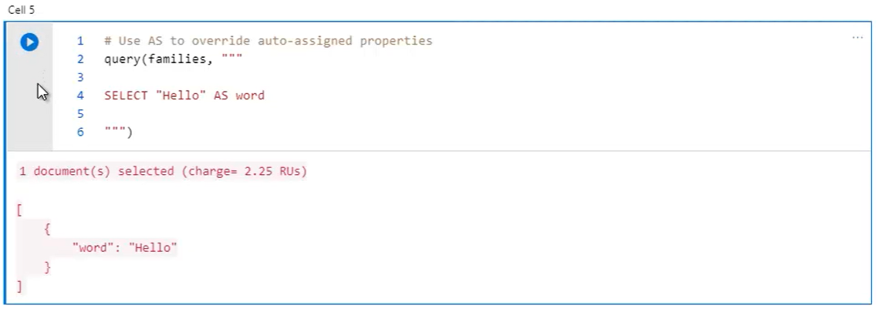

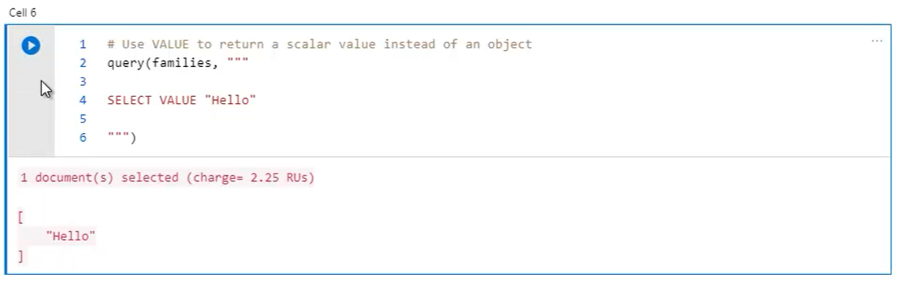

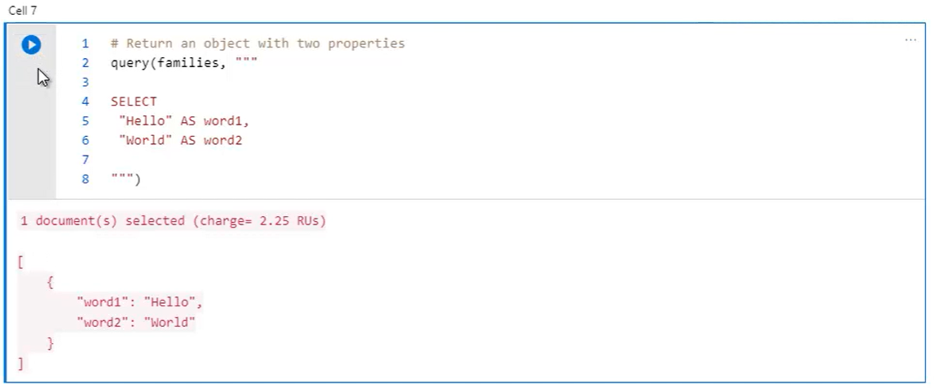

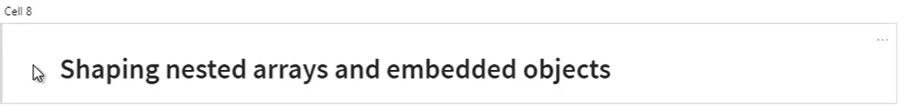

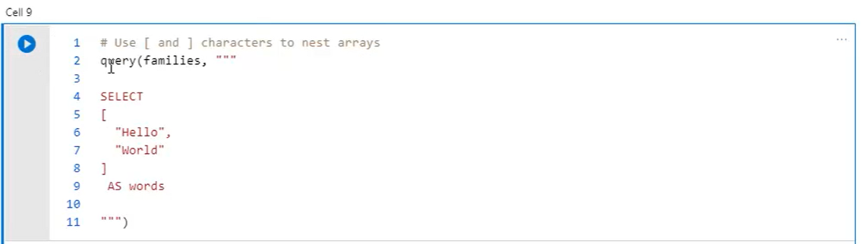 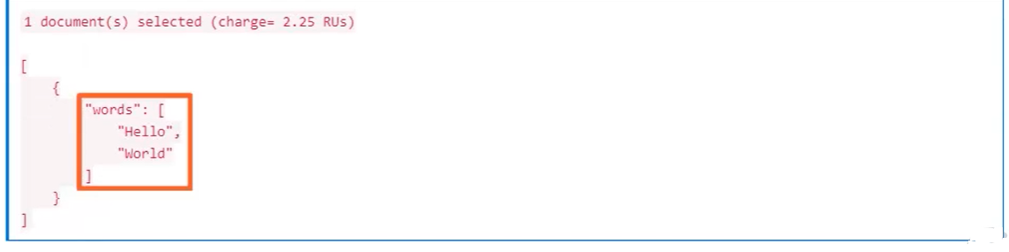

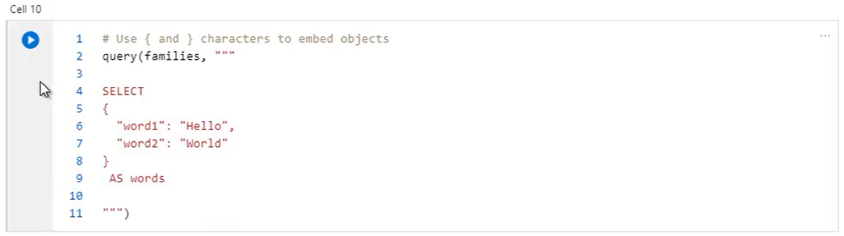 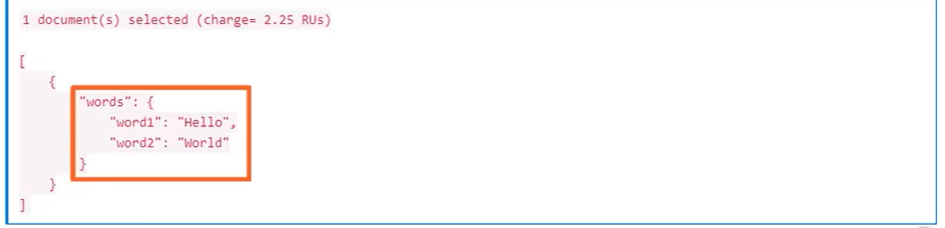 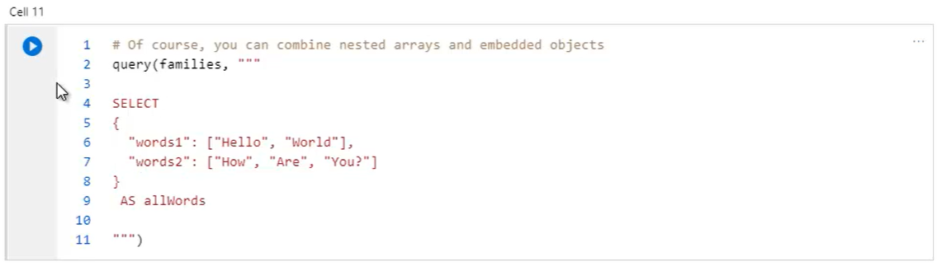 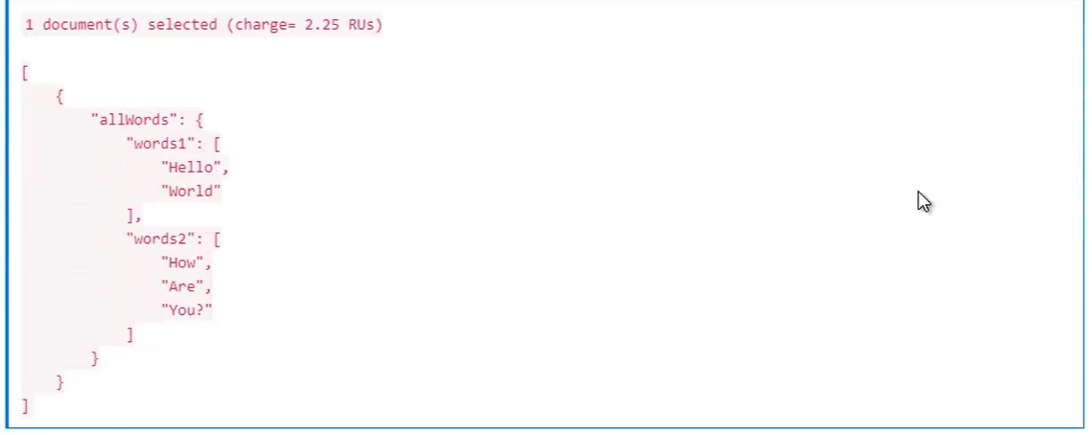

**Demo-Query Operators and Built-in Functions:**

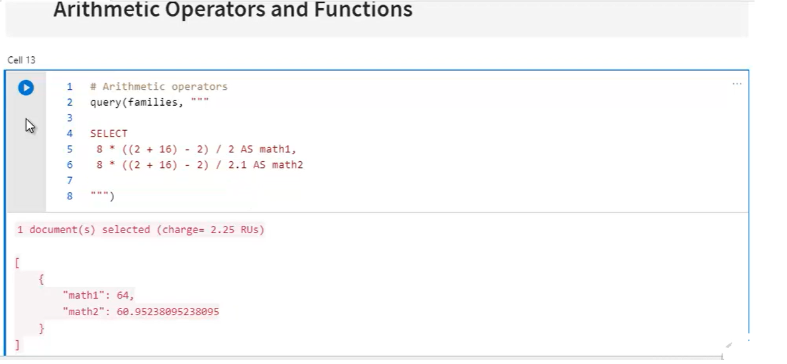 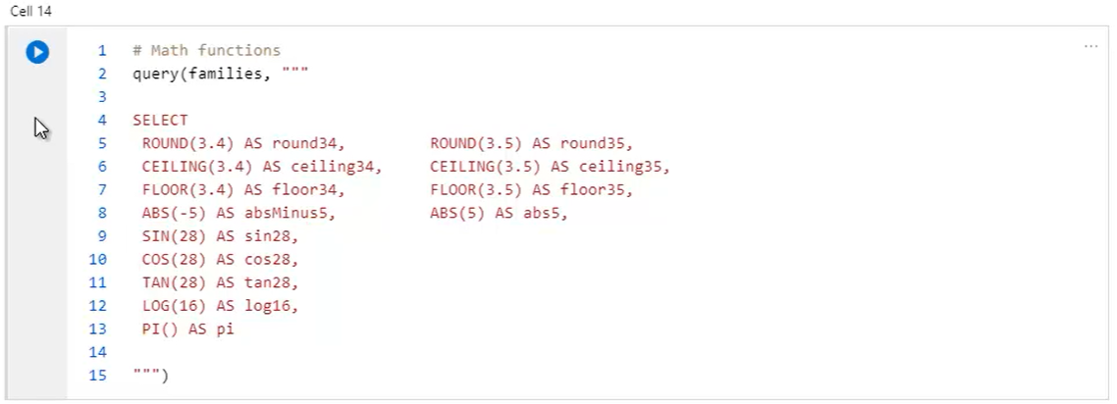 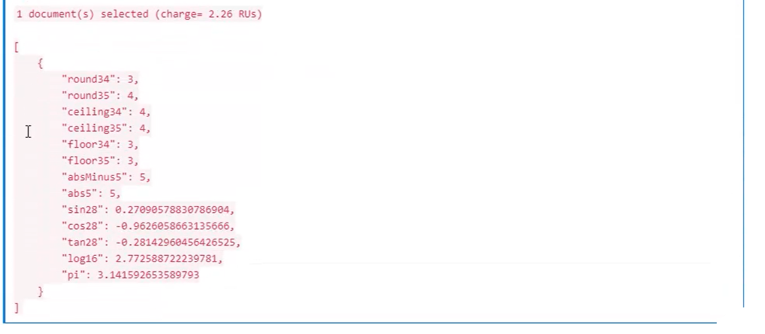 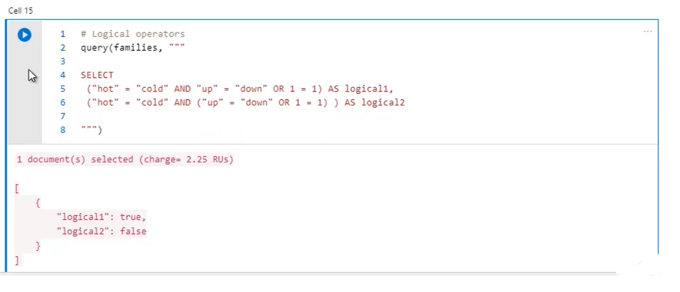 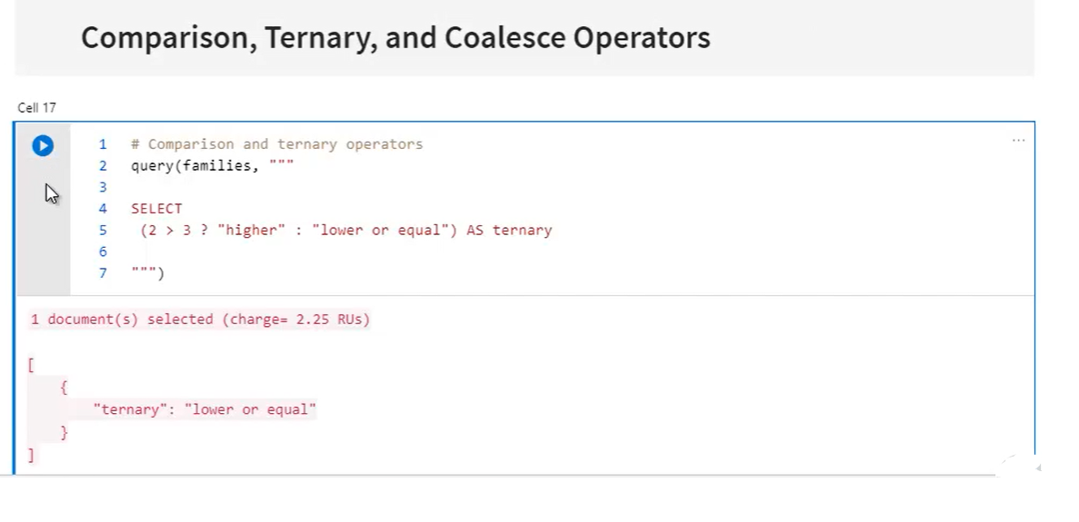

* Coaleasce can be used to detect if specific property exists. If property does’t exists are treated as undefined

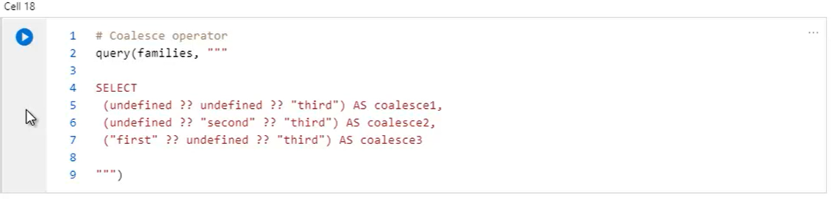 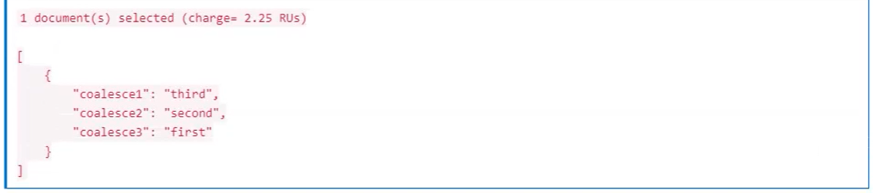 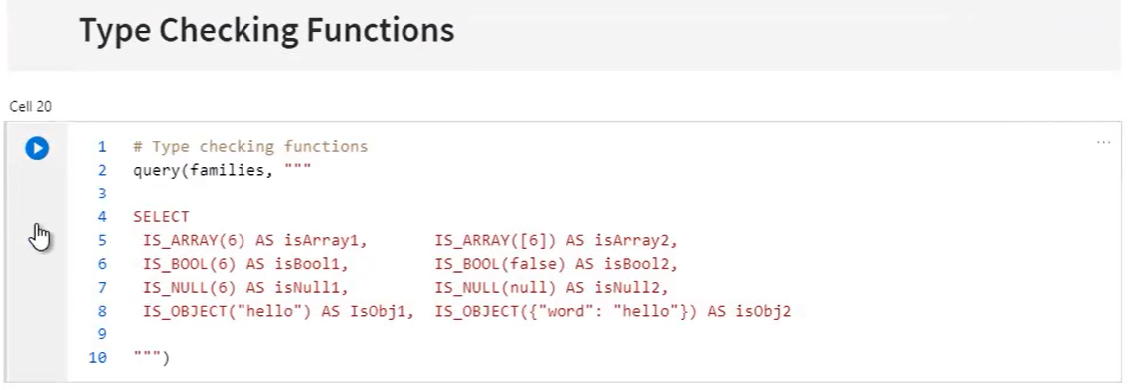 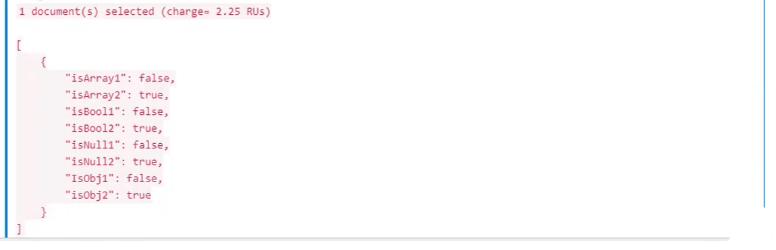 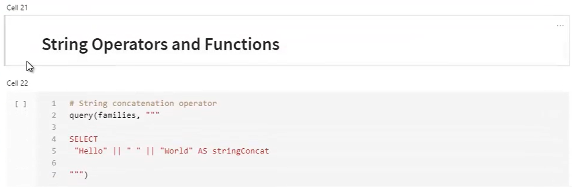 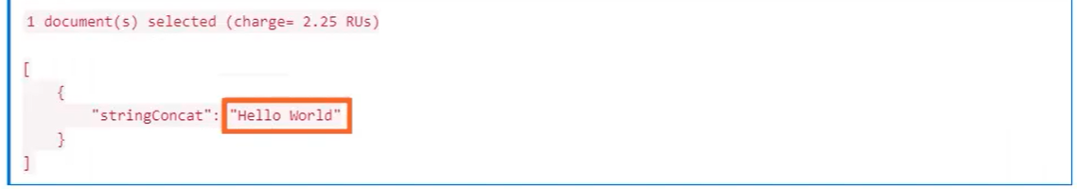 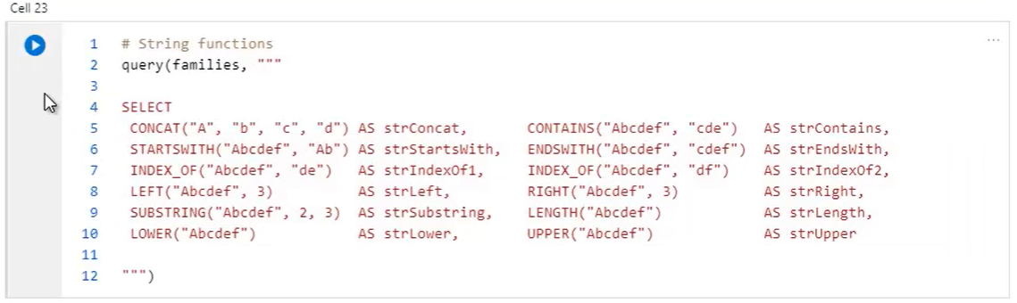 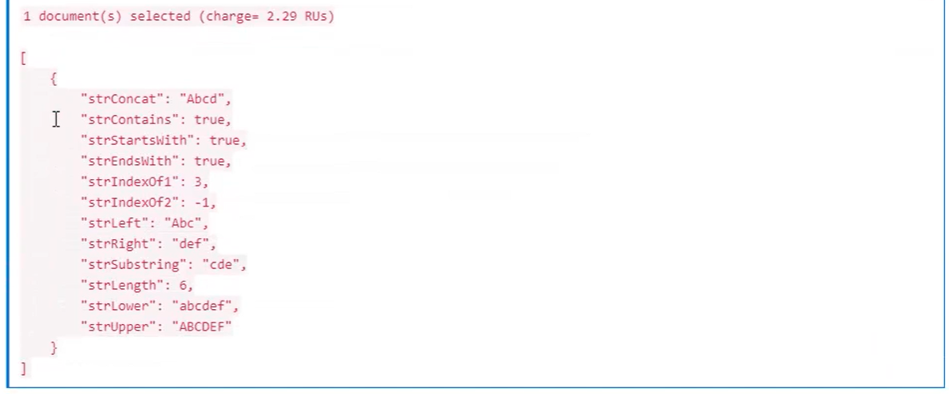 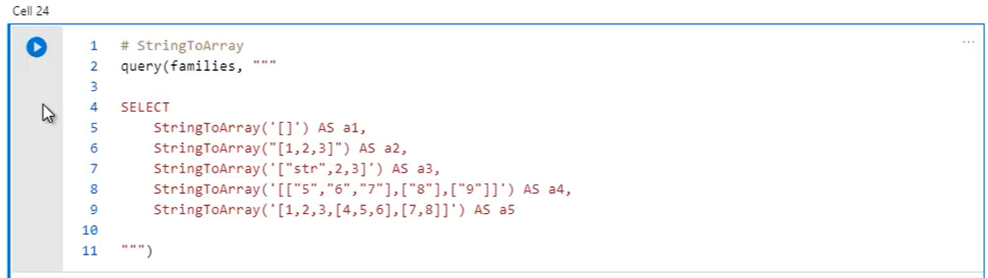 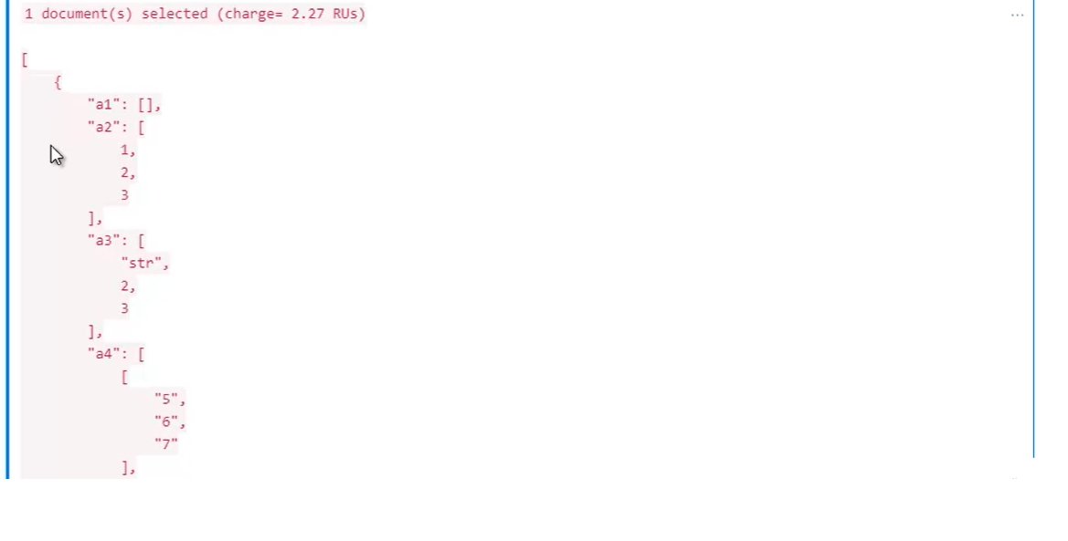 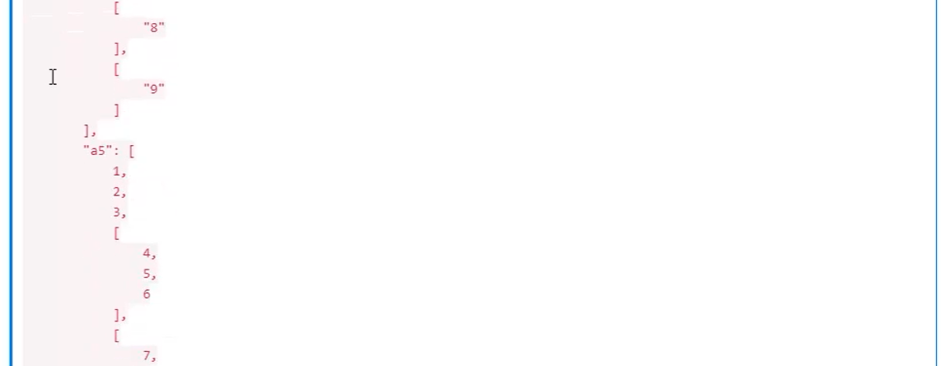 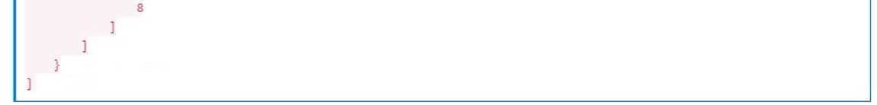 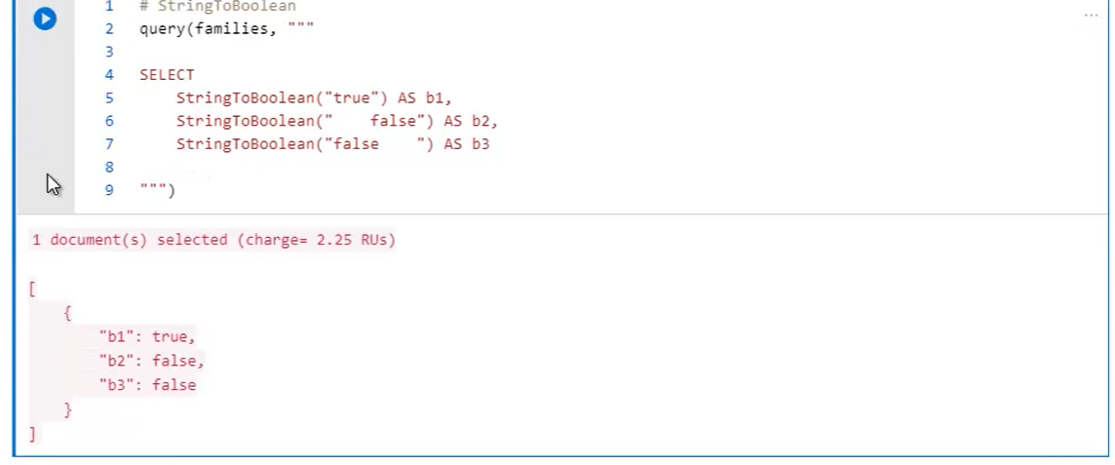 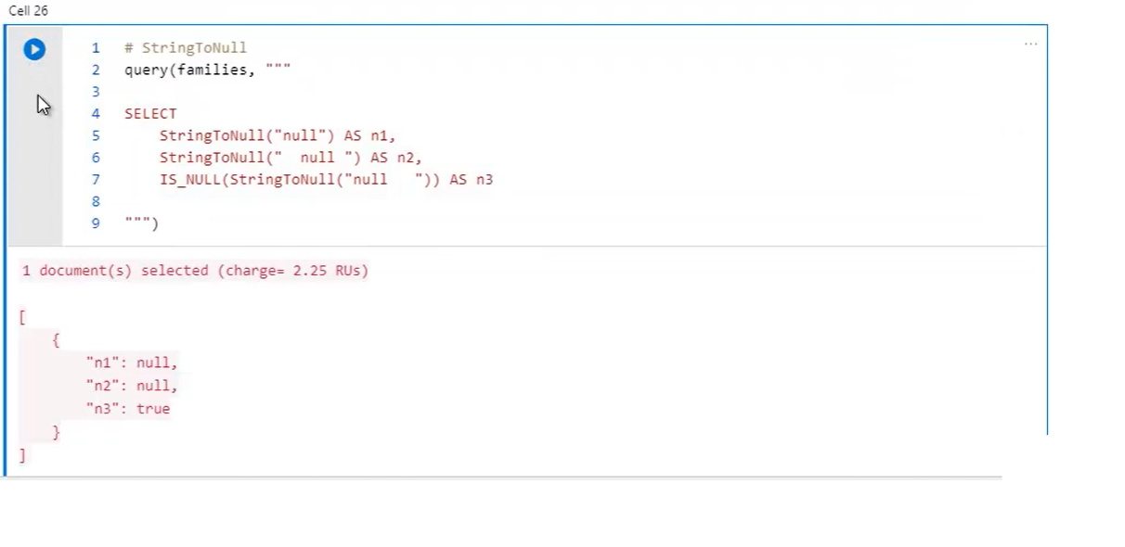 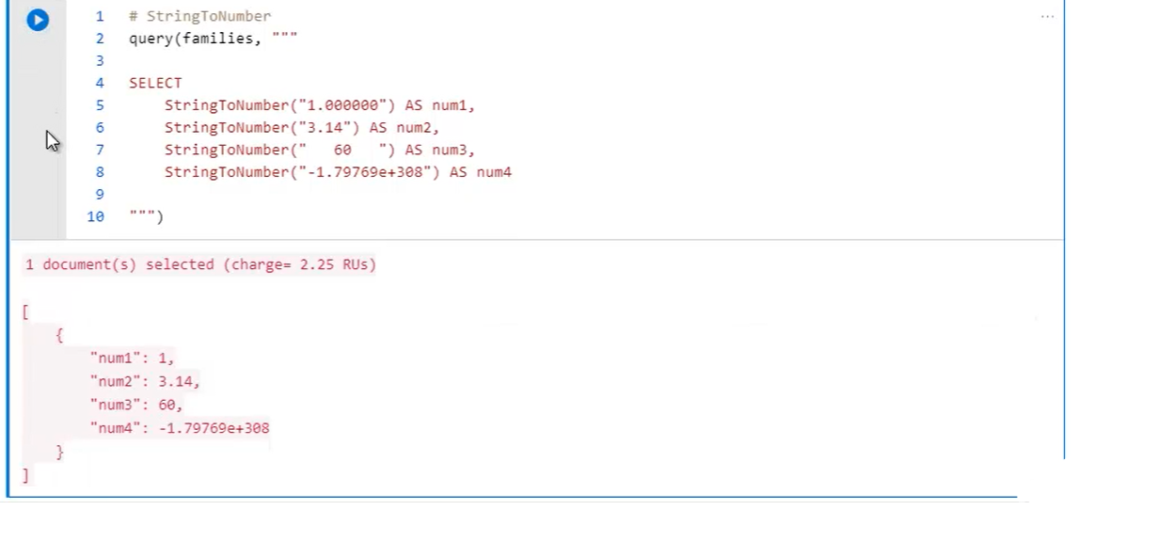 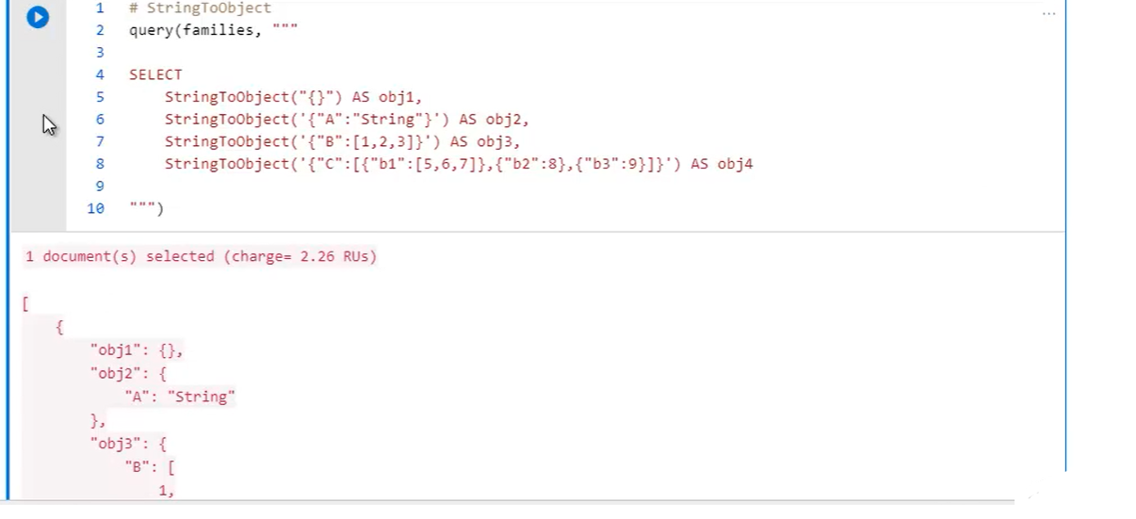

-------------- 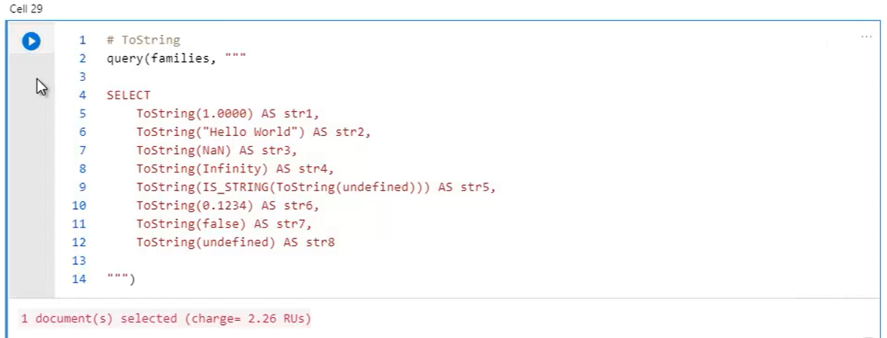 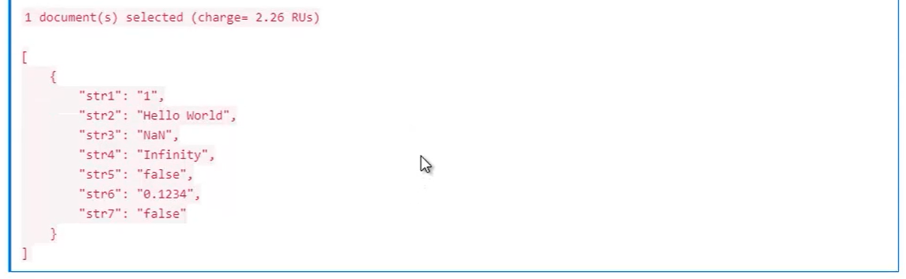 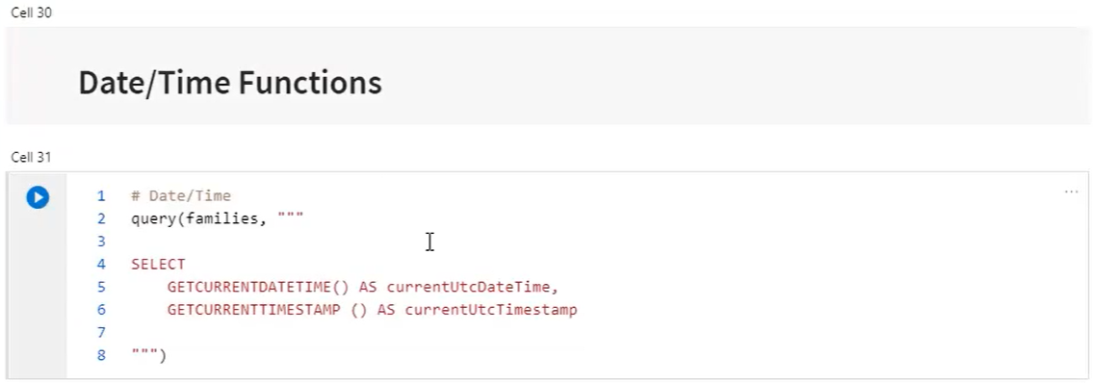 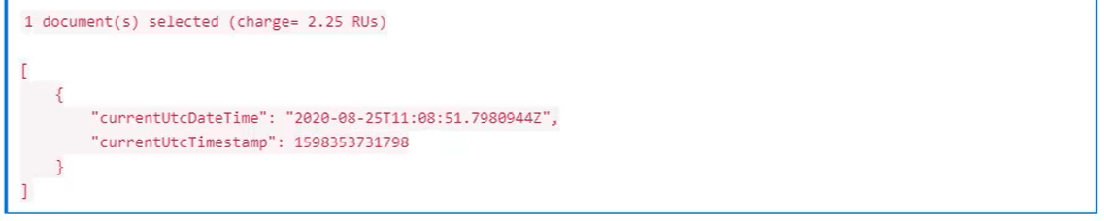 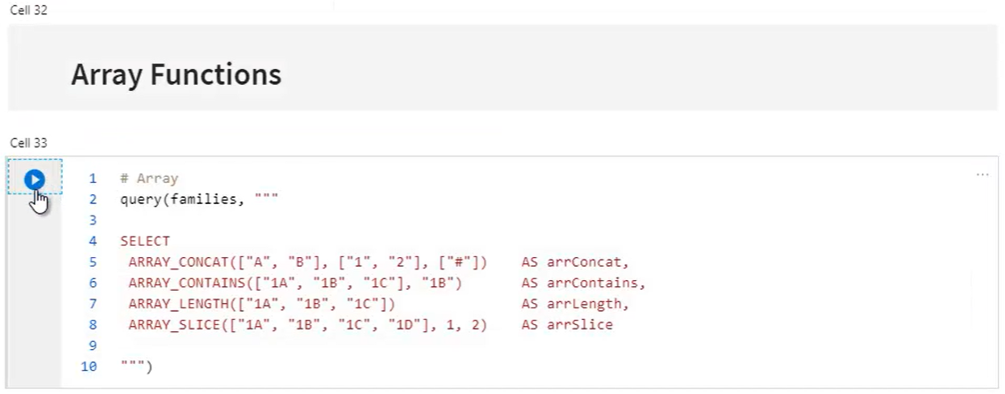 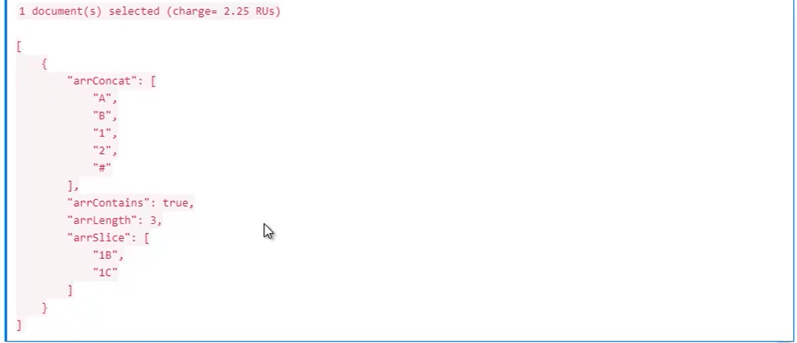

**Demo-Qyerying a Container:**

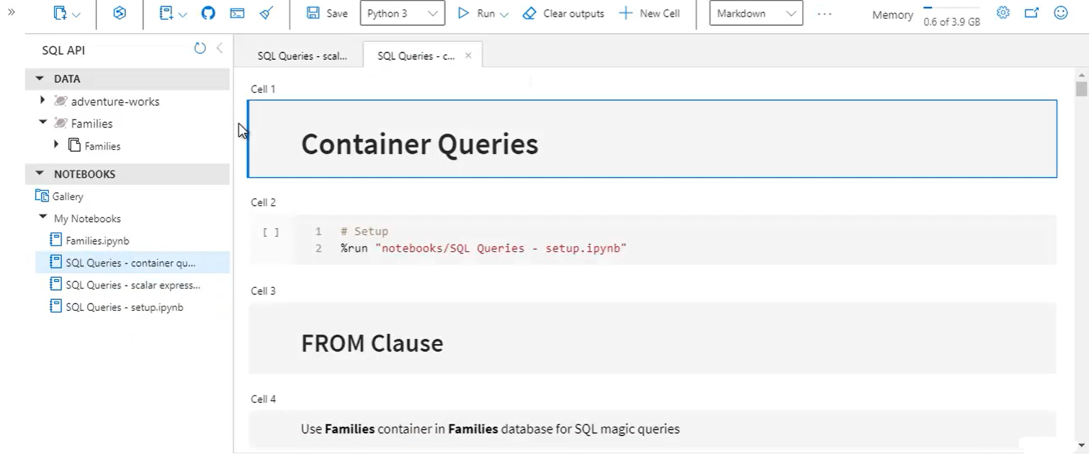

* Set DB and containers names as defaults instead of passing everytime

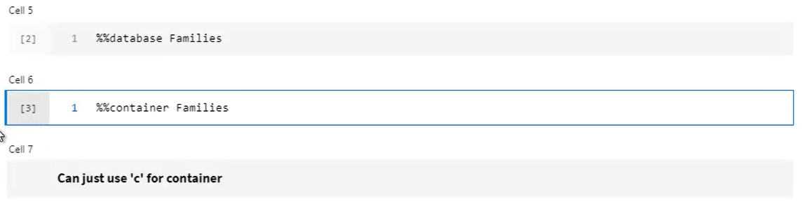

* Without FROM > scalar expression Query
* With FROM > document query that runs over container . but the container isn’t named inside the query itself, instead we use ‘c’ as an alias (for current container) to mean container

 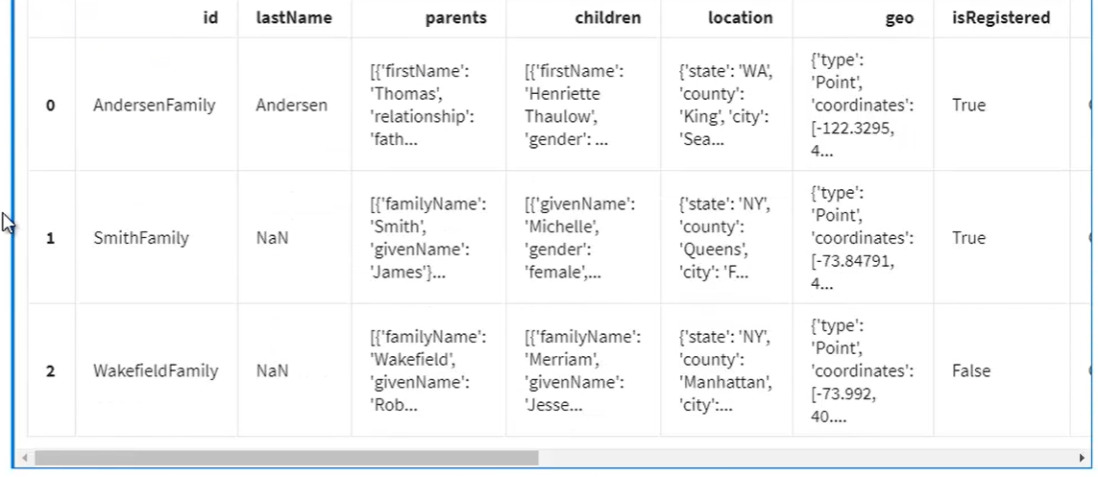 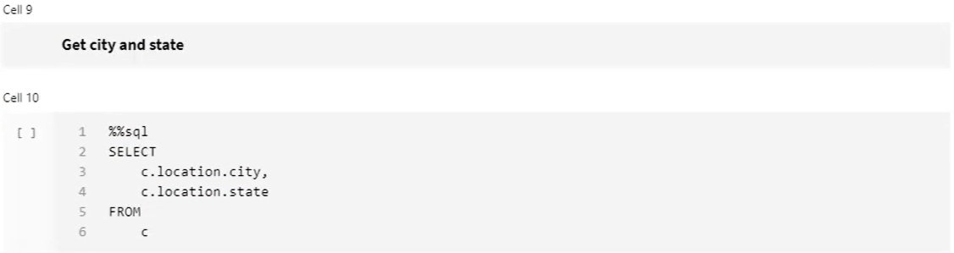 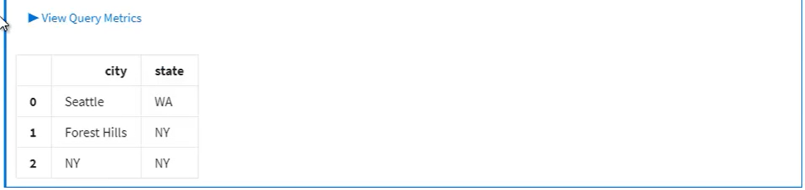

* Alias name can be any. It can also be name of container itself but its still asn alias. Eg: ‘c’ , ‘Families’

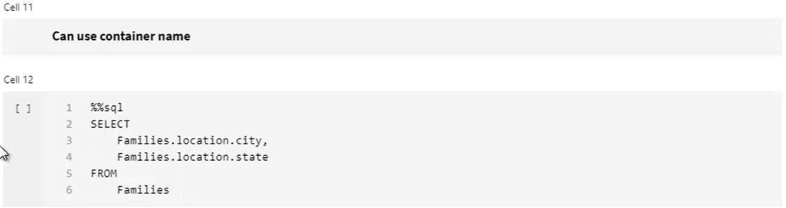 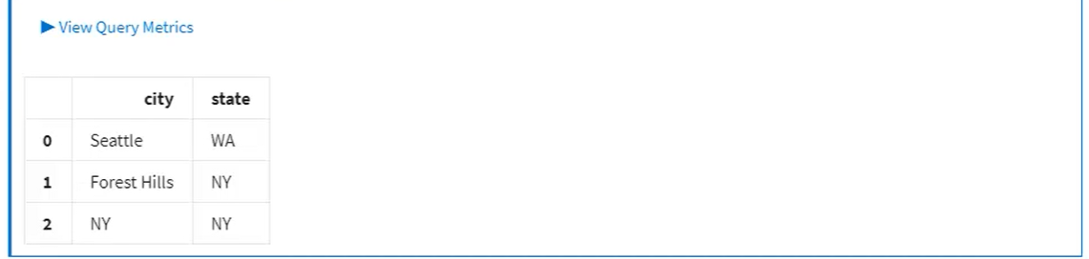 

* Alias the alias

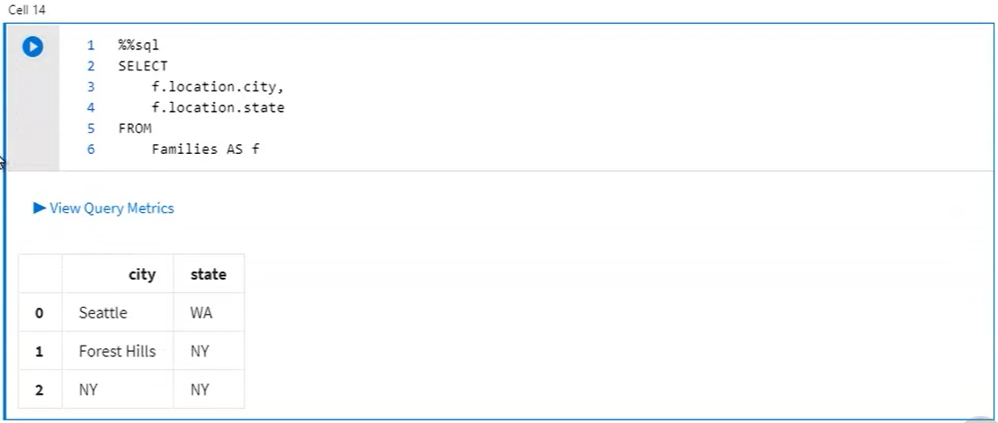

* Simple FROM clause operates over each document in its entirity, but you can also limit the source of the query to only a subset of each document. It improves performance when yu have large documents but you querying only small section inside each one.
* c.children :: limits query scope of visibility to just children property and inside it(children’s pets). But nothing outside it (children’s parents)

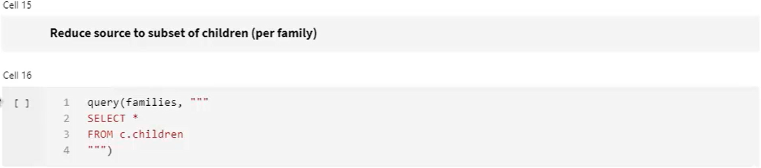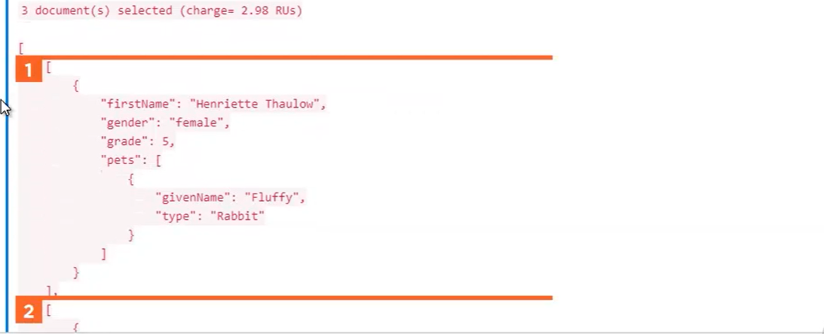

* location is outside children

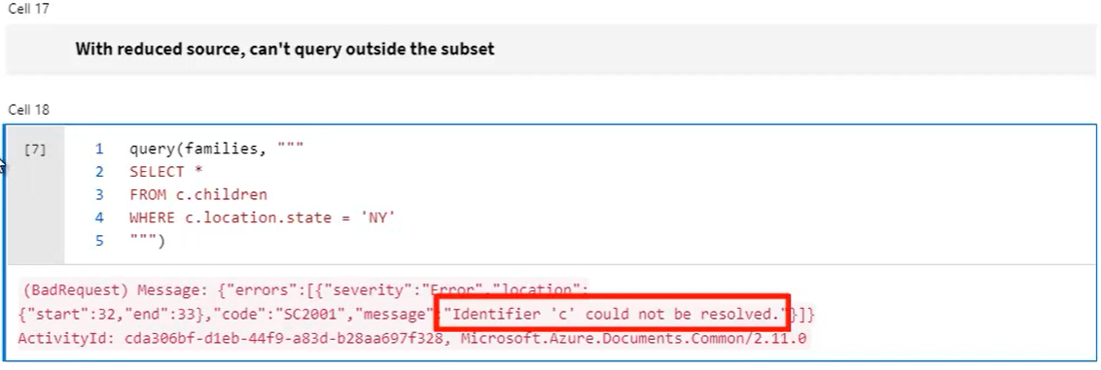

* Remedy: since you need location also, keep scope as entire document

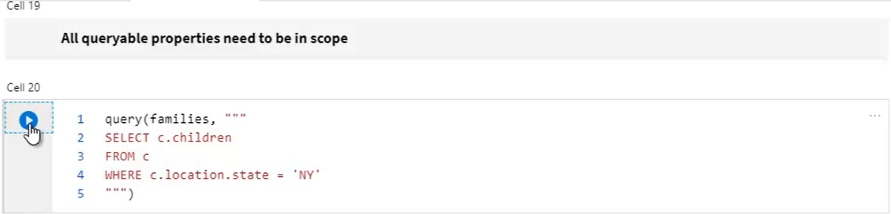

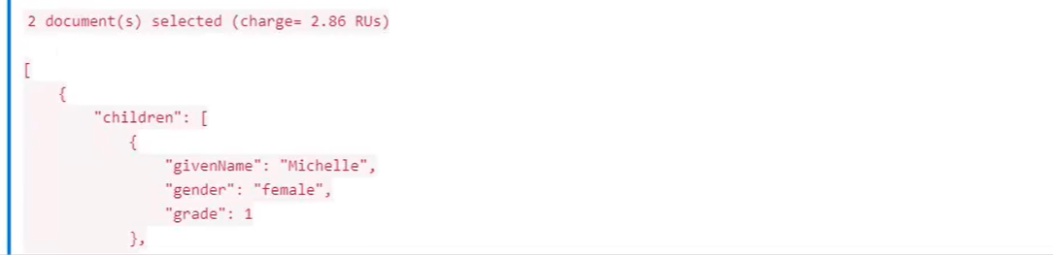

* Combined with IN, the FROM clause is capable of flattening or breaking the query source on the array you specify after IN
* Eg: we want each child object nested in ‘children’ array where the container is aliased as ‘c’ and we aliasing each child document in the children array as ‘ch’
* Below you get all ‘children’ from 3 families. This is returning 5 documents, 1 for each child. Before it used to return 3 documents 1 for family.
* So using IN, it essentially broke a part each document in the child array, turning 3 documents into 5. This is useful when working with arrays in documents.

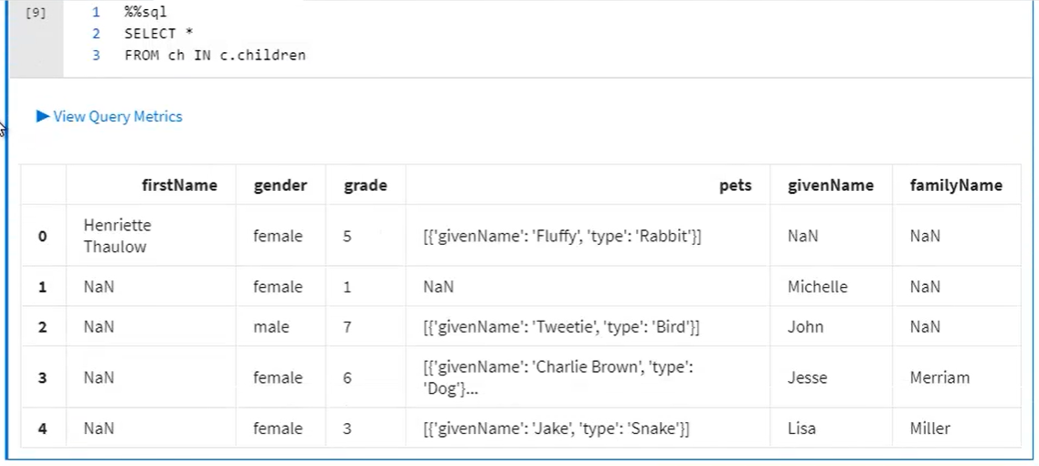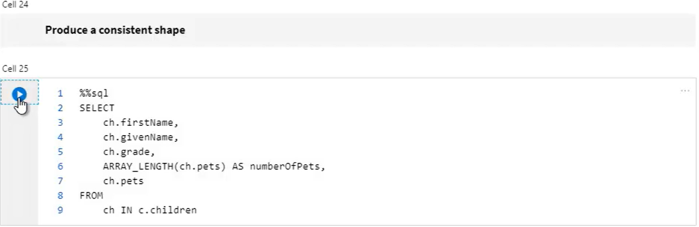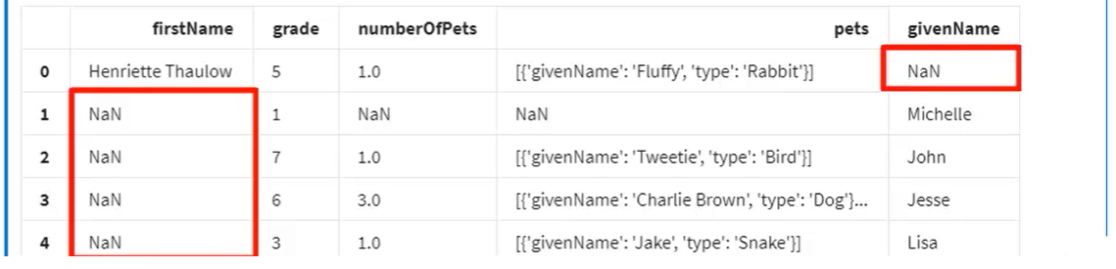

* From above, since the schema of each document is different, the name is either in ‘firstName’ or ‘givenName’. Also since ‘Michelle’ doesn’t have a pets at all there are more NaNs. So, clean this

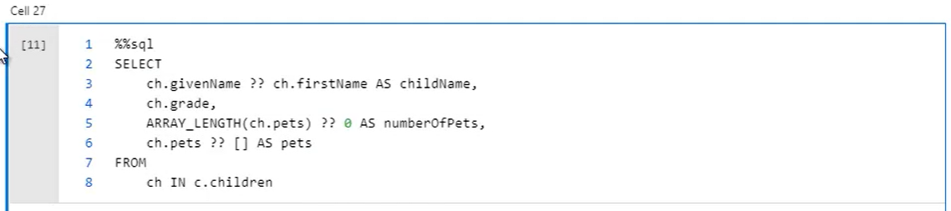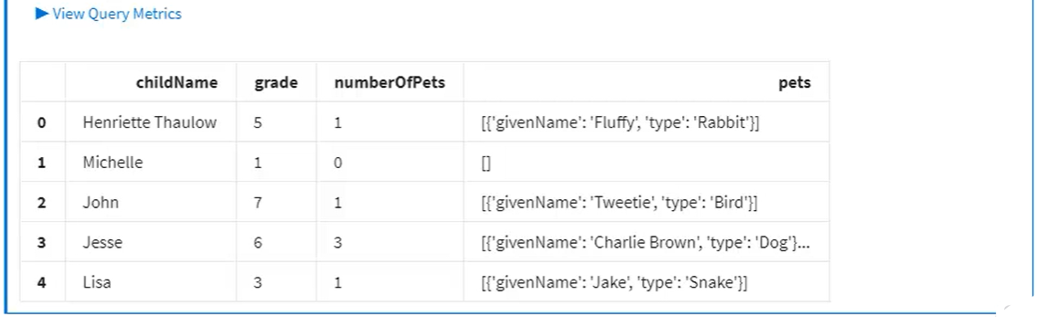

This is great, but what if you want to include properties from outside the children subsection of each document, say the family's city and state. We're using IN, and that flattens families down by children, but we saw that also means that we're limiting the query source to just children, which means that the family's city and state are out of scope. Remedy:: **use joins**

**Intra-Document Joins:**

* JOIN here is not like relational DB SQL. In CosmosDB SQL, JOIN do not combine separate documents, instead they perform ‘intra-document’ join (that flattens or breaks single document on some child array) between parent Object and child array just like IN does. Except that with JOIN the entire document including the parent family information does remain inscope.
* Similar to INNER JOIN in regular SQL, this CosmosDB JOIN is duplicating parent information for each child in the same parent.

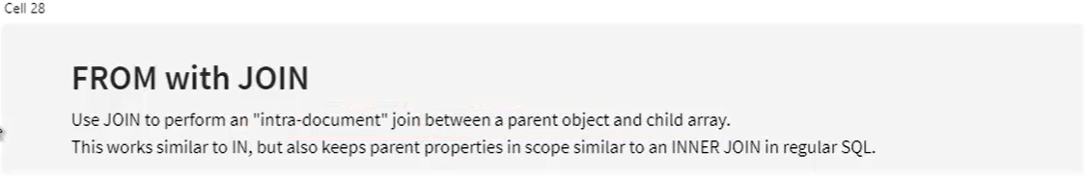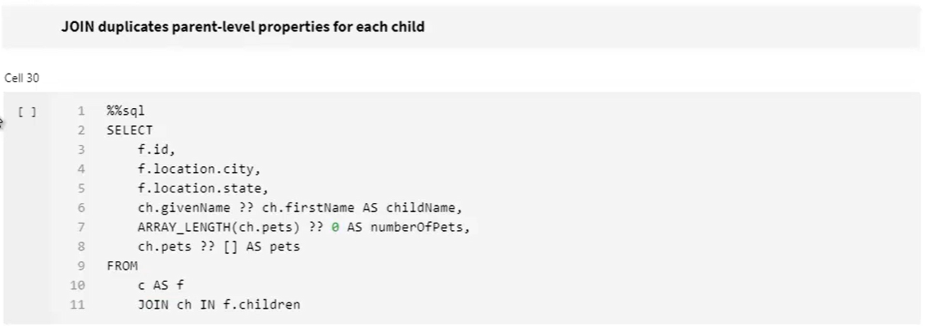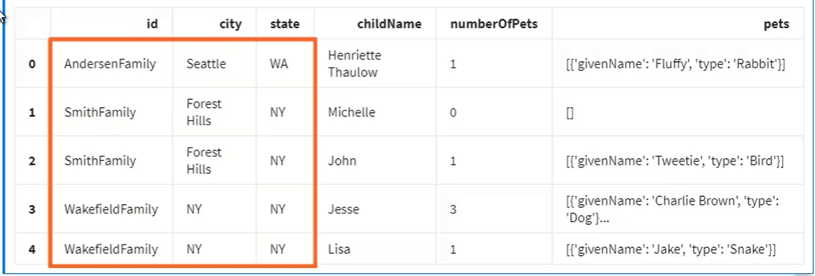

* Given documents with deeply nested arrays, you can pile on the JOINs to flatten the query source even further
* Because each child on ‘children’ array also has its own array of pets per child, so you can double up JOINs to flatten our source to the level of each pet
* Below, query returns 6 documents, which comes from 3 original family documents in the container in which there are 5 children who has 6 pets
* Michelle who has no ‘pet’ property, is excluded by the JOIN

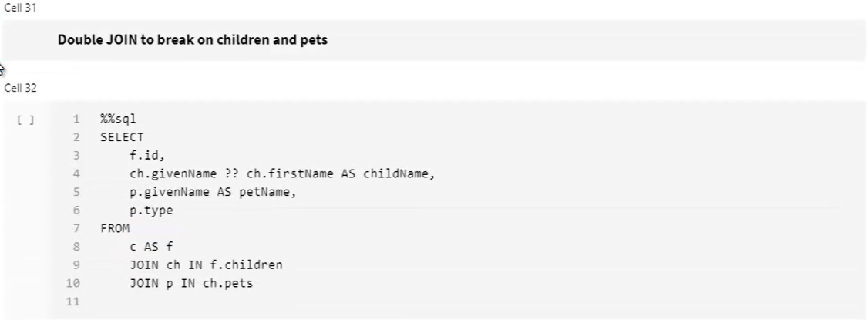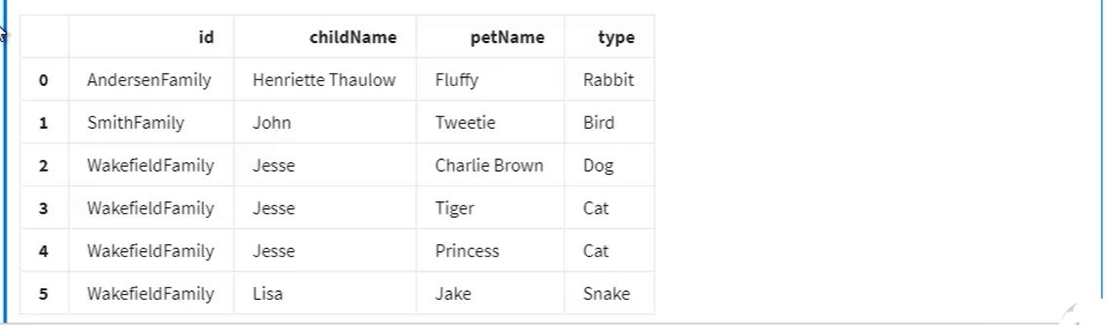

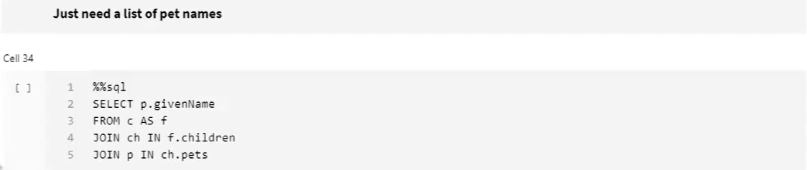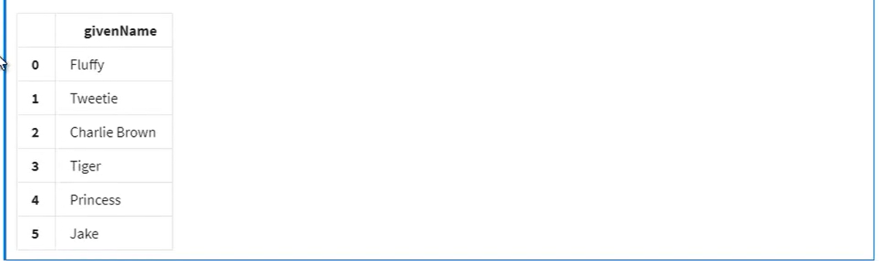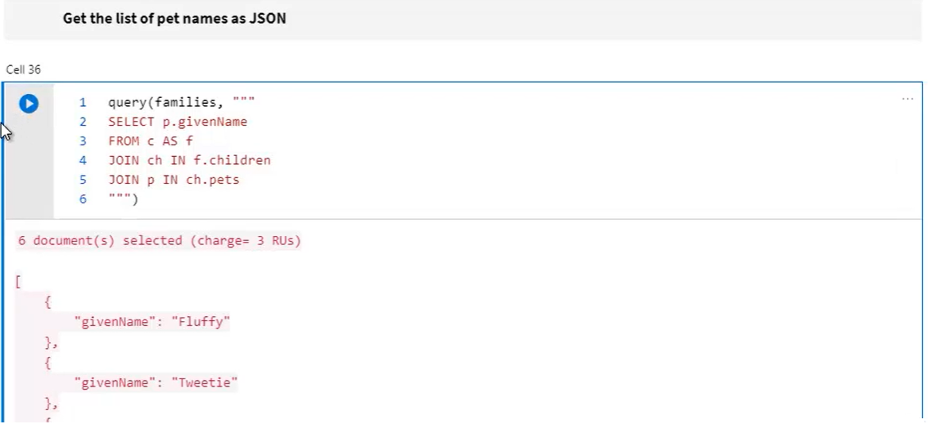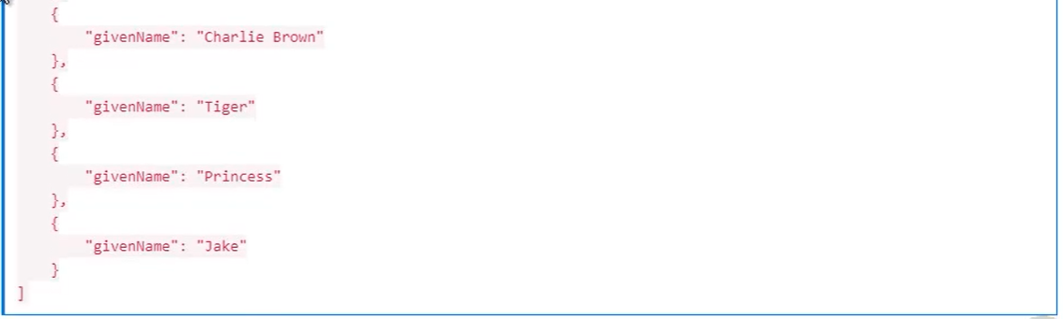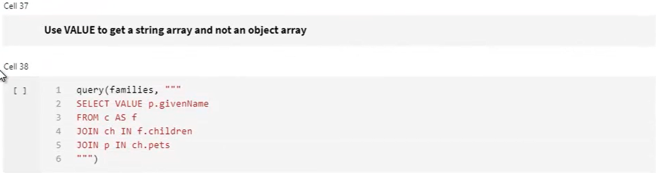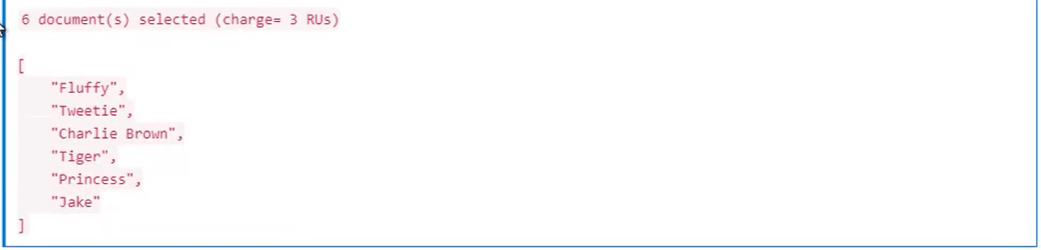

**Demo- Projections:**

* Stores contains in adventure-works

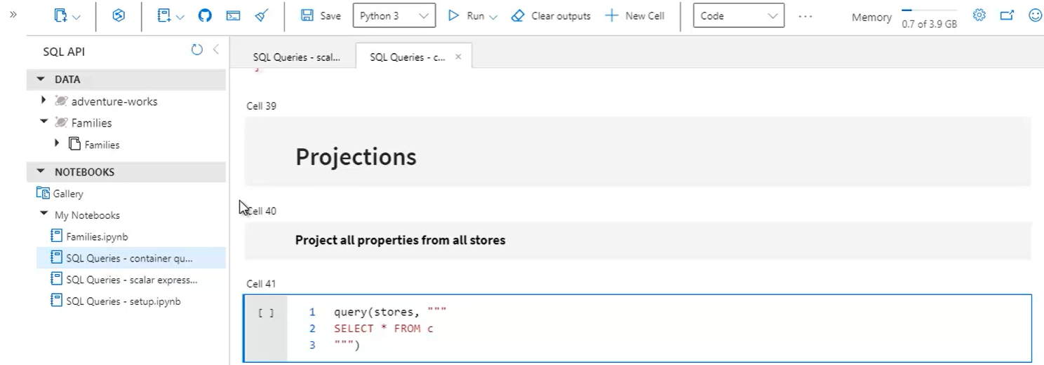 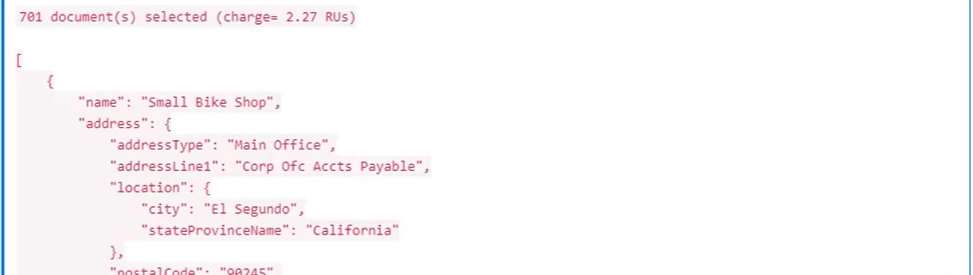 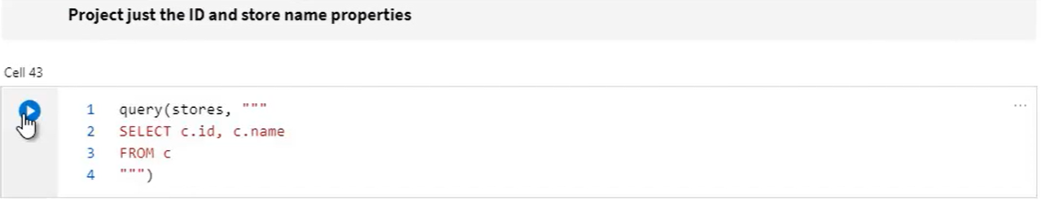 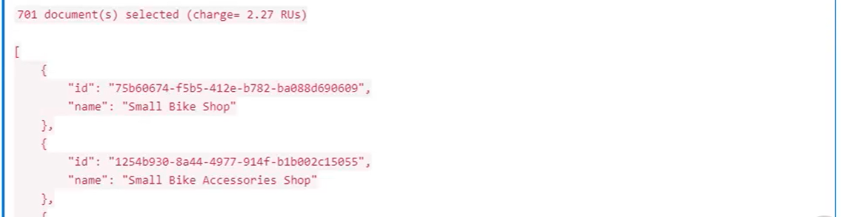 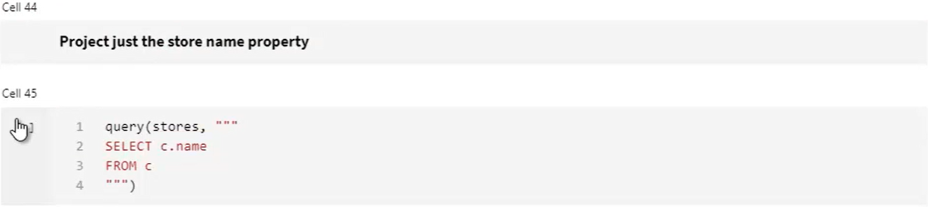 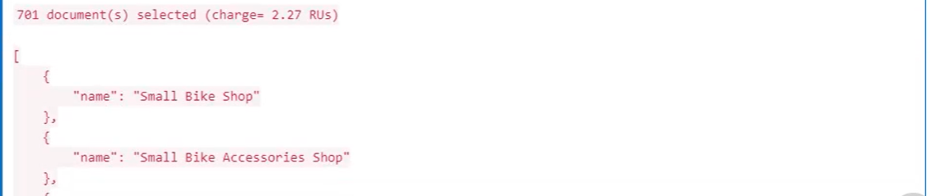 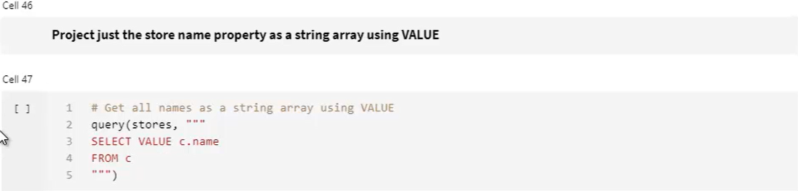 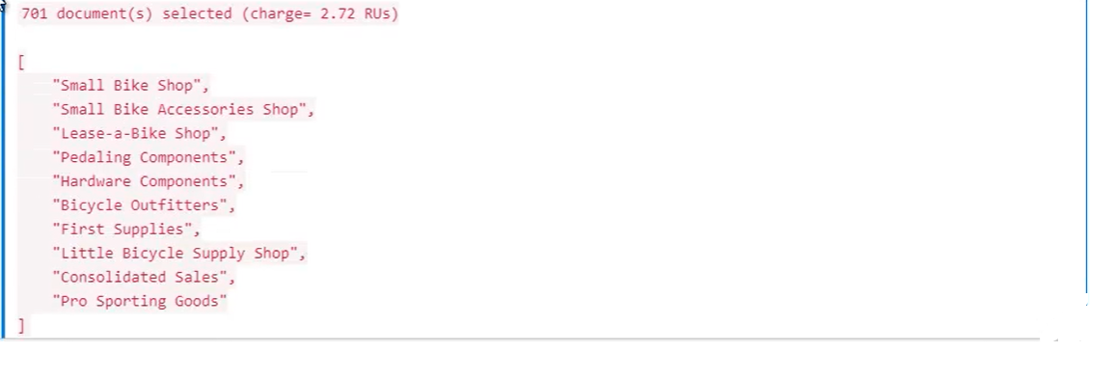 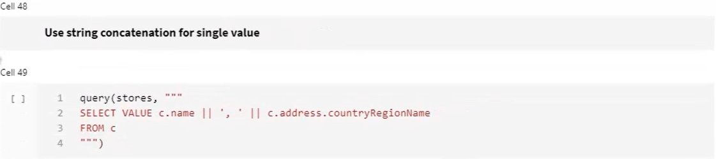 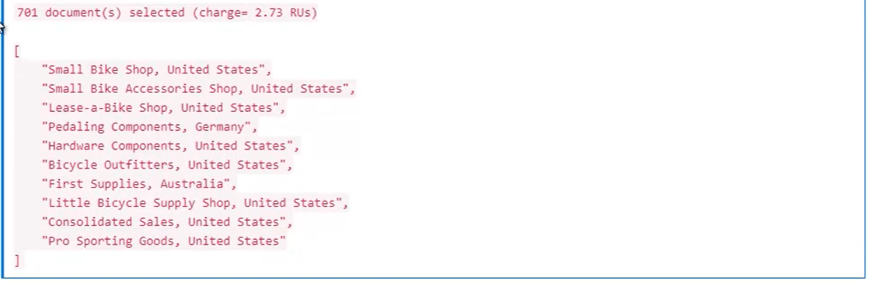

* Stores documents data with own specific schema

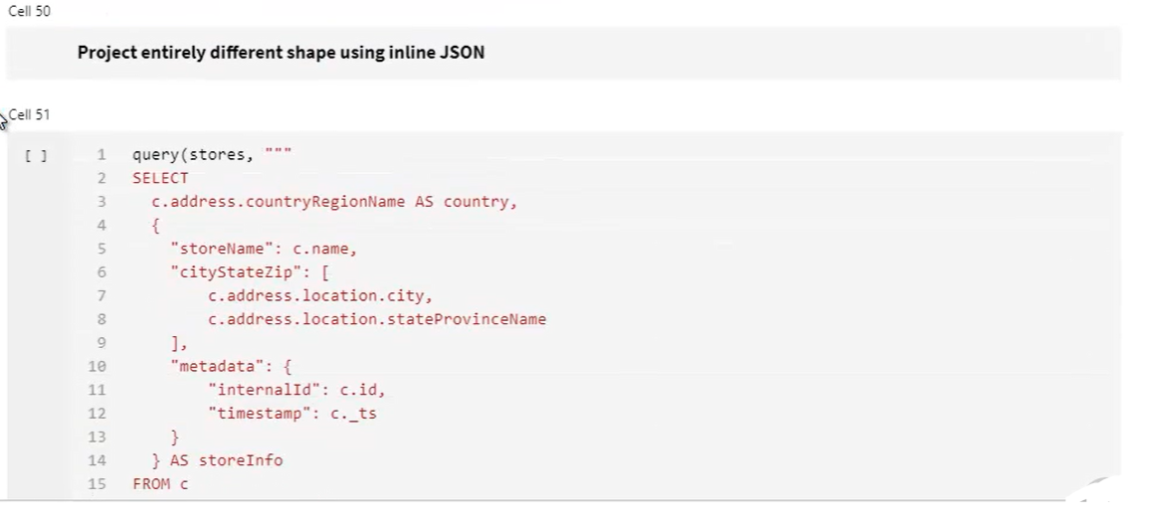 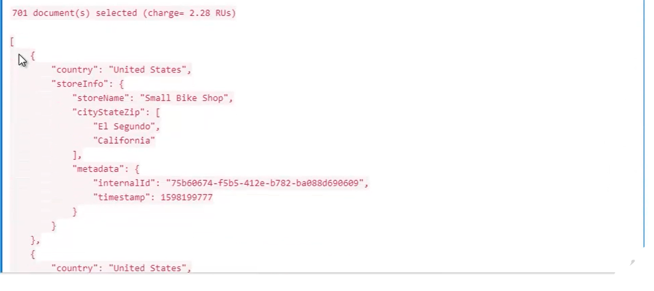

**Demo- Range Queries and Sorting**

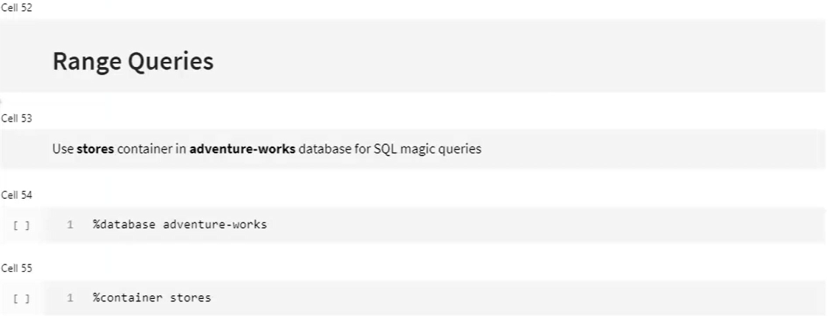

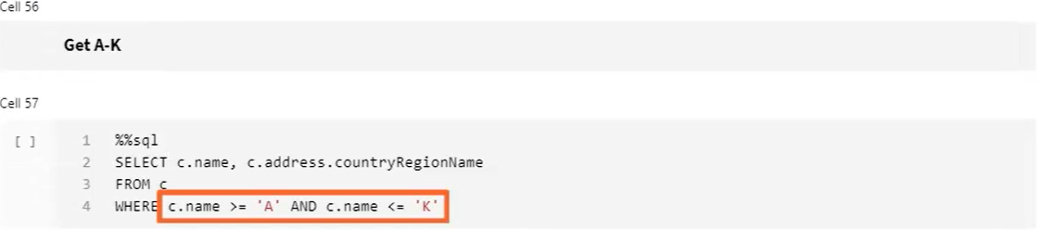 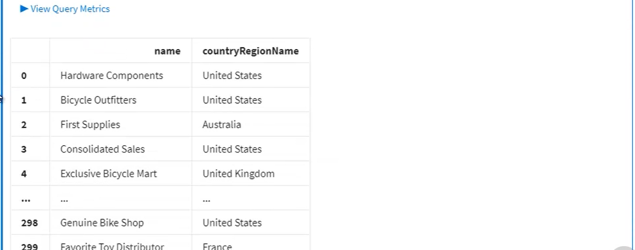 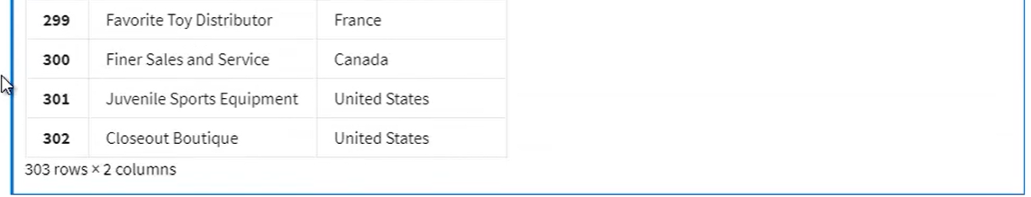 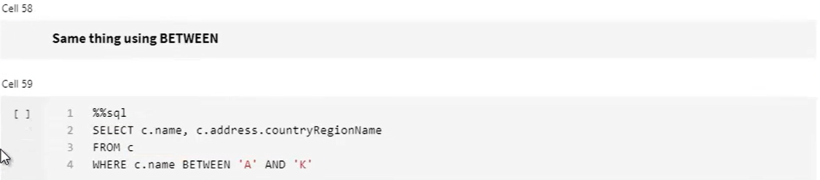 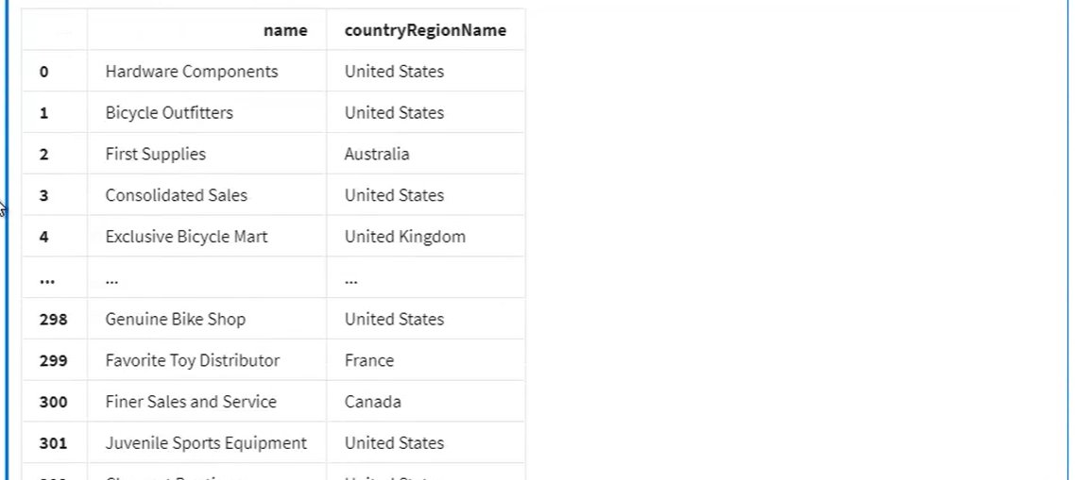 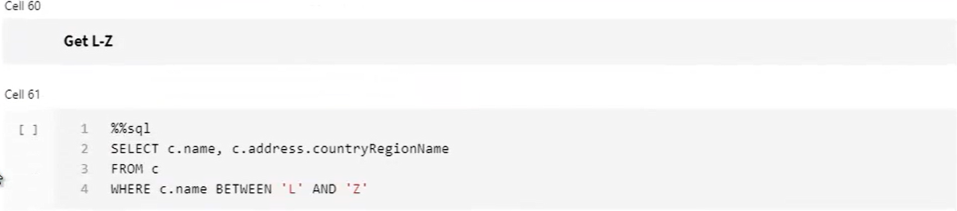 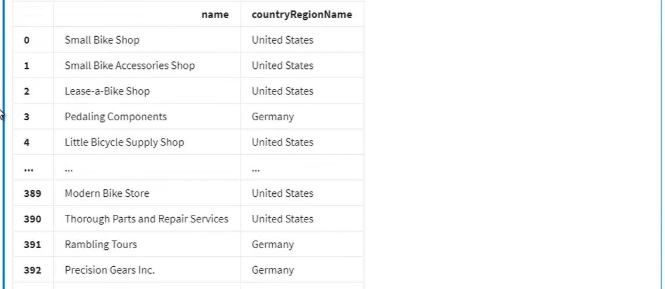 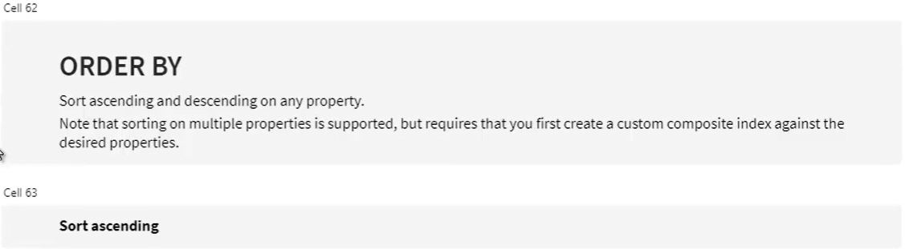 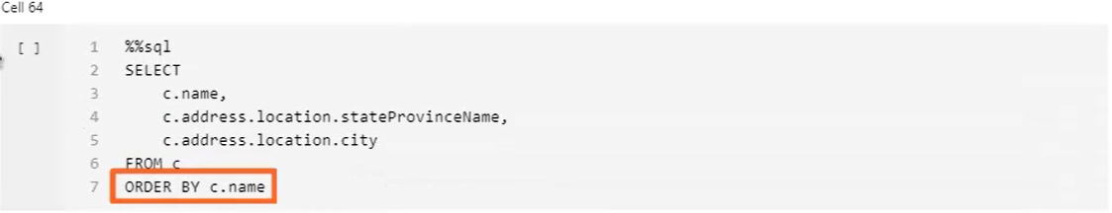 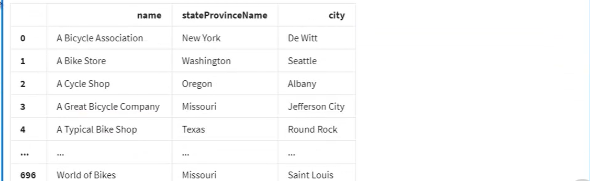 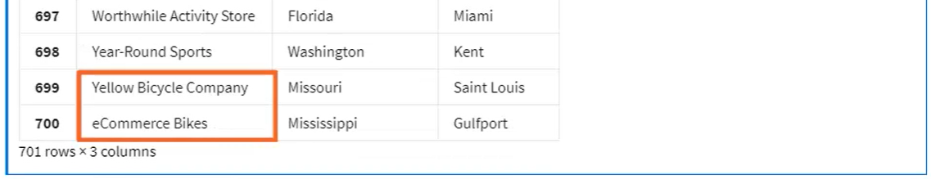

* Sorting is case sensitive. That’s why in above data ‘eCommerce’ is after ‘Yellow…’. Remedy:maintain two separate versions of a property within the document. One in mixed case and one in either all lower or all upper case that you use for sorting and searching for case insensitive manner
* Ascending:: A-Z then a-z

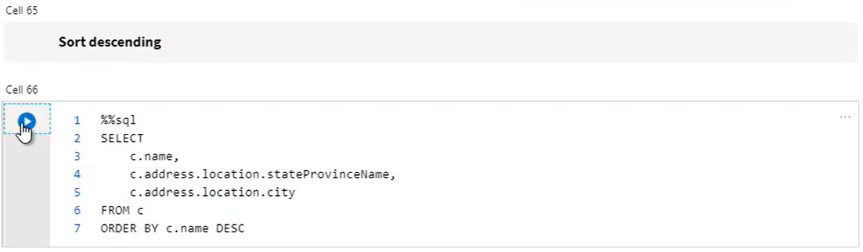 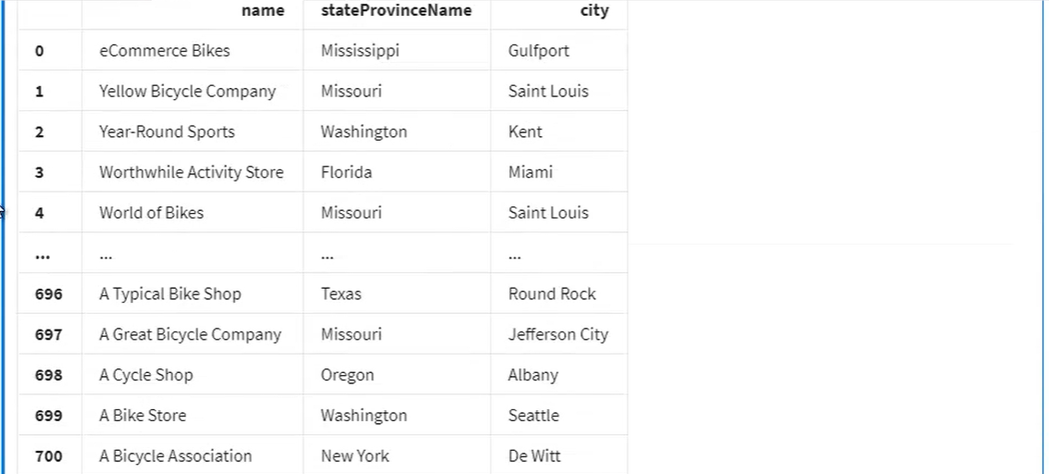  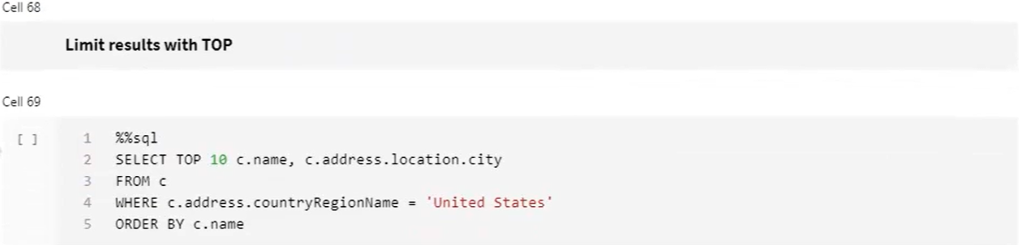 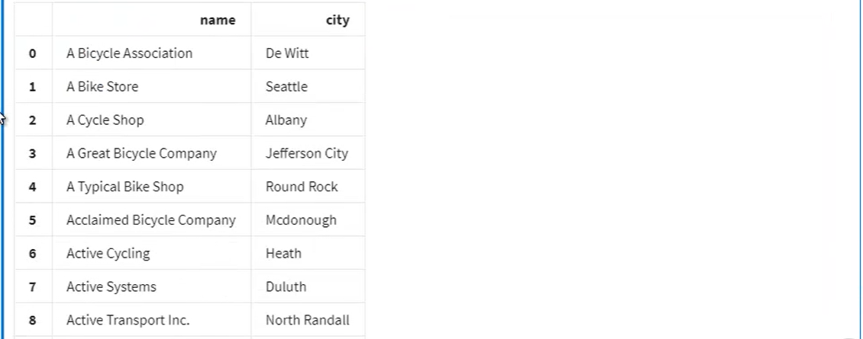

* OFFSET is a 0 based index

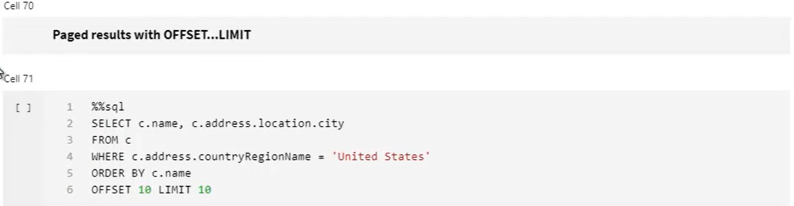 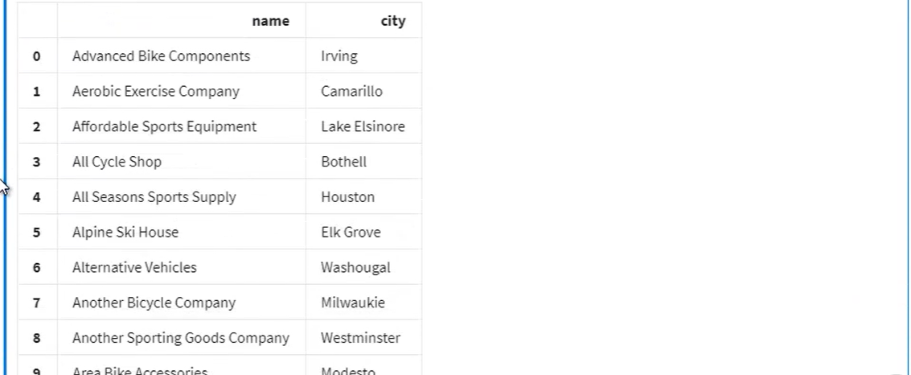

**Demo- Subset Filtering:** 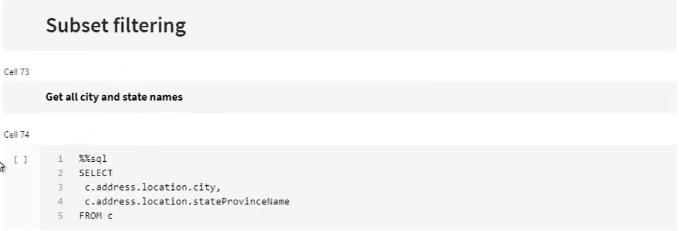 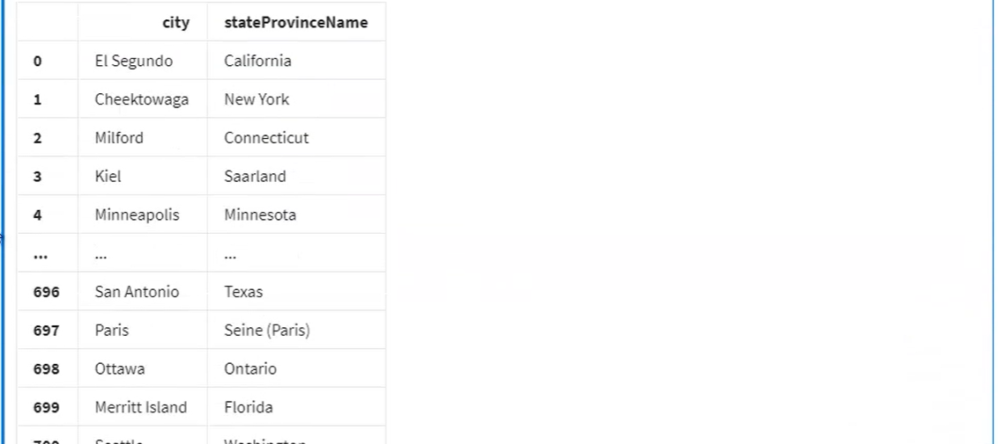

* Below is efficient. But can’t query outside the subset

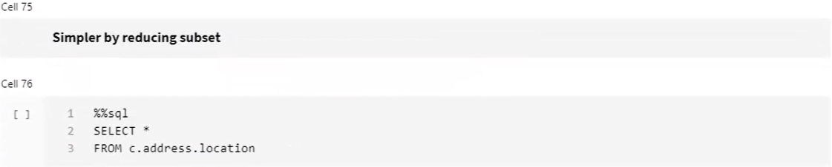 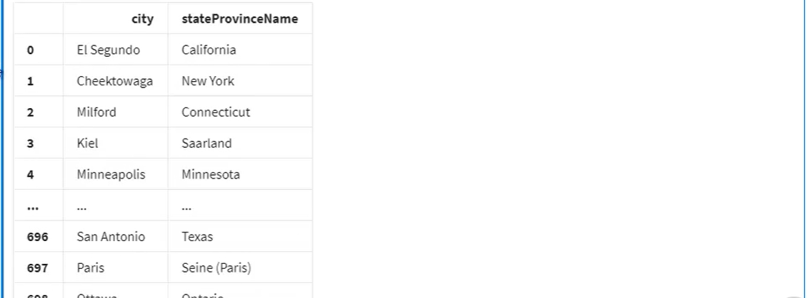 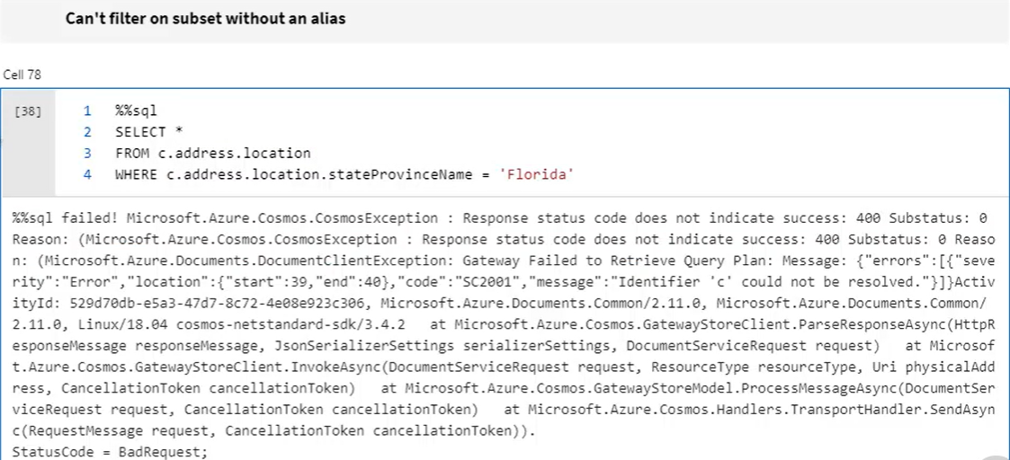 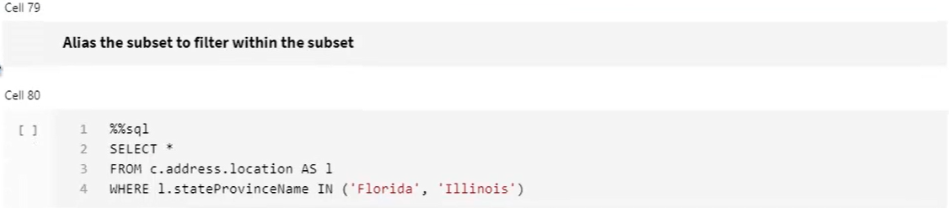 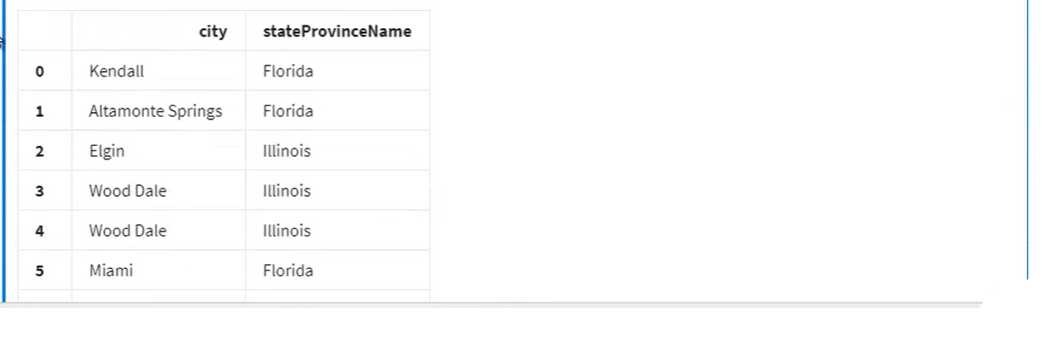

**Demo- Calculated Properties:**

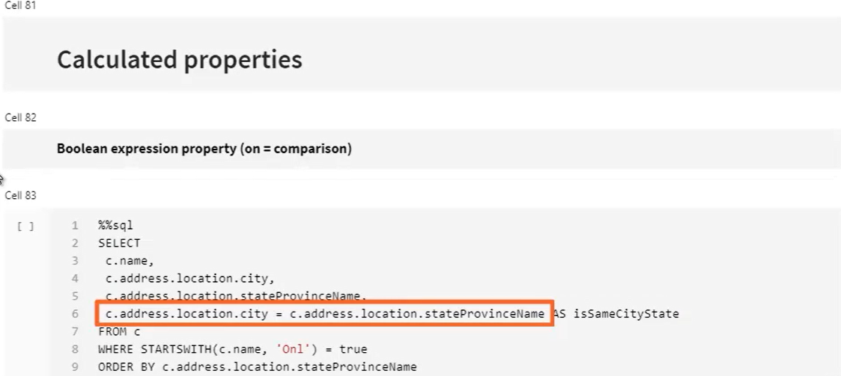 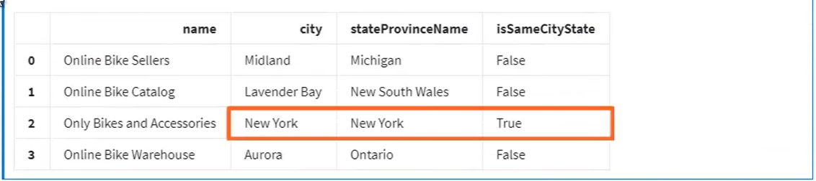 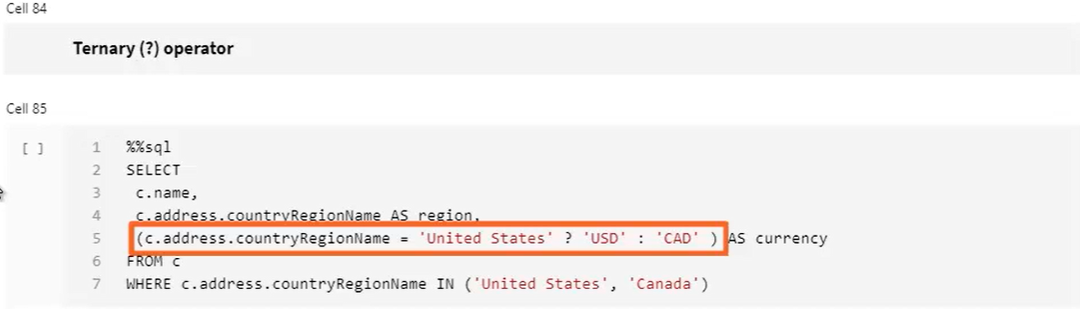 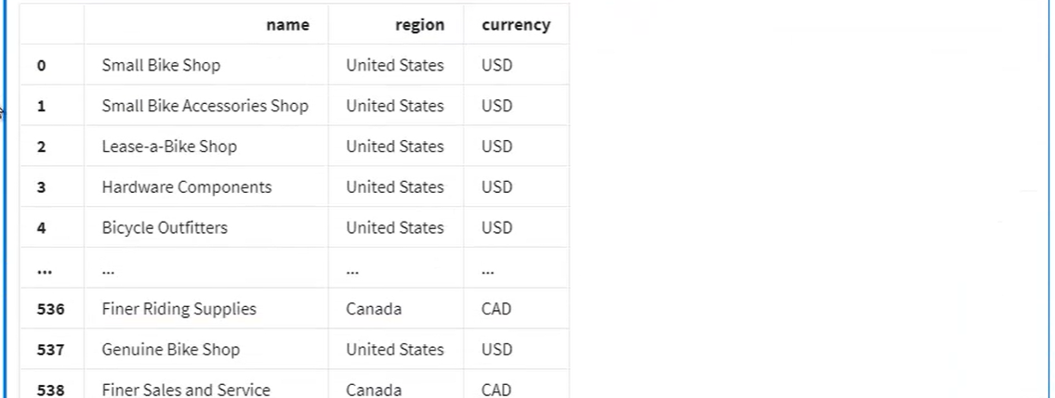 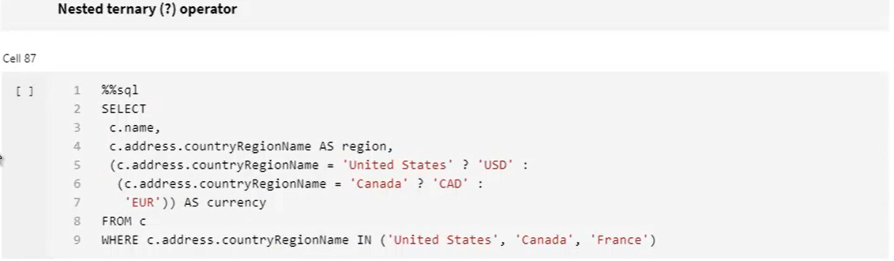 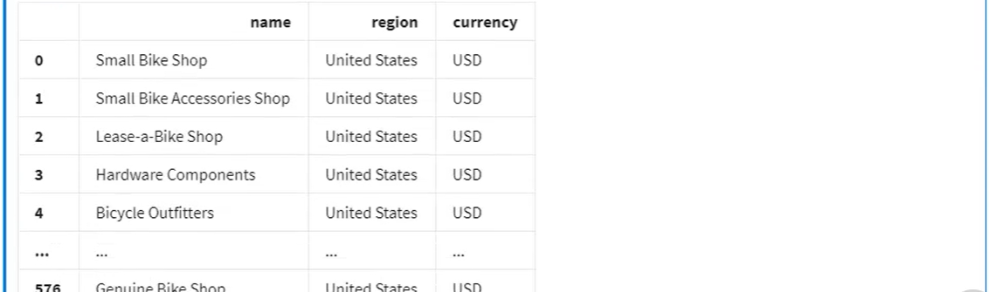

**Demo- Aggregation Queries:**

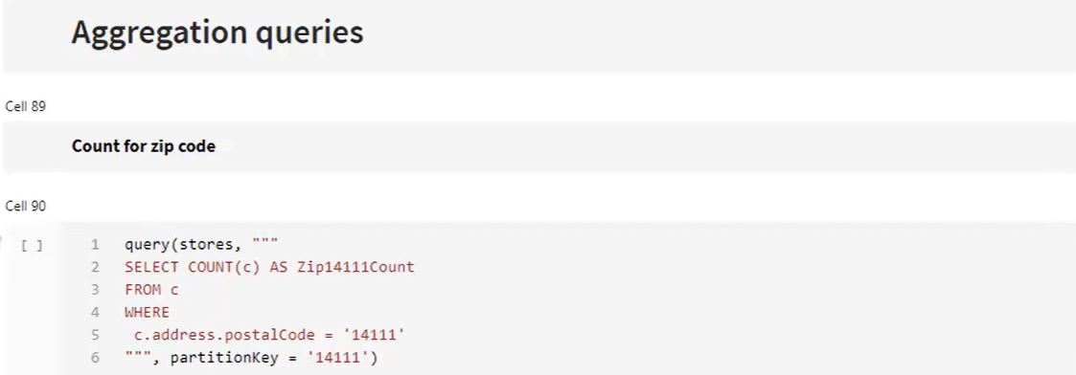 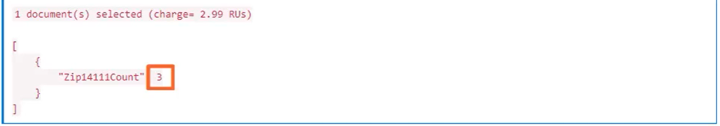 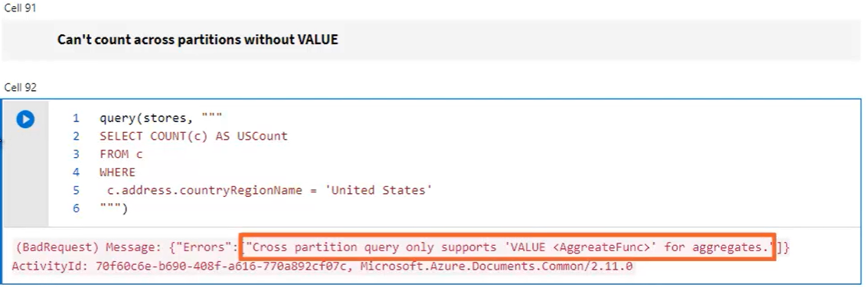 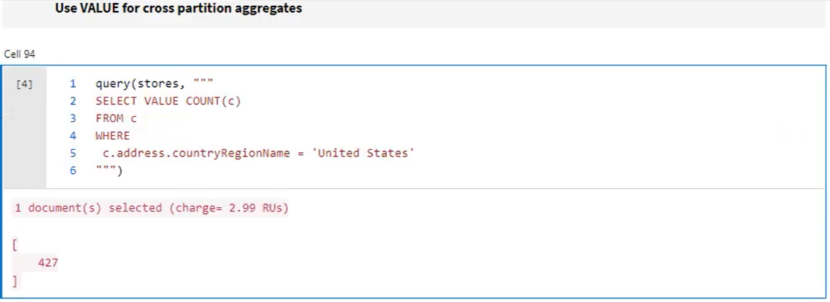

* You can put all aggregates in one query, but its only possible with **single partition query** like below

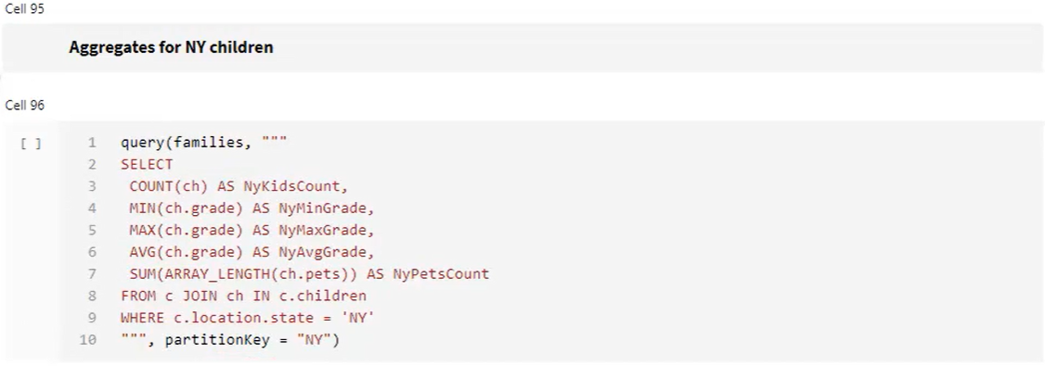 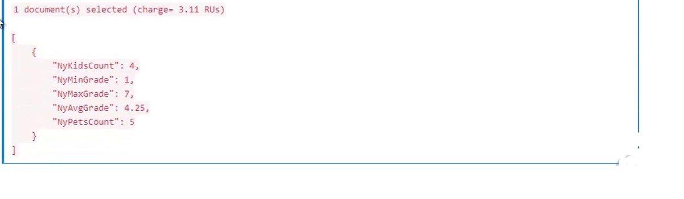 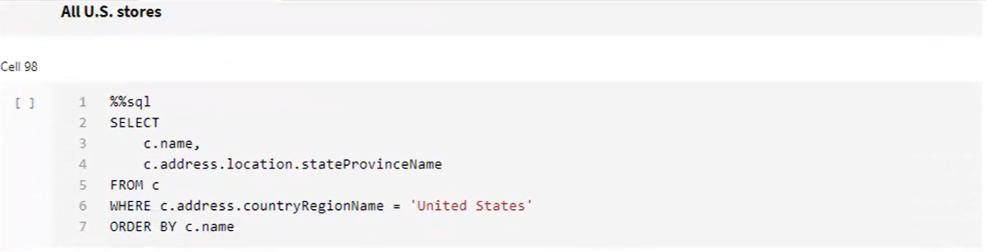 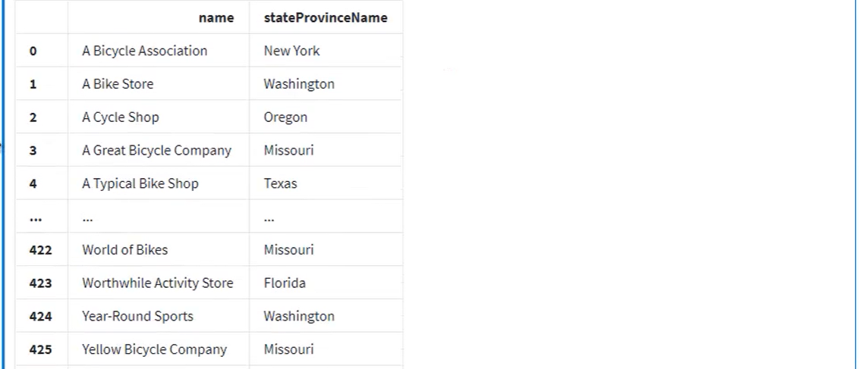 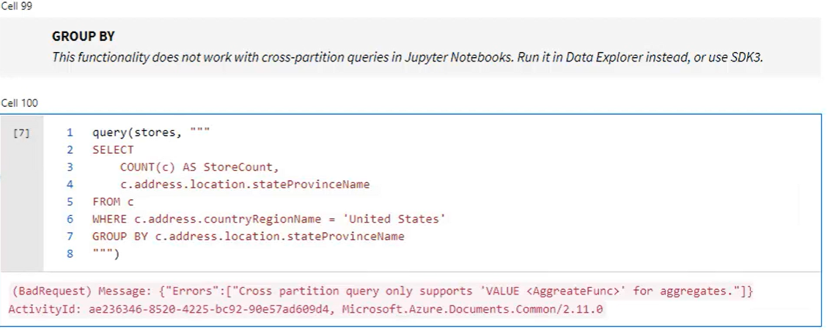

* But works in data explorer. (since this is crosspartion query has it is entire united states not just by state(partition key))

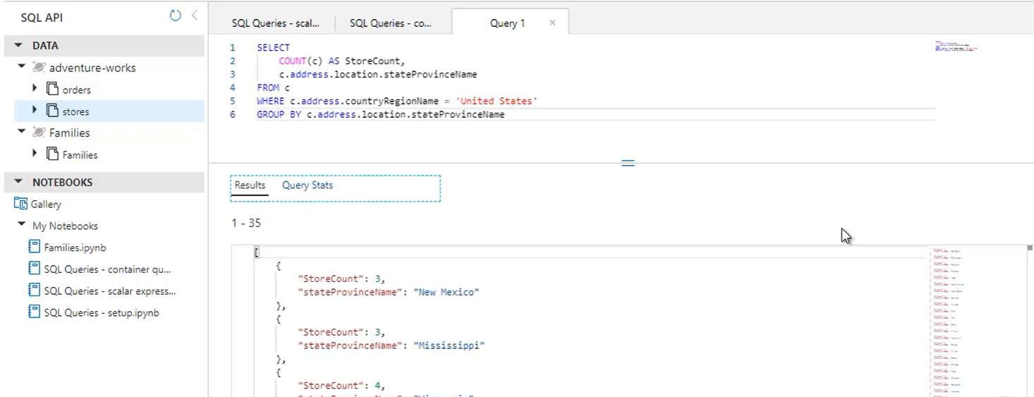

* To make above work in notebook
* Store result in a dataframe(df_usStores) without groupBy. Then manipurate and visualize data

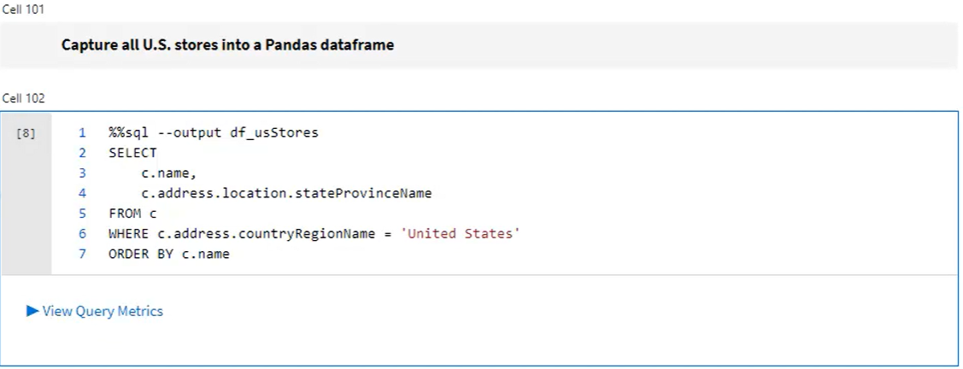 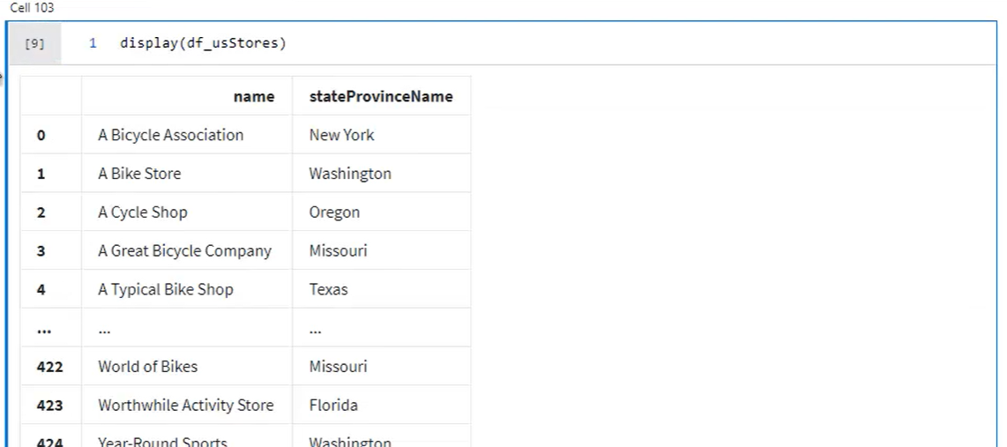 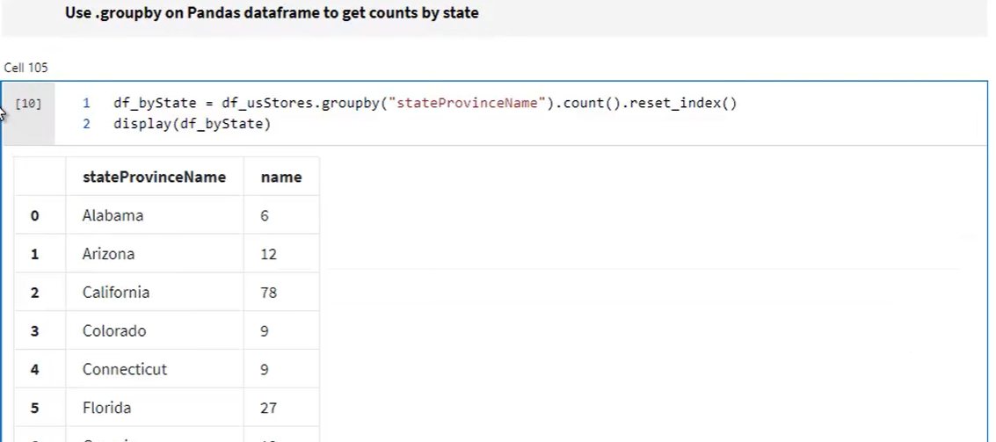

* Display with html display feature for reach output

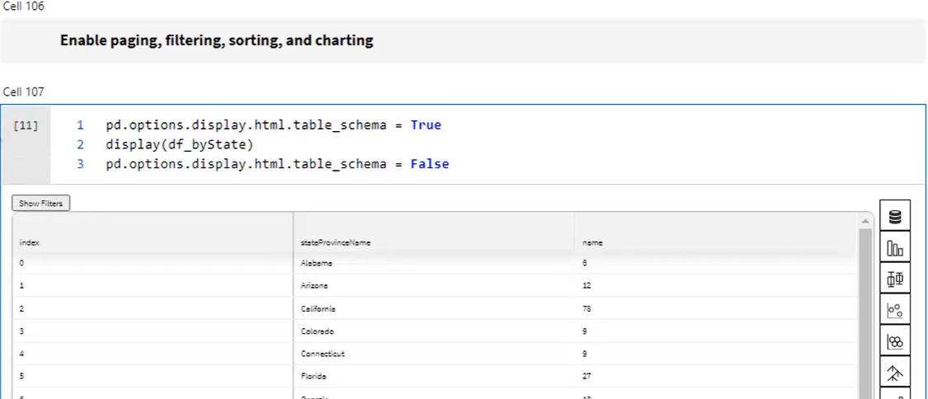

**Demo- Special Queries:**

* Families containes has geo co-ordinates data

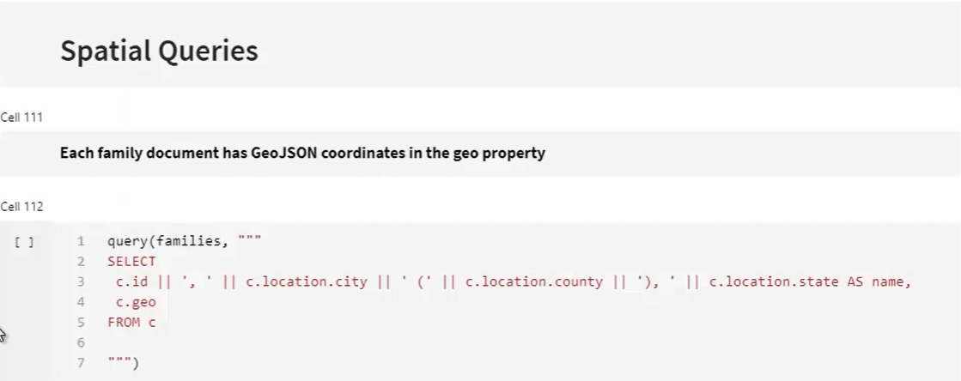 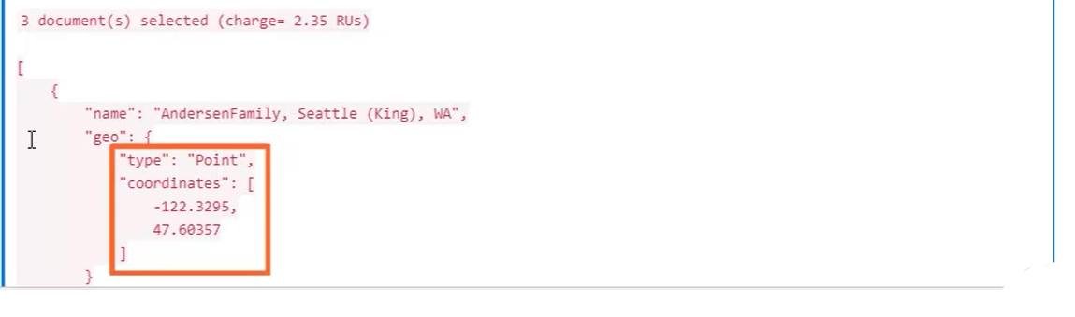 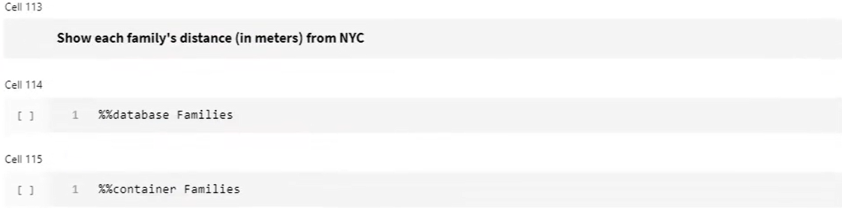

* [-73.992,40.73104] > hard coded ‘midtown manhattan’ location

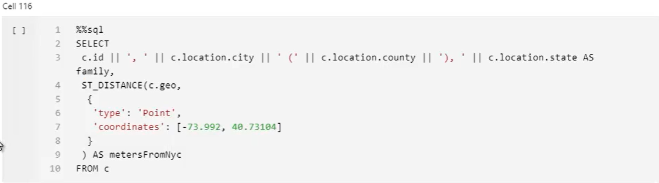 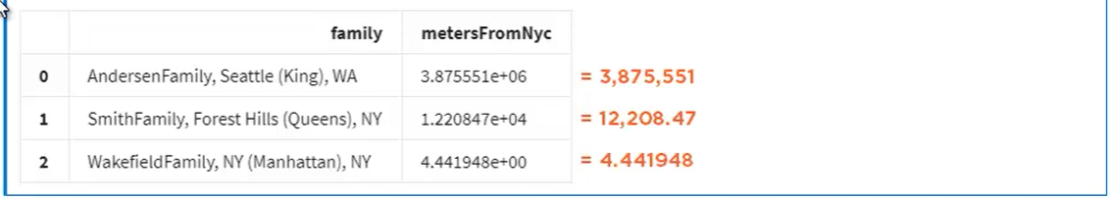 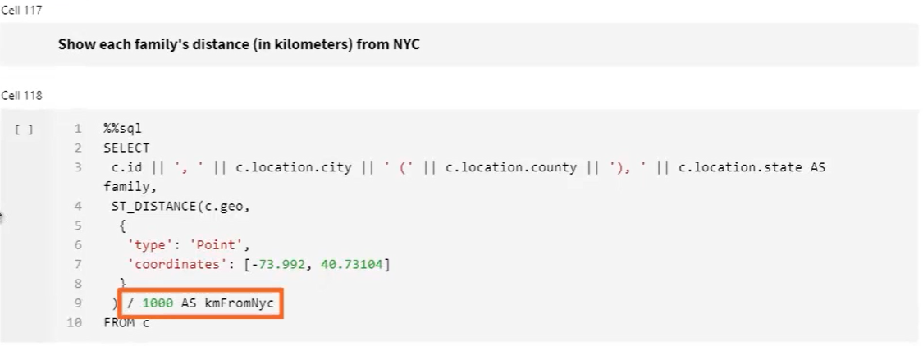 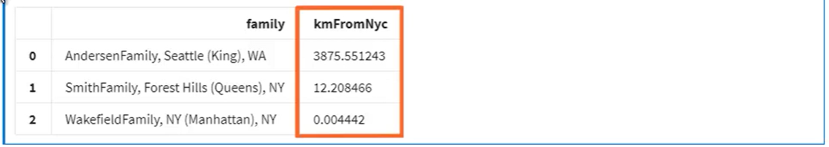 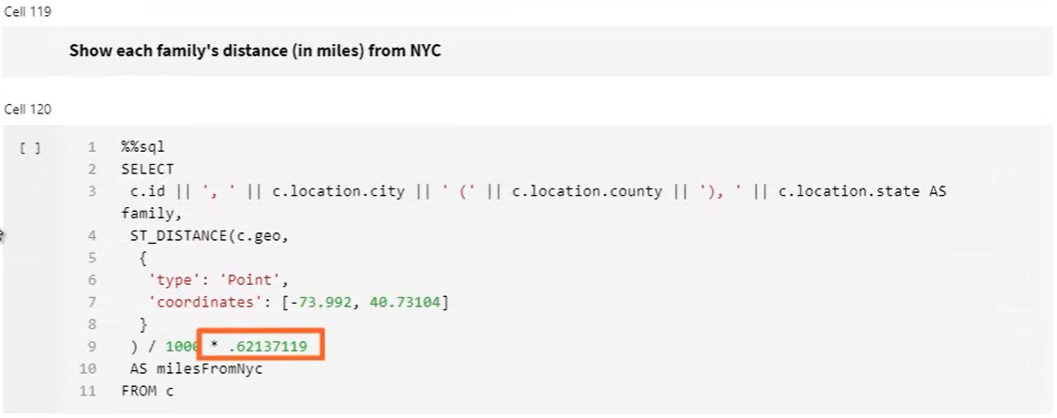 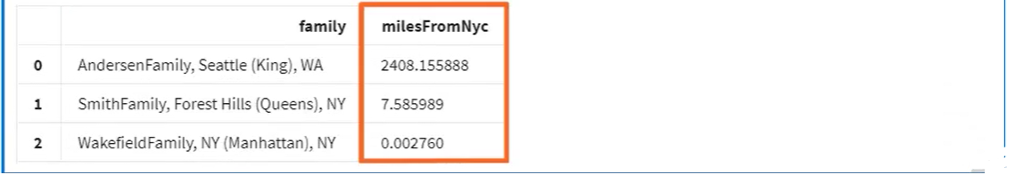 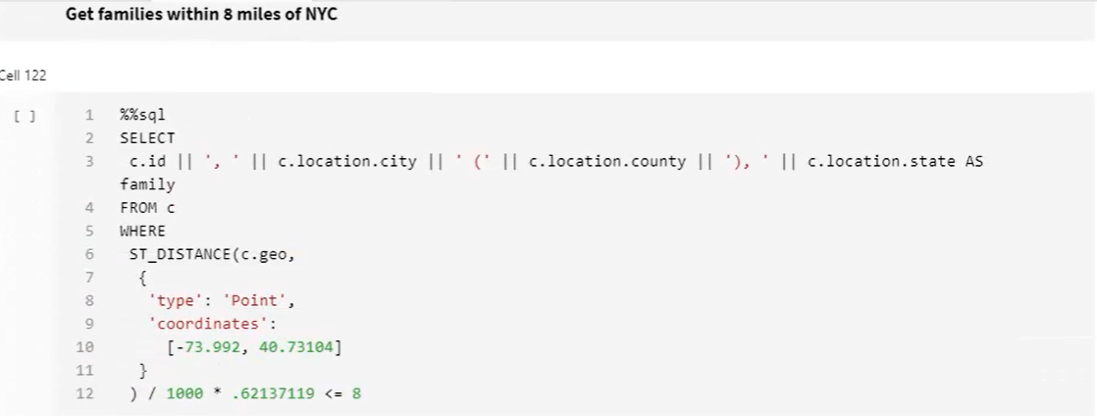 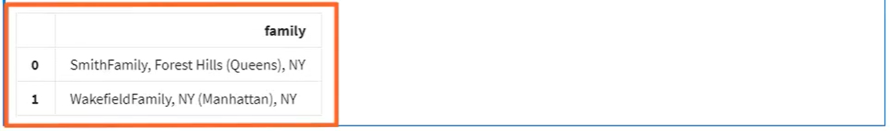 

* ST_INTERECTS > return ture/false base on whether point coordinate overlaps with polygon
* Below are polygon coordinates for manhattan

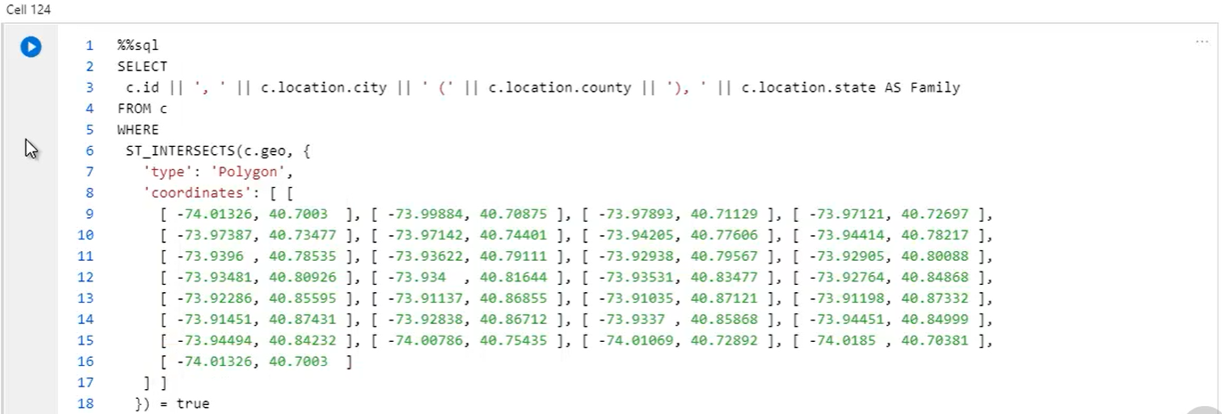 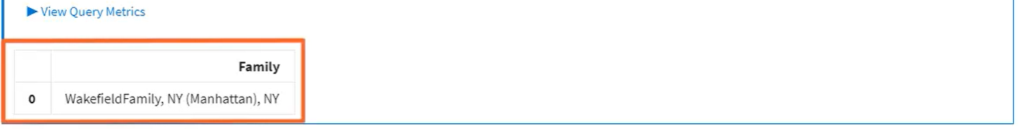

* To get polygon cocrdinates, draw on below map and copy polygon cocordinates
* There is free online tool to draw a polygon around Manhattan using the mouse and then copied out these coordinates. The tool is designed for use with Google Maps, so I still had a little work to do on this data into GeoJSON. First, I had to swap the values of each coordinate to be longitude first, latitude second, and then I also had to reverse the entire order of the coordinates themselves, which is known as the vertex order. So for Google Maps, these clockwise coordinates form a polygon that represents Manhattan, but for GeoJSON, it represents the entire planet Earth, except for Manhattan, which gets cut away, which is why I had to reverse the order to counter‑clockwise for the query.
* It's also important to define spatial indexes over your GeoJSON properties so that Cosmos DB can run your spatial queries much more efficiently. You can do this right in the portal, or, programmatically using the .NET SDK

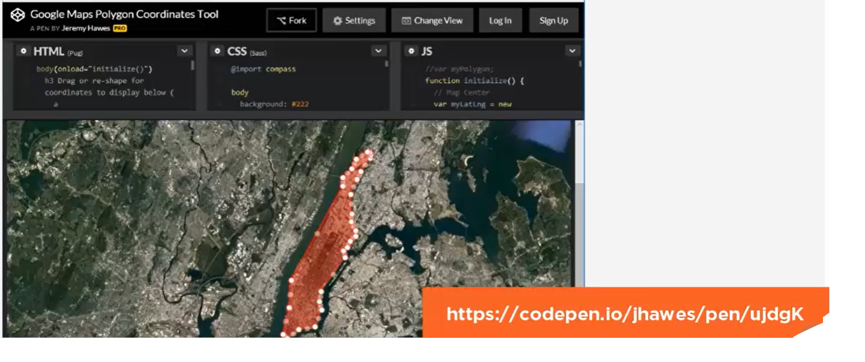 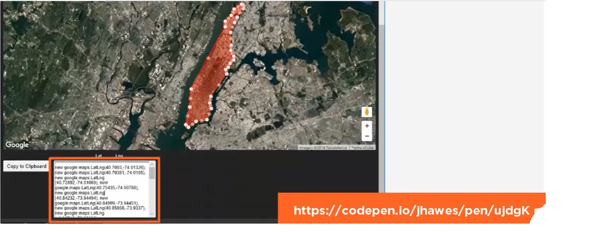

* GeoJSON supports points and polygons , as well as line strings, which have two or more coordinates that represent the line segments of an unclosed shape.
* what if you encounter bad GeoJSON? its treated as undefined and just gets ignored. So to test for valid GeoJSON, the query language provides two other spatial functions called ST_ISVALID and ST_ISVALIDDETAILED.

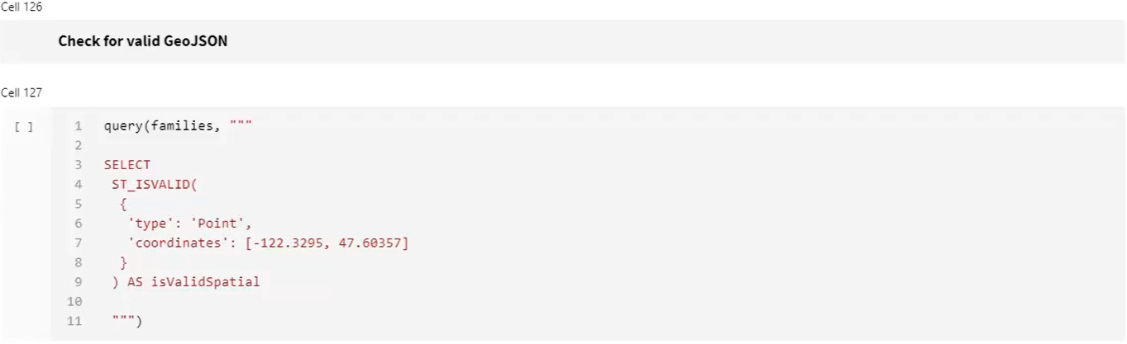 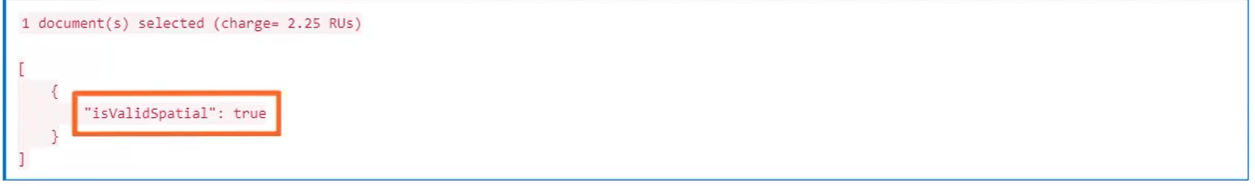 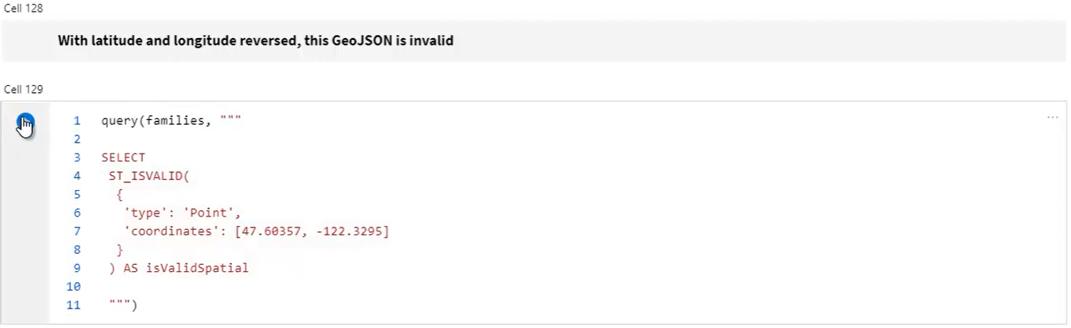 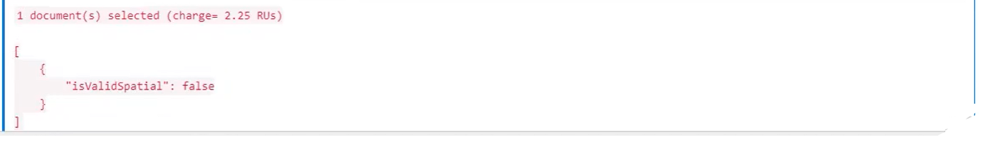 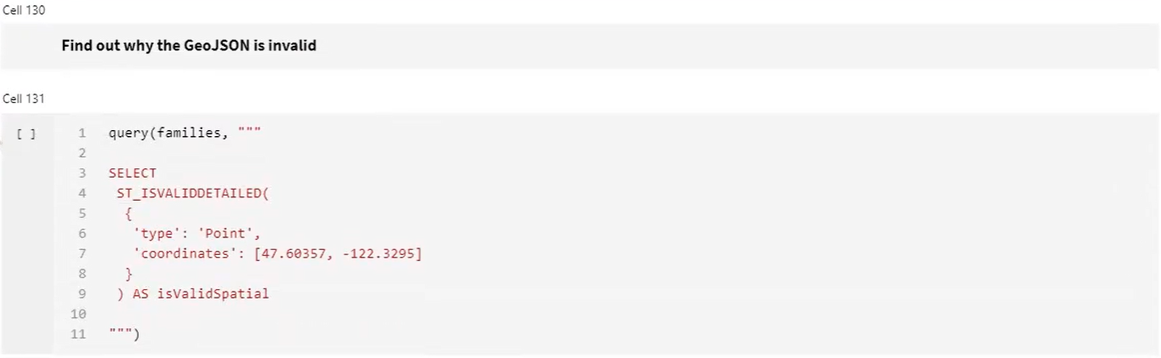 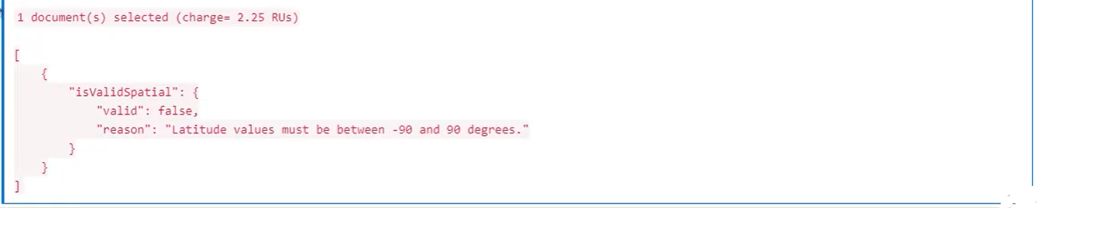

**PROGRAMMING WITH .NET SDK**

